

Project 3

Viral - Social Media Platform

[Devin Sterling](mailto:sterlingd2@montclair.edu)

[Rafael Hidalgo](mailto:hidalgor2@montclair.edu)

Dr. Jenq

CSIT-537

May 11, 2023

# Table of Contents

**Table of Contents 1**

**1. Introduction 4**

Available Web Pages 5

Available Modals 6

Web Interface 6

Recent Page 6

Popular Page 8

Search Page 8

Post Page 9

Edit Post Page 11

Create Post Page 12

User Page 12

User Posts Page 13

User Comments Page 13

User Bookmarks Page 14

Account Settings Page 15

Password Settings Page 16

(Admin) All Users Page 16

Login / Signup Modal 17

**2. Implementation 17**

Front-End 18

Front-End Dependencies 18

Axios 18

React Query 19

React Router Dom 19

React Bootstrap 19

React Markdown 19

Remark GFM 20

Autosize 20

Back-End 20

Back-End Dependencies 20

Express Session 21

BcryptJS 21

Cors 21

Sequelize 21

MySQL2 22

Environment 22

Requirements 22

Database Preparation 22

Back-End and Front-End Preparation 22

Execution 23

**3. Testing 23**

Test Plan 23

Objectives: 23

Scope: 23

Test Cases: 24

Test Steps: 24

Guests 24

Navigation: 24

Users 24

Navigation: 24

Input Data: 25

Responsiveness: 25

Error Handling: 25

Admin 25

Navigation: 25

Input Data: 25

Responsiveness: 26

Error Handling: 26

Expected Results 26

Actual Results 26

Guests 26

Navigation: 26

Users 32

Navigation: 32

Input Data: 37

Update Biography 44

Update Profile Picture 45

Responsiveness: 49

Error Handling: 52

Passwords do not match 54

Email is not in email format 55

Admin 55

Navigation: 55

Input Data: 59

Edit User 60

Delete User 61

Update Post 63

Responsiveness: 65

Error Handling: 66

**4. Discussion 68**

**5. Conclusion 68**

**6. References 69**

# 1. Introduction

Viral is a sleek mock single-page social media platform that enables users to share posts and comments using a user-driven voting system. With the user experience in mind, it simultaneously supports large and small devices with minimal screen clutter thanks to a responsive design. Furthermore, it utilizes popular technologies such as Markdown, Bootstrap, ReactJS, and Express. Finally, as a social media platform, Viral caters to guests, users, and admin roles to ensure a smooth experience.

The main component of Viral is its ranked user voting system, where users can upvote or downvote posts and comments. Their votes affect the ranking of such posts and comments and can entail whether the information conveyed is of popular opinion. Moreover, if there are more downvotes than upvotes, such posts or comments are less likely to appear in a user's feed under the popular section. Conversely, posts and comments with a high upvote-downvote ratio will appear nearer the top.

Another vital component of Viral is user customization. Users can identify themselves under a unique username. In addition, they can provide a self-introduction or biography for others to view. They can also change their profile picture, email address, and password. All in all, supplying customization of their user account.

Another component is the post and comment feature offered by Viral. It allows users to share their opinions or findings with others as an outlet for communication. Most importantly, it features rich customization of user input through Markdown. Markdown allows users to emphasize text, share code, embed images, tables, links, etc. Giving users who like to be creative make their posts and comments stand out. Furthermore, posts are searchable using the search bar provided in the web interface to assist users with finding posts that interest them.

Viral also supports bookmarks for users who wish to refer to a post at a later period. They can add as many bookmarks as they want, visible under the bookmarks tab on their profile page. Additionally, it enunciates which posts users are interested in. Overall, such a feature enables users to keep track of bookmarked posts, especially when switching from one device to another.

Guests can search and browse through posts like any other user. When viewing posts, guests can view comments from other users. In addition, they can view the status of users through the profile page, viewing their posts, comments, and bookmarks. However, as guests, there are restrictions, which prevent them from altering the state of the application. For example, while guests can view user votes for posts and comments, they cannot actively participate in upvoting or downvoting posts or comments. They also cannot comment, post, or have access to profile customization. Ultimately, guests are limited to querying data. If guests wish to share, respond, vote, etc., they must log in or sign up.

Upon registration, users have access to features that guests do not. They can participate in the voting system for posts and comments to rank them appropriately. Including writing their comments and posts to share with other users on the platform. In addition, as mentioned above, they obtain access to profile settings, where they can change their username, biography profile picture, etc.

An admin is a superset of a user. Their additionalities include access to modify or delete users or their posts. Additionally, in the web user interface, they will be labeled as an admin, making it easy for guests and users to differentiate between different roles on the platform.

To facilitate users in completing their tasks, the web interface includes a set of web pages and convenient modals. The use of modals allows users to conveniently perform actions without having to be redirected to another page to complete a task, including signing up and logging in.

## Available Web Pages

* **Guest**
  + Home: **“/”** (Redirects to **“/recent”**)
  + Recent: **“/recent”**
  + Popular: **“/popular”**
  + Search: **“/search/:query”**
  + Post: **“/post/:id”**
  + User: **“/@:username”**
    - User Posts: **“/@:username/posts”**
    - User Comments: **“/@:username/comments”**
    - User Bookmarks: **“/@:username/bookmarks”**
  + Error (404): **“/*”**
* **User** (Contains access to all web pages available to **Guest**)
  + Create Post: **“/post/create”**
  + Edit Post: **“/post/:id/edit”**
  + Settings: **“/settings”** (Redirects to **“/settings/account”**)
    - Account Settings: **“/settings/account”**
    - Password Settings: **“/settings/password”**
* **Admin** (Contains access all web pages available to **User**)
  + Edit Other User Account Settings: **“/settings/:userId/account”**
  + Edit Other User Password Settings: **“/settings/:userId/password”**
  + View All Registered Users: “**/admin/users**”

## Available Modals

* Guest
  + Log in / Sign up Modal
* User
  + Delete Post Modal
* Admin (Contains access to all modals available to **User**)
  + Delete User Modal

## Web Interface

### Recent Page

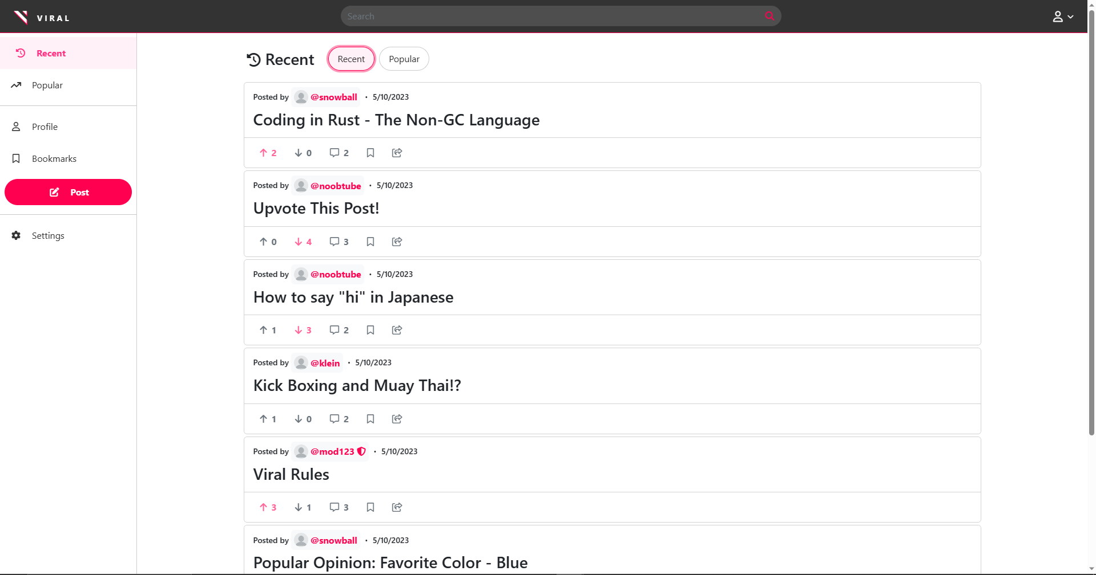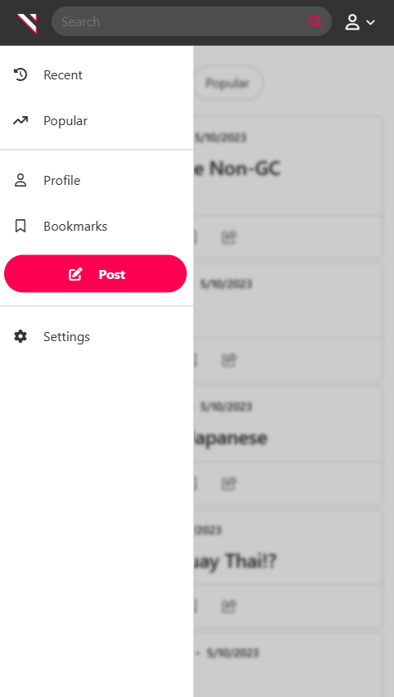

**Figure 1 & 2. “Recent” Page (Desktop and Mobile View)**

As soon as guests land on the Viral homepage, they're greeted with an intuitive layout that showcases the latest posts from users across the platform. Posts are displayed in vertical stacks of ten, and users can seamlessly load additional posts by scrolling to the bottom of the page thanks to cursor pagination and infinite scrolling features. Each post is accompanied by a multitude of information, including the username of the poster and the date it was shared. Clicking on the poster's name directs users to the poster's profile page for further context. Directly underneath, users can find the post's title, which provides context about the post. In addition, each post includes detailed statistical information, including the number of upvotes, downvotes, and comments it has received. Signed-in users can cast their vote by clicking on the upvote or downvote button, with their vote counting towards the post's overall ranking. Clicking on the comment count directs users to the post page, where they can view and engage with other users' comments. For added convenience, each post includes a bookmark button that allows users to save posts for later reference, as well as a share button that copies the post's link to the user's clipboard. The upvote, downvote, and bookmark icons are highlighted when a user has engaged with them, providing instant feedback on their actions.

At the top of the page is the global navigation bar that enables users to conveniently search for posts and sign in. Designed with user convenience in mind, the navigation bar is accessible from anywhere on the site, thanks to its fixed position. Users can effortlessly scroll through pages without losing access to the navigation bar. At the far left of the navigation bar, the Viral logo acts as a shortcut to the “Recent” page and a toggle for the sidebar on small-screen devices. Clicking on the person icon at the far right toggles a drop-down menu that allows users to access their user profile or settings page with ease. In addition, at the far bottom of the drop-down is a red pill button that changes depending on the user's sign-in status. For users who haven't logged in, the button will read “Login”, with a modal popping up upon clicking it. However, for signed-in users, the button will switch to “Sign Out”, enabling quick and effortless log-out capabilities.

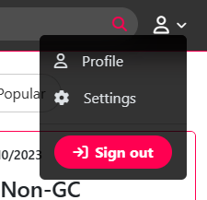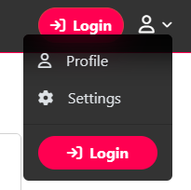

**Figure 3. Navigation Bar Drop-Down Menu**

On the far right of the interface, is the sidebar, which allows traversal throughout the platform with ease. It provides access to viewing the latest or most popular posts, viewing the signed-in user’s profile, creating posts and accessing current user’s settings. Similar to the navigation bar, it is fixed in position and accessible throughout the entire set. On smaller devices, the sidebar remains hidden until users click on the Viral logo on the navigation bar, as shown in Figure 2. For users who haven't logged in and try to access features such as “Profile”, “Bookmarks”, “Create Post”, or “Settings” found on the sidebar, a modal will appear, enforcing them to log in before proceeding

### Popular Page

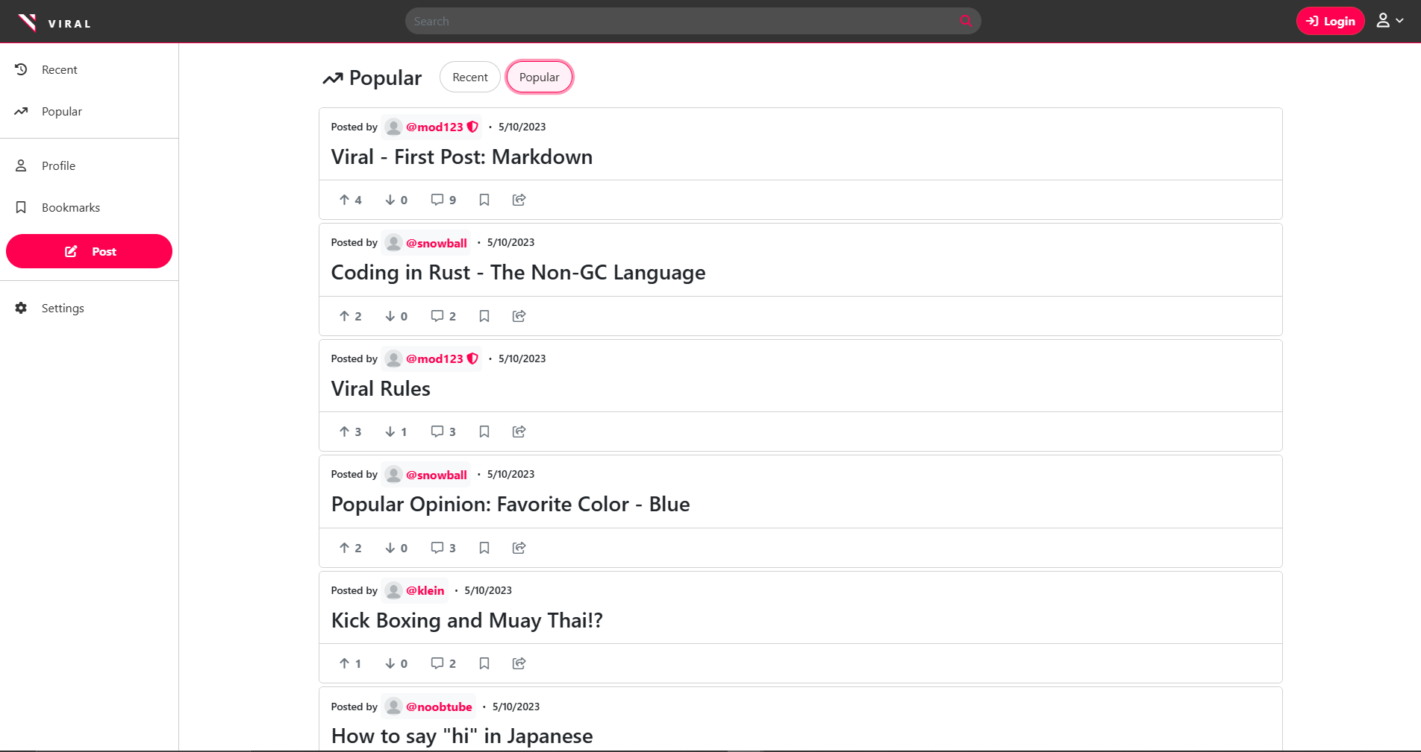

**Figure 4. “Popular” Page on a Desktop**

On the “Popular” page, accessible through the sidebar or “Recent” page, shows the user-driven vote system in action. On this page, the most popular posts are displayed in descending order based on net upvotes. With the same cursor-based pagination and infinite scrolling functionality as the "Recent" page, browsing through popular posts is bandwidth-efficient. The only difference between the two pages is the header, which displays "Popular," and the ordering of the results

### Search Page

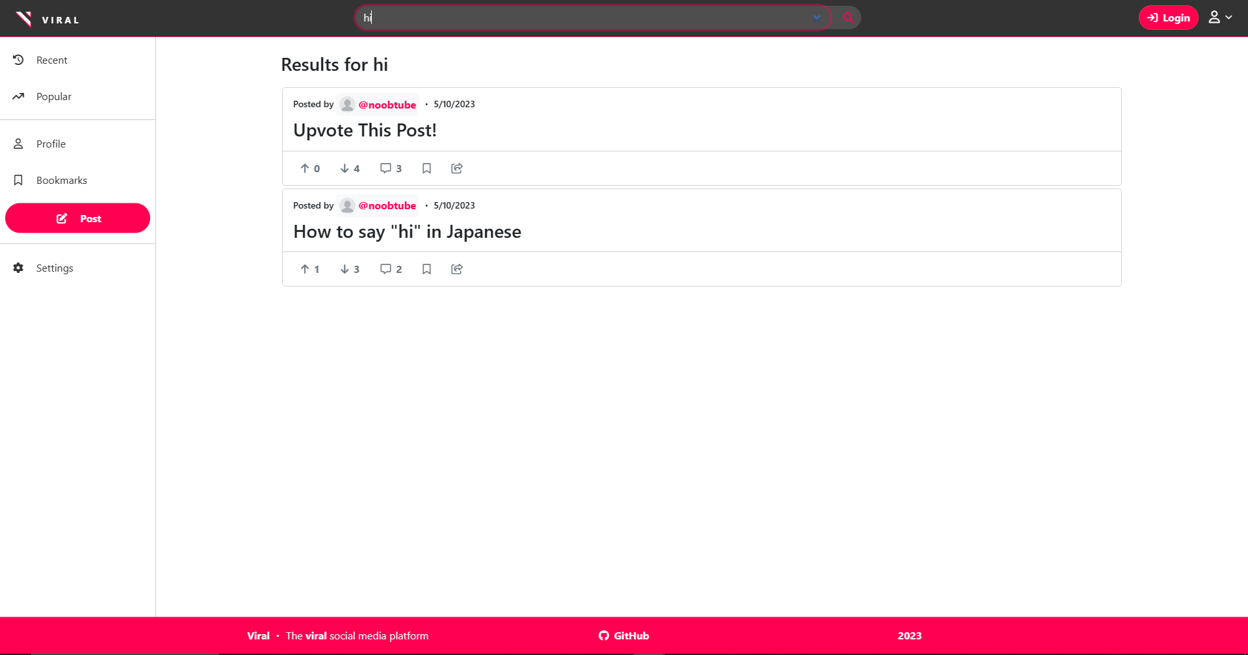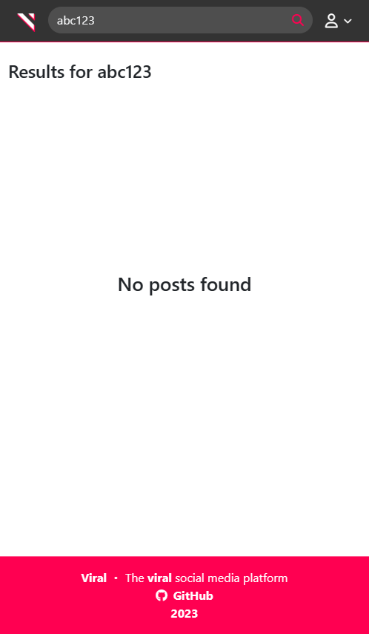

**Figure 5 & 6. “Search” Page (Desktop and Mobile View)**

The search bar, located at the center of the navigation bar, allows users to easily search for posts of interest by their title. Once a user enters their search query and hits enter or clicks the search button, they are directed to the “Search” page, where the results are ordered by recency to show the most up-to-date posts. Similar to the “Recent” and “Popular” pages, users can navigate through the results using cursor-based pagination and infinite scrolling, with posts grouped in batches of ten. In the event that no posts match the user's search query, a prominent "No posts found" message is displayed, as shown in Figure 6.

### Post Page

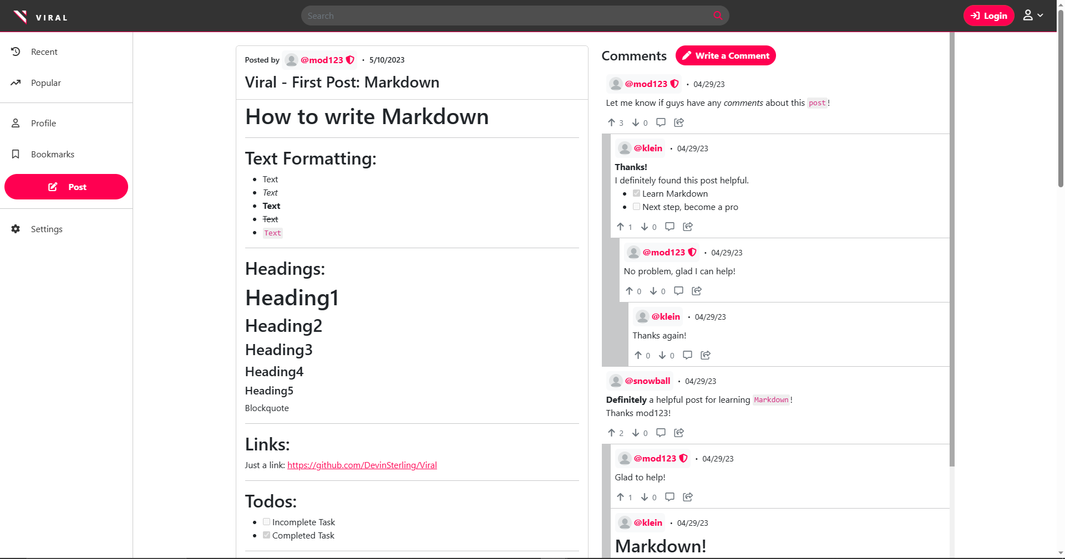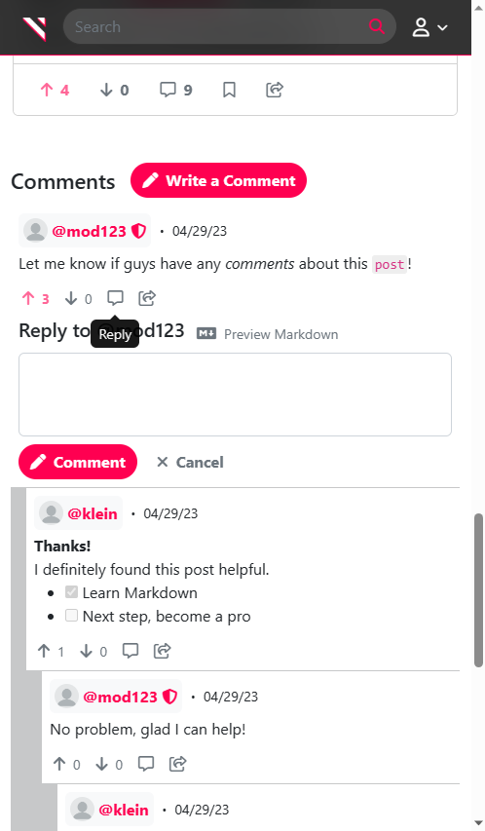

**Figure 7 & 8: “Post” Page (Desktop and Mobile View)**

When a user clicks on a post snippet found on other pages, such as the “Popular” page, they will be directed to the associated “Post” page, where they can view the post content along with its comments. Comments are organized hierarchically and are ordered using the user-driven voting system. Like posts, comments have a poster and buttons to perform actions such as upvoting or downvoting, and sharing the link. However, with the addition of a reply button with a comment icon. Logged-in users can reply to existing comments or write a new comment. Thanks to its responsive design, on larger screen devices, the post and comments are displayed side by side, while on smaller screen devices, they are stacked instead. If a user attempts to reply or upvote/downvote a comment while not signed in, they will be prompted to log in through a modal.

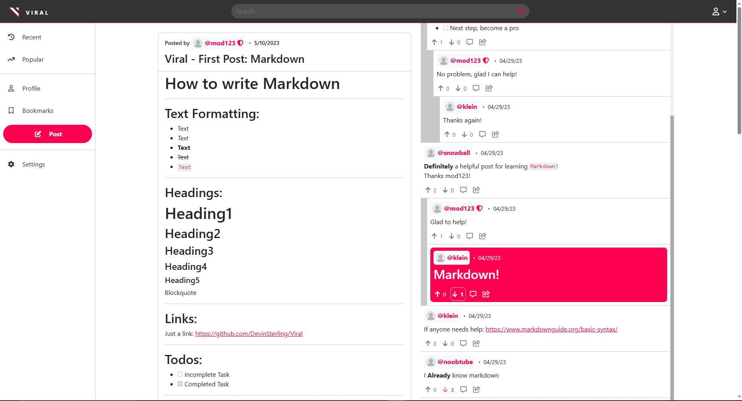

**Figure 9: “Post” Page: Copying Comment Link**

As mentioned earlier, users can use the share button on a comment to copy the link to the clipboard. When the link is pasted and executed in a browser, the web page will automatically highlight the comment where the link was copied from, making it easy to find in the future, especially for posts with many comments. This feature is particularly useful for users who want to share with others and refer to a specific comment in a discussion.

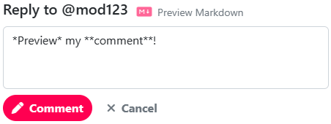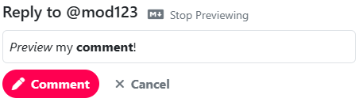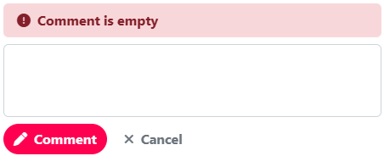

**Figure 10, 11, & 12: Commentary**

When a user writes a comment, they can preview how their comment will look by using Markdown. Markdown is a lightweight markup language that allows users to add formatting, such as images, URLs, and lists, to their comments (IBM). Once the user is satisfied with their comment, they can submit it by clicking the “Comment” button. The comment form includes input validation to ensure that users enter valid and non-empty data. If a user tries to submit an empty comment, they will be prompted to enter text before they can submit.

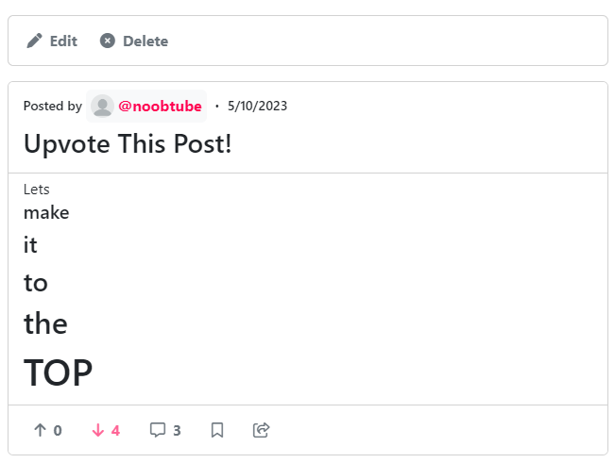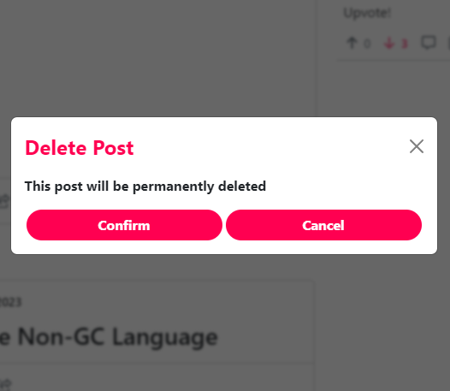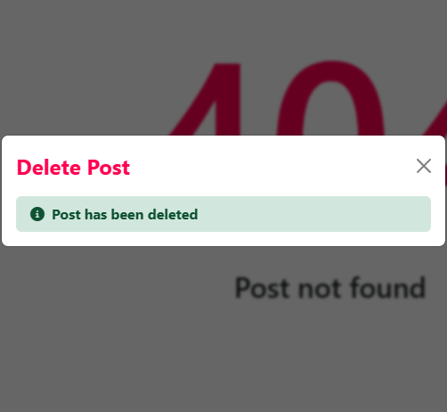

**Figure 13, 14, & 15: Delete Post Modal**

On the “Post” page, if the user is the author of the post or an admin, they have the option to edit or delete it. Clicking on the edit button will redirect the user to a page where they can modify the post content. On the other hand, clicking on the delete button will trigger a confirmation modal asking the user if they want to permanently remove the post. If the user confirms, a request will be sent to the server to delete the post. If the deletion is successful, a success message will be displayed on the web interface and the background behind the modal would change to a 404 message displaying the post can no longer be found as shown in Figure 15. Otherwise, an error message will be shown in the modal.

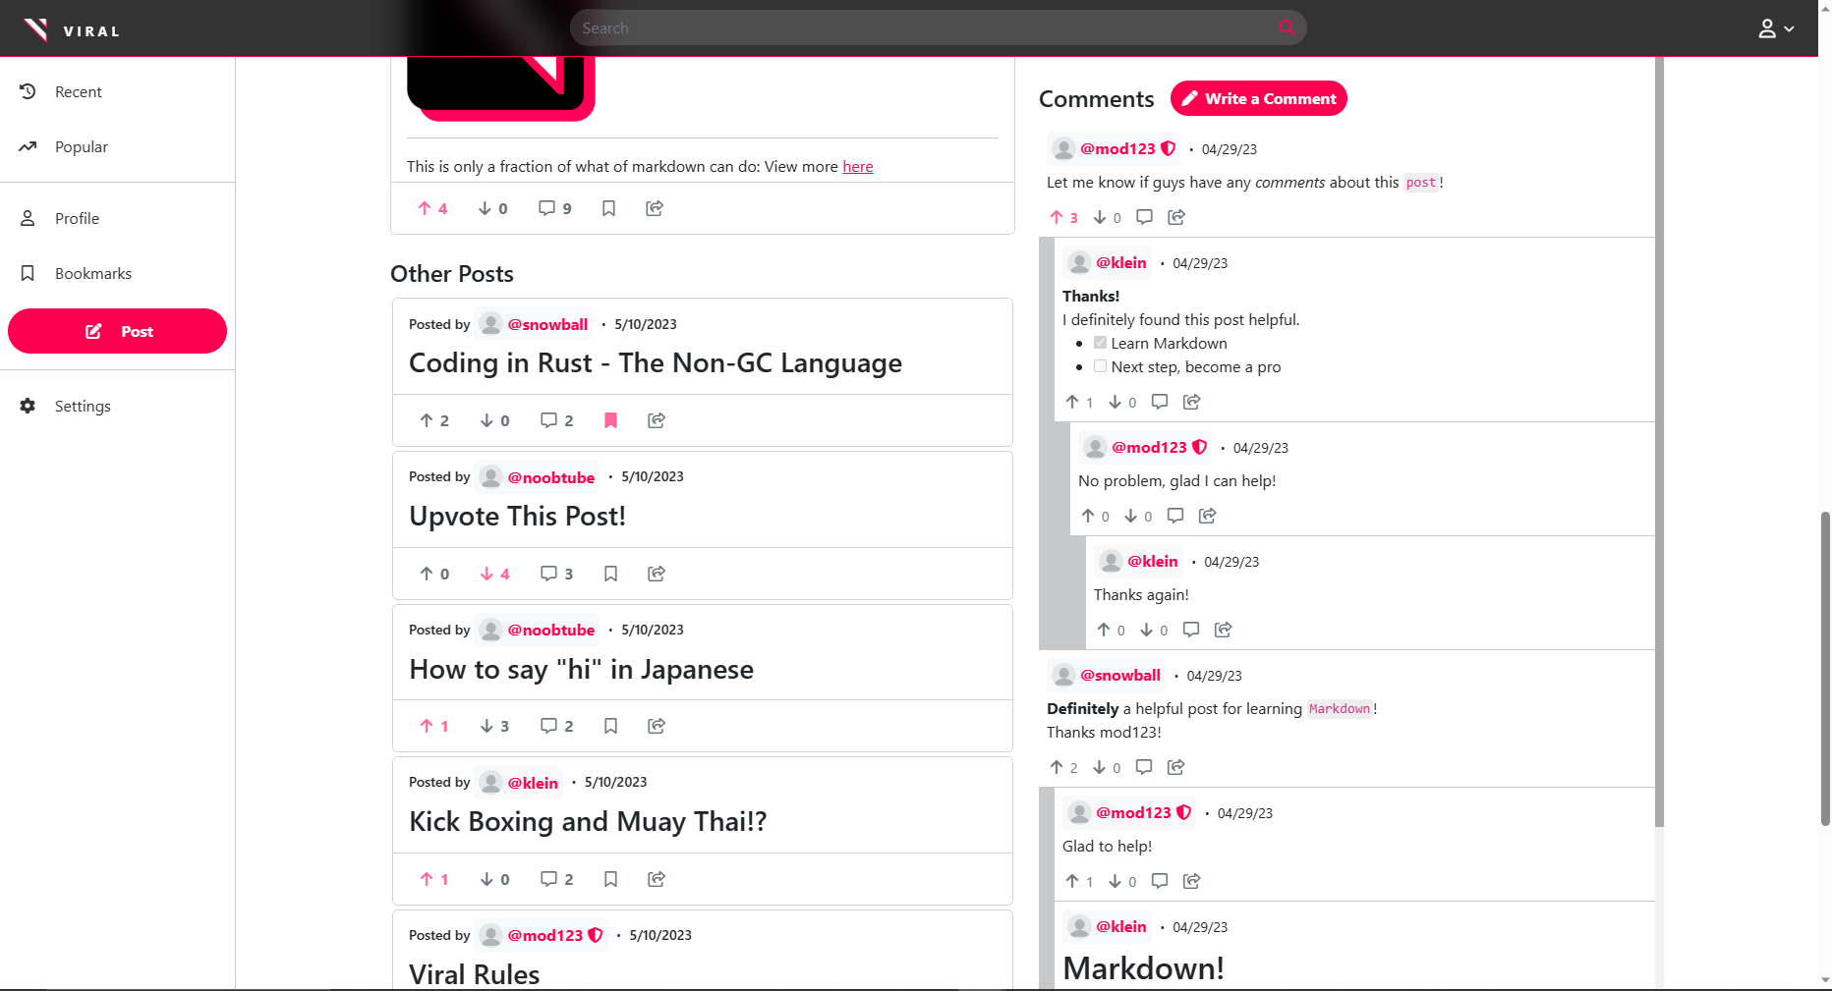

**Figure 16: “Post” Page: Other Posts**

In addition, the “Post” page displays ten recent posts that may pique the interest of the user. Its intended purpose is to keep the user engaged and encourage them to explore and interact with other posts on the platform.

### Edit Post Page

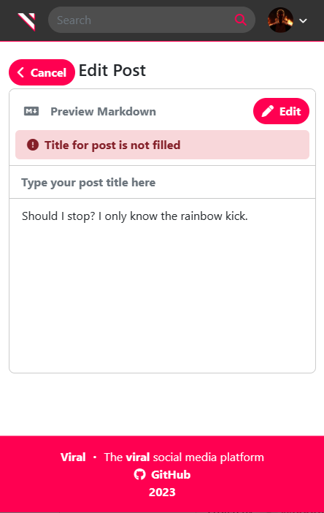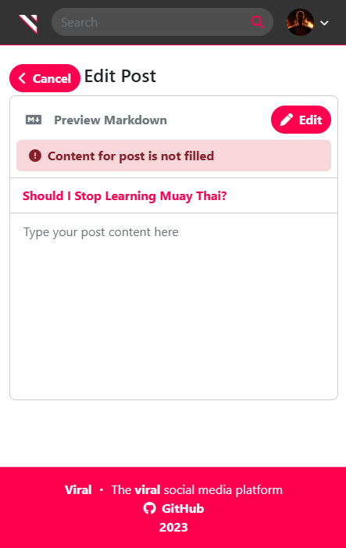

**Figure 17 & 18: “Edit Post” Page**

When the user clicks on the “Edit” button on the”Post” page, they are taken to the “Edit Post” page where they can modify the post title and content. Like the comment section, the “Edit Post” page has a preview function for Markdown, which allows users to format their content easily. Input validation ensures that the title and content fields are not empty. If the user decides not to save their changes, they can click on the “Cancel” button located at the top left of the page. However, if they wish to save their changes, they can click on the “Edit” button located at the top right of the interface, as shown in Figure 17. After a successful submission, the user is redirected to the updated “Post” page, reflecting the changes made. If an error occurs during the submission process, the user is notified of the issue without being redirected.

### Create Post Page

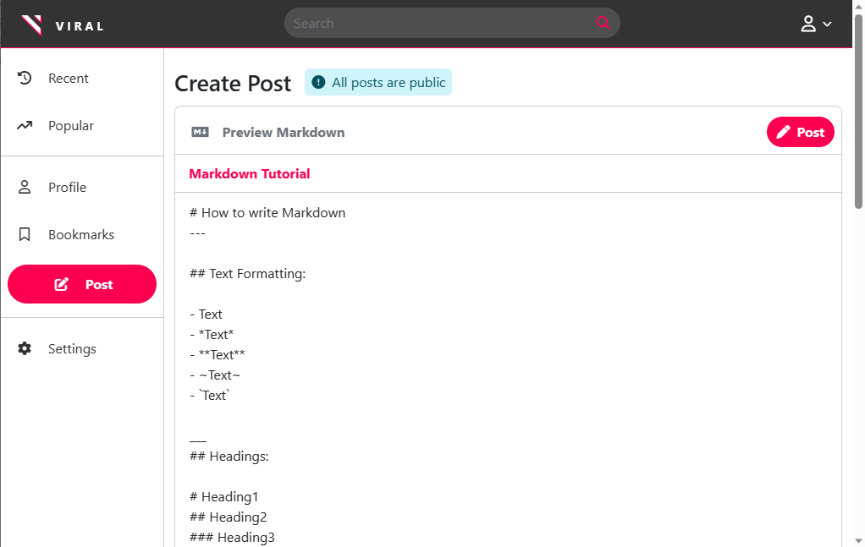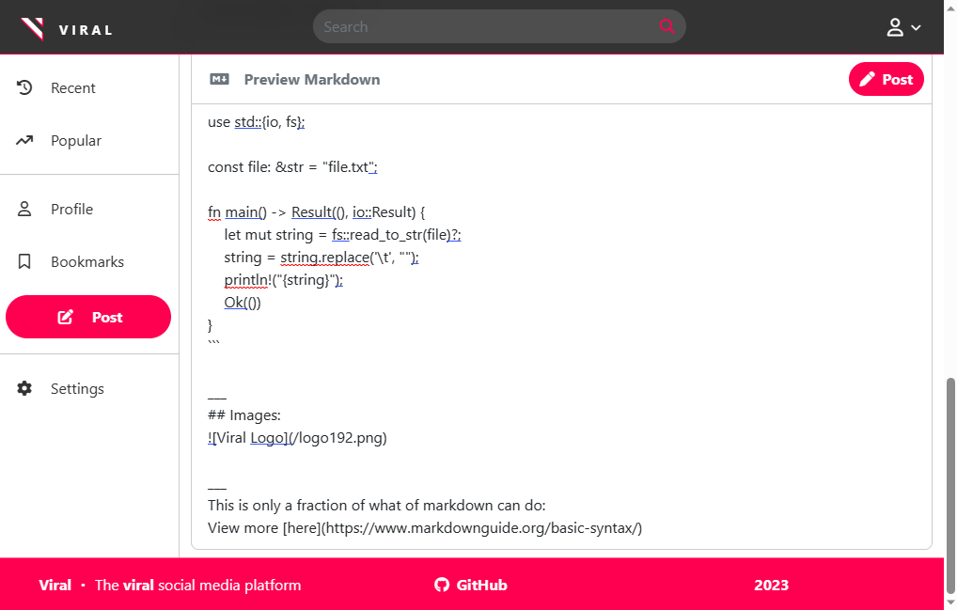

**Figure 19: “Create Post” Page**

The “Create Post” page can be accessed through the sidebar, allowing users to share their content with others on the platform. Similar to the “Edit Post” page, it offers markdown preview and input validation to ensure that required fields are not left empty. After composing their post, users can click on the “Post” button located at the top right corner of the interface to publish it. If the post is successfully created, the user will be redirected to the new post's page. However, if any errors occur during submission, the user will be promptly notified without being redirected, similar to the behavior on the “Edit Post” page.

### User Page

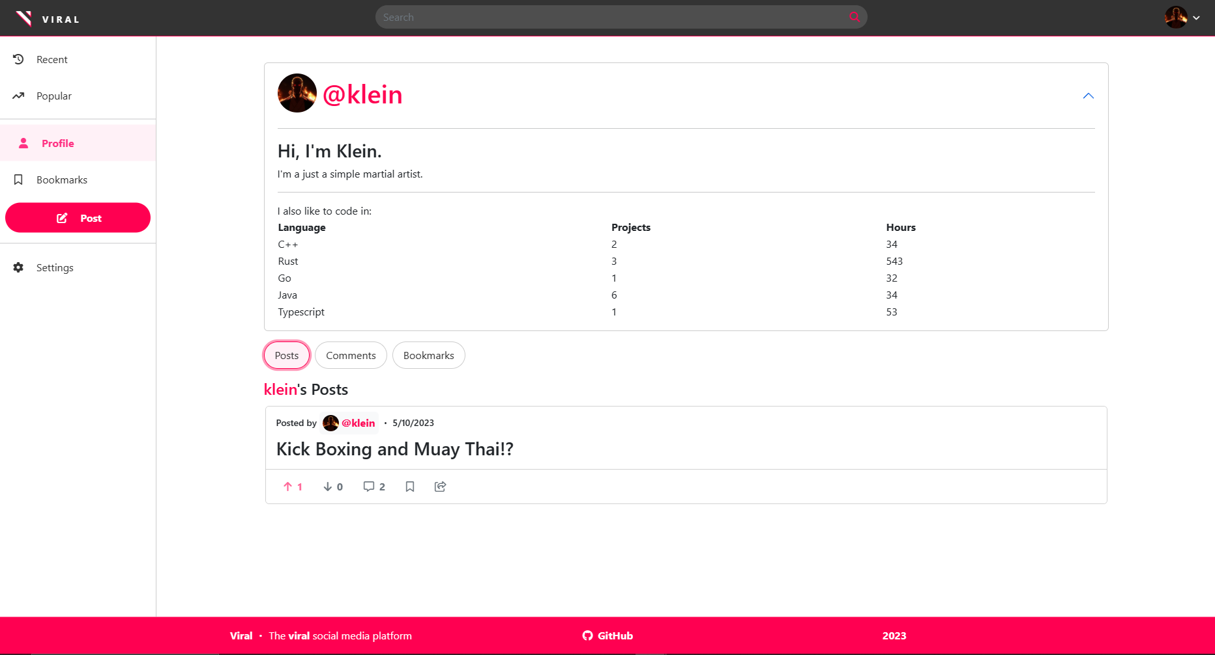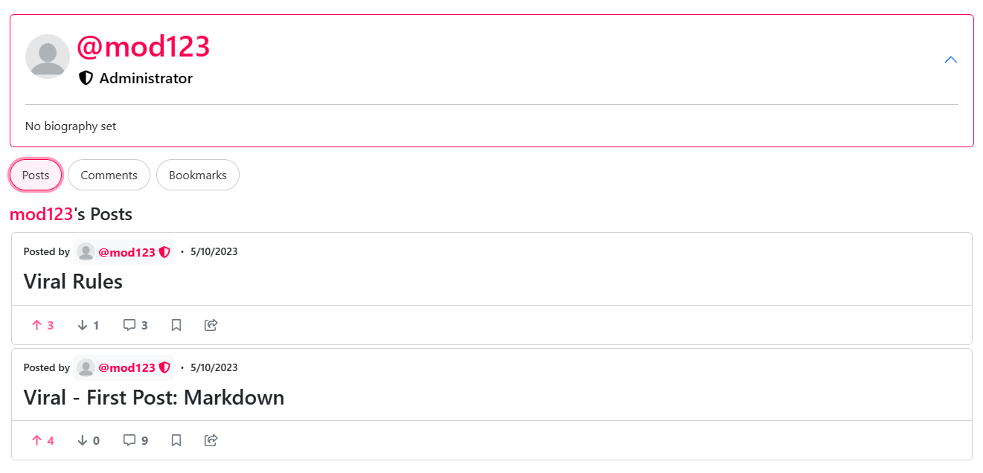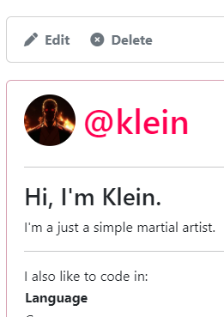

**Figure 20, 21, & 22: “User” Page**

The "User" page allows users to showcase their identity by adding a biography and a profile picture. To access their own profile page, users can click on “Profile” found on the sidebar or navigation bar drop-down menu. If no profile picture is provided, a default gray avatar will be displayed instead. In addition, if no biography is set, users are given a default, “No biography set”. Users can format their biography using Markdown, which offers a variety of text formatting options, including tables as shown in Figure 20. Admins can be easily identified by a shield icon next to their username, which regular users do not have. If a user is viewing their own profile, they can choose to edit it by clicking on the “Edit” button, similar to how they would edit a post. Clicking on the “Edit” button will redirect the user to their settings page, where they can edit their user details. Admins, on the other hand, have the additional option to delete the profile entirely. If an admin chooses to delete a user profile, a confirmation modal will appear, similar to Figure 14. If the deletion is successful, a success message will be displayed on the web interface, and the background behind the modal will change to a 404 message indicating that the profile can no longer be found, as shown in Figure 15. If an error occurs during the deletion process, an error message will be displayed in the modal.

### User Posts Page

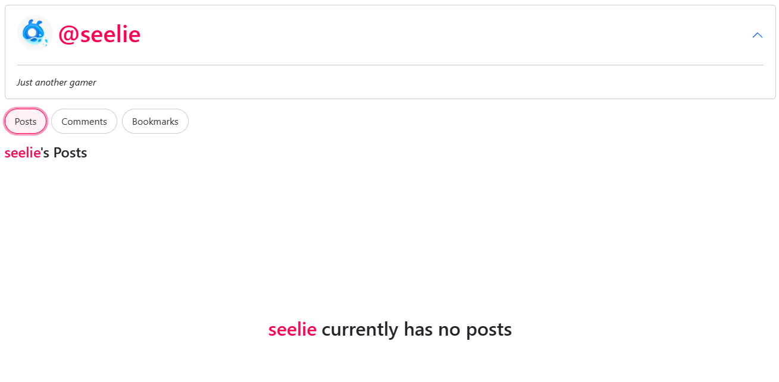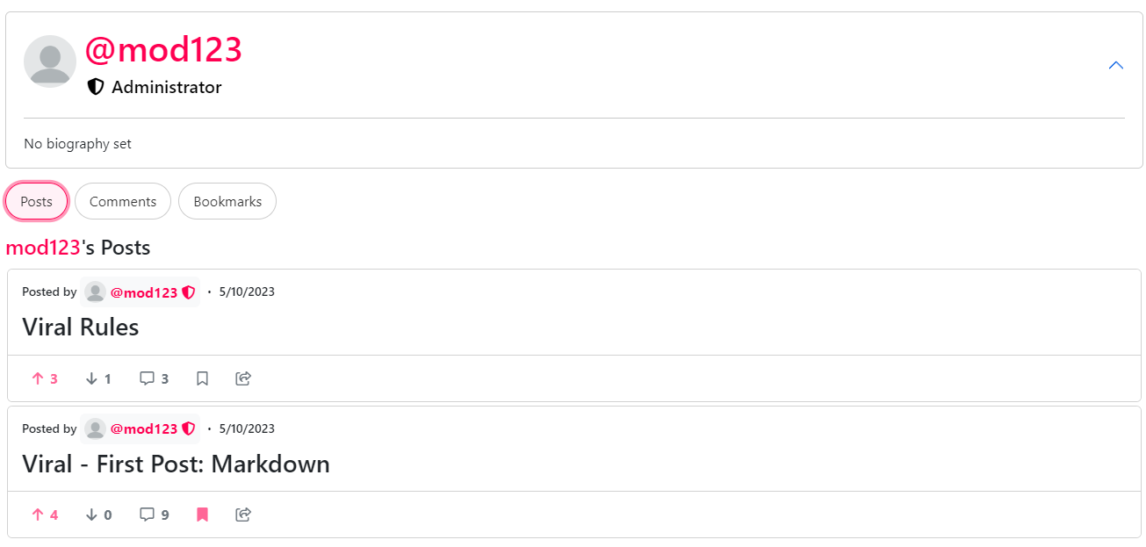

**Figure 22 & 23: “User Posts” Page**

On the “User Posts” page, users can view all the posts created by a specific user. This page can be accessed by clicking on the “Posts” tab located in the “User” page. If the user has not created any posts yet, a message will be displayed to inform them of this. Otherwise, the posts are displayed using cursor pagination and infinite scrolling, with the most recent posts shown first. Users can scroll through the posts to view them.

### User Comments Page

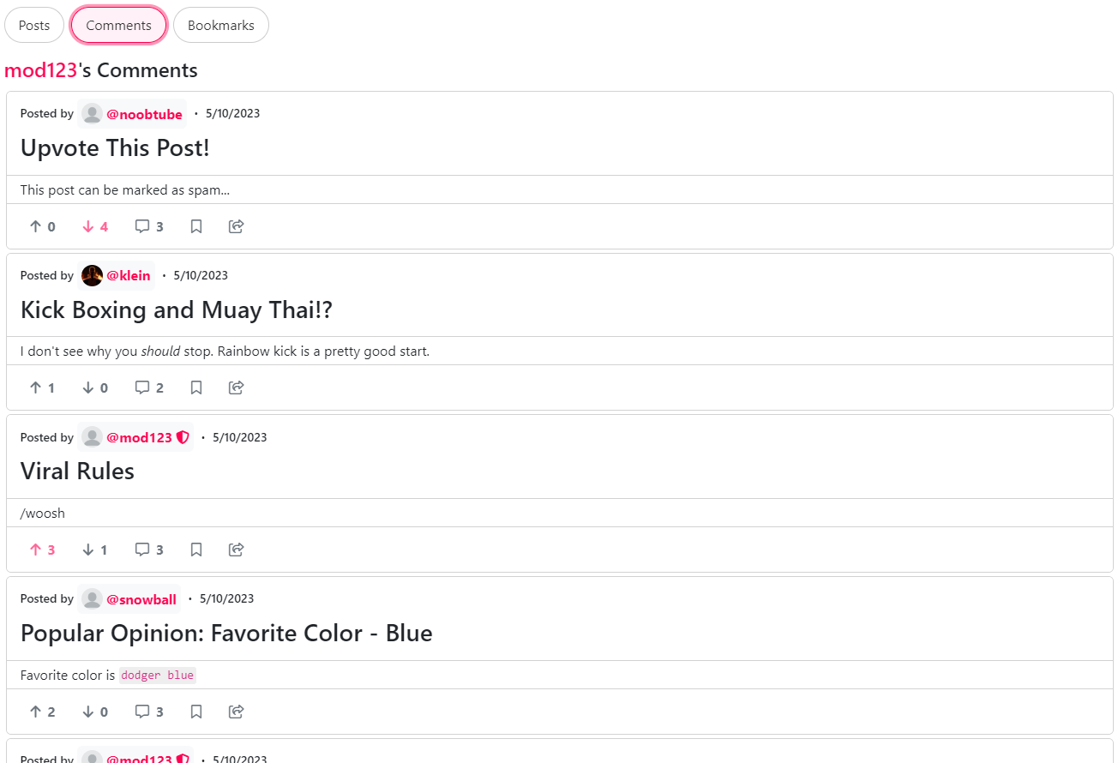

**Figure 24: “User Comments” Page**

On the "User Comments" page, users can view all comments posted by a specific user. This page can be accessed by clicking on the “Comments” tab located on the user's profile page. Similar to the “User Posts” page, if the user has not posted any comments yet, a message will be displayed to inform them of this. Otherwise, the posts are displayed using infinite scrolling and a cursor-based approach. All post details are displayed, including the author of the post, title, upvotes, downvotes, etc. However, the user comment is shown beneath the title of each post as shown in Figure 24. This design allows users to quickly browse through a user's comments without having to navigate to individual posts. However, if users wish to see the post content and comment simultaneously, they can click on the post title to be redirected to the associated post page, which will then automatically scroll to and highlight the requested comment.

### User Bookmarks Page

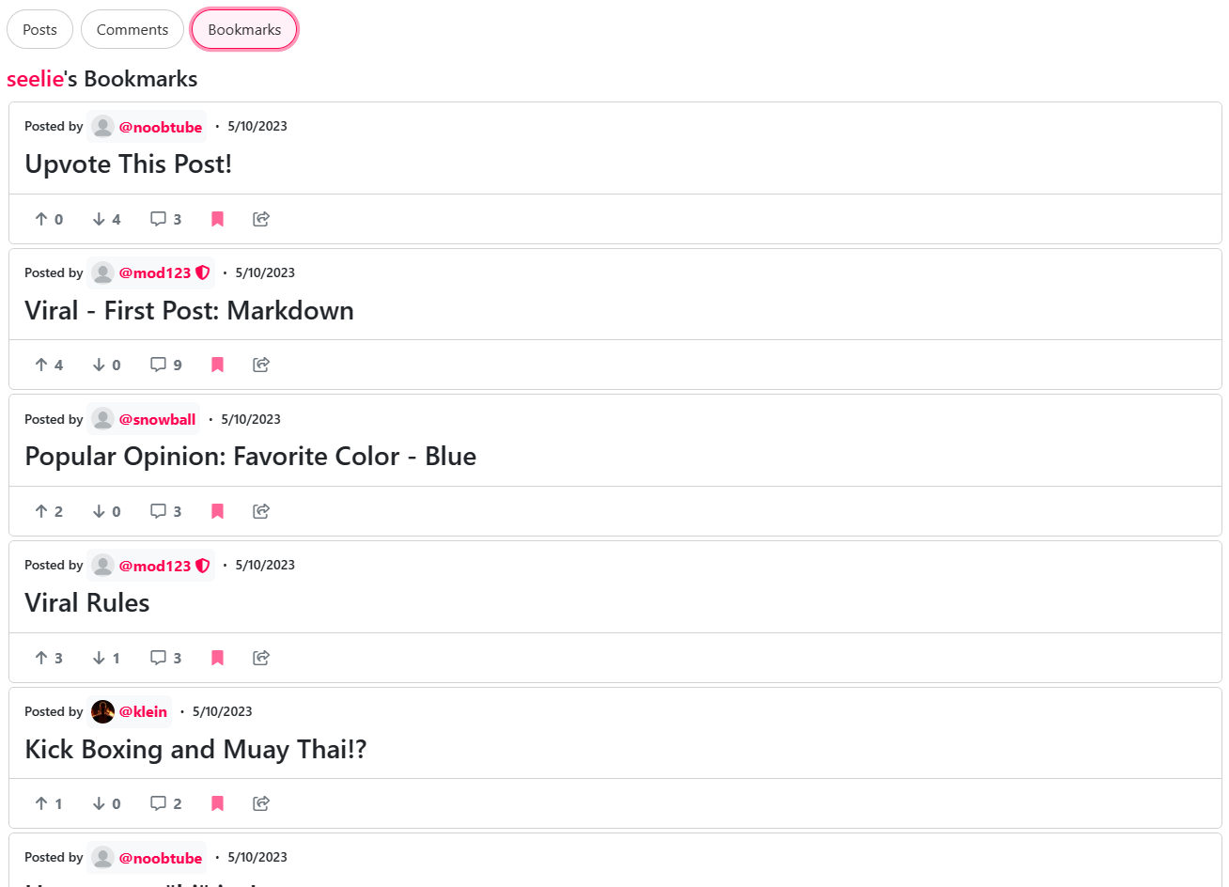

**Figure 25: “User Bookmarks” Page**

On the “User Bookmarks” page, users can view all posts bookmarked by a specific user. As shown in Figure 25, the current user is viewing their own bookmarks page. As a result, all post entries shown have the bookmark icon highlighted to signify that the post is bookmarked. Clicking on the bookmark icon for a post will remove it from the user’s bookmarks. Furthermore, similar to the “User Comments” and “User Posts” page, this page features a cursor-based pagination approach and infinite scrolling.

### Account Settings Page

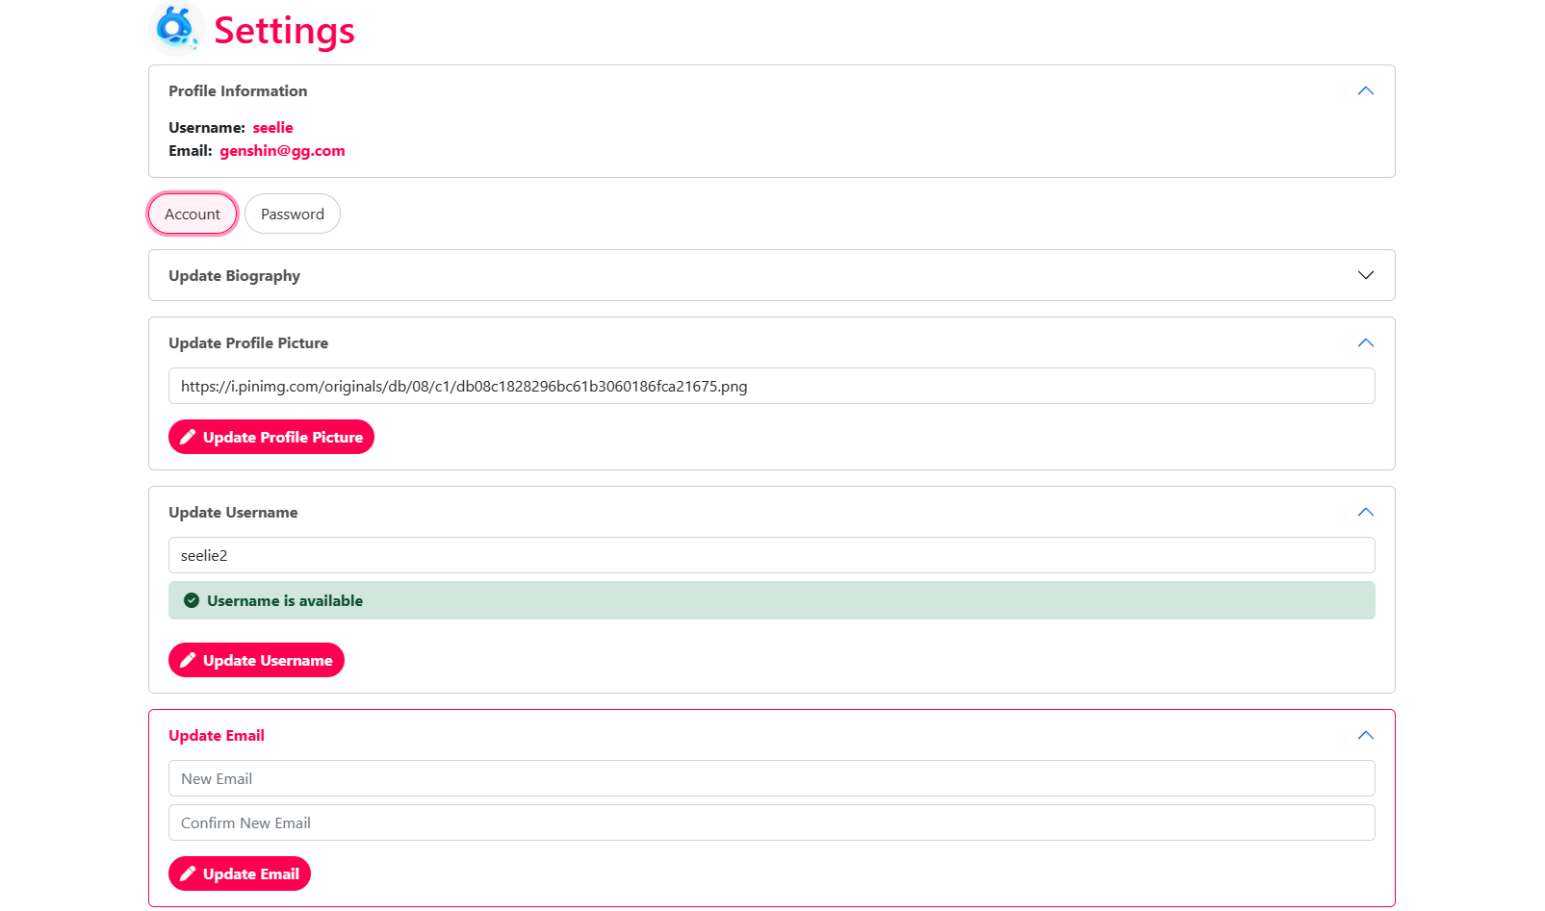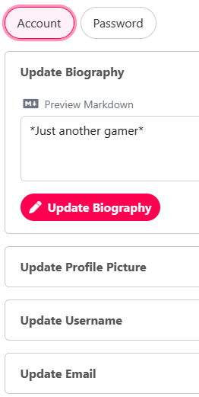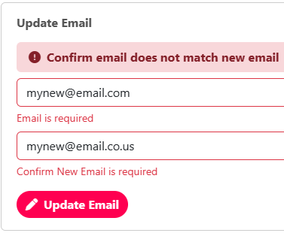

**Figure 26, 27, & 28: “Account Settings” Page**

The user “Account Settings” page can be accessed through the sidebar or the user's own profile page. At the top of the page, the user's basic information, such as their current username and email address, is displayed. The page also features drop-down forms that allow the user to make changes to their account information. All forms include input validation and require non-empty input, except for the optional biography and profile picture forms. When a user changes their biography or email, the system automatically inputs their existing information for convenience, so users will not have to retype everything, especially for large biographies. Furthermore, When changing their username, the system alerts the user if the requested username is available in real-time, making it easier for the user to confirm their selection. If a user decides to change their email address, they are required to type their new email twice to avoid attaching their account to the wrong email as shown in Figure 28. After submitting any of the forms, the system reports any errors and notifies the user of any successful changes. Lastly, the UI is updated accordingly to reflect any changes, such as a new profile picture, username, or email.

### Password Settings Page

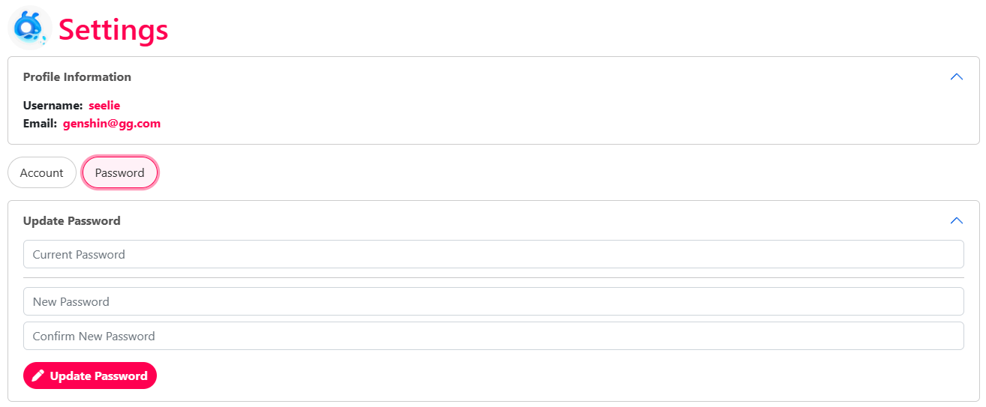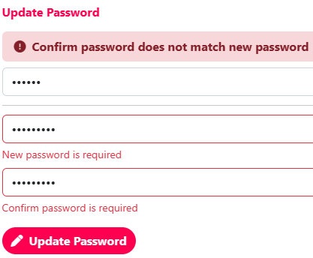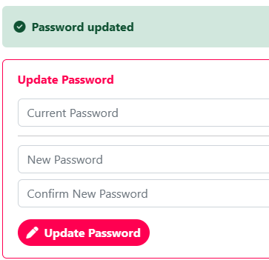

**Figure 29, 30, & 31: “Password Settings” Page**

The “Password” tab in the “Settings” page allows users to change their current password. This form, like others in the Viral platform, has input validation and requires the user to provide non-empty input. To successfully change their password, users need to provide their existing password and enter their new password twice for verification. Once the user submits the form and the change is successful, a notification will inform them that their password was updated. If any errors are encountered, the user is notified.

### (Admin) All Users Page

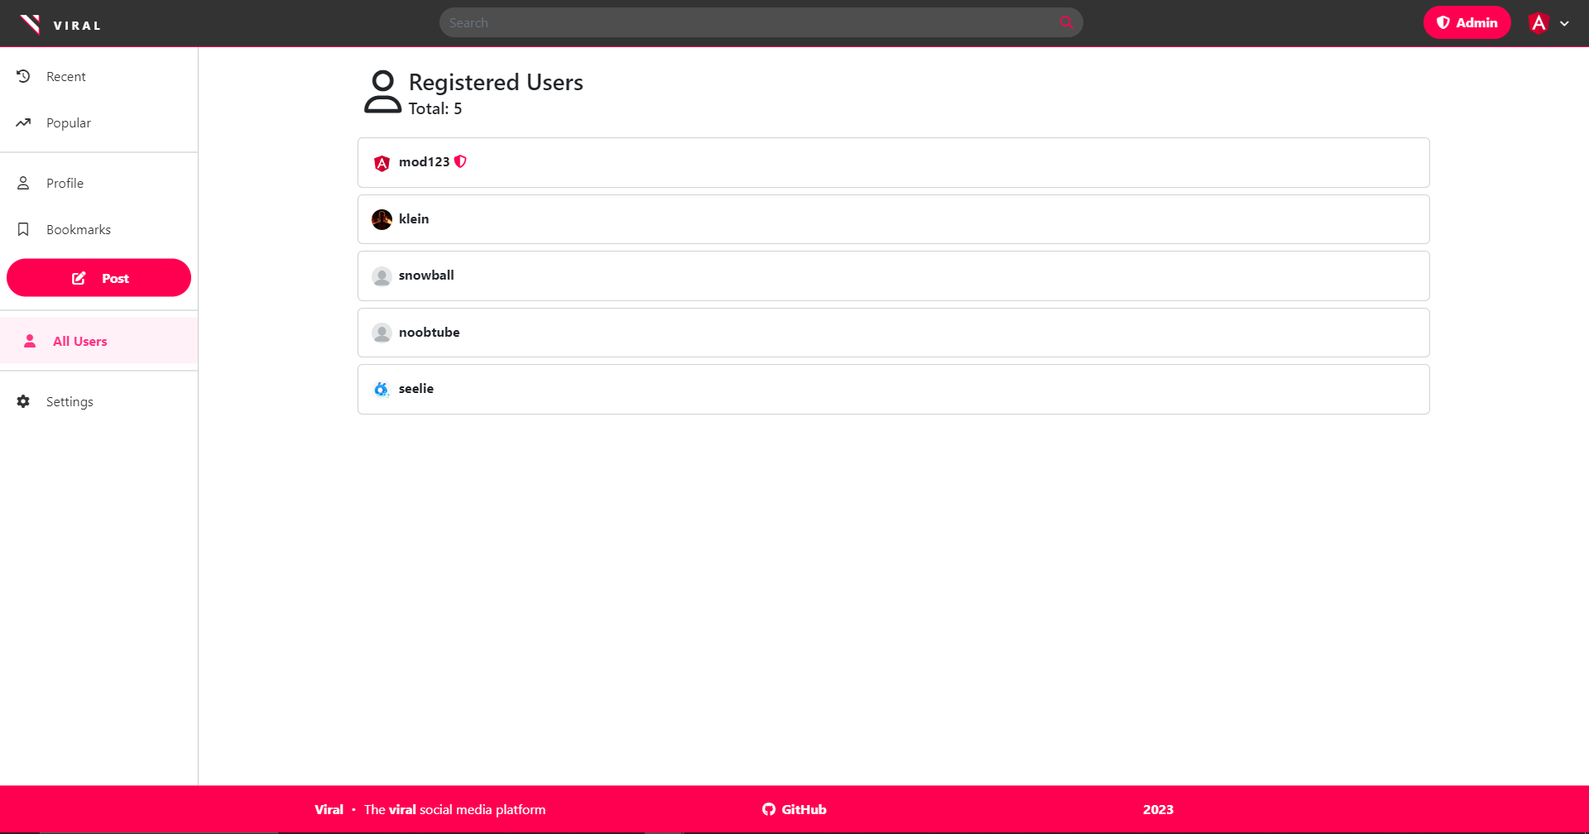

**Figure 32: “All Users” Page (Admins Only)**

Accessible through the sidebar when the user is an Admin is the “All Users” page. It allows admins to view all registered users and total count. On the page, all registered users are stacked vertically in a list. Each user entry shows their profile picture, username, and if the user is an admin, a badge directly to the left of their username. When an admin clicks on a user, they will be directed to their associated “User” page, where admins have additional options available such as editing or deleting the user. If non-admins attempt to visit the page, they will be given a 404 error message. Contrarily, even if they manage to bypass the front-end role-gating as client-side code can be tampered with, the server side will ensure that admins only have access to view all user details and deny their request to list all users.

### Login / Signup Modal

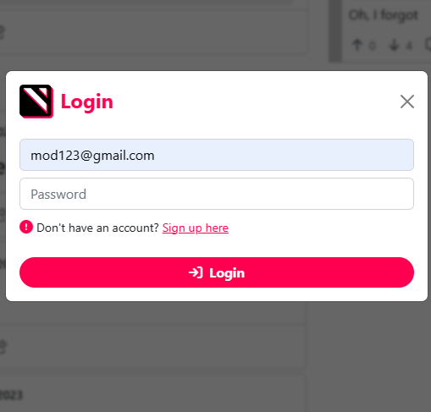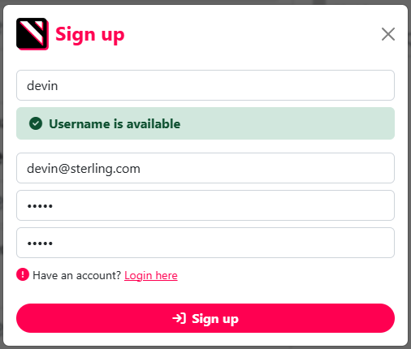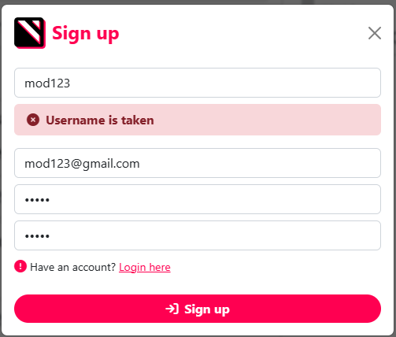

**Figure 33, 34, 35: Login and Modal (Side by Side)**

The “Login” and “Sign up” modal can be accessed from any page via the navigation bar's login button or any component that requires an account, such as attempting to post, comment, bookmark, upvote, or downvote. As modals allow for uninterrupted browsing, users can log in or sign up without being redirected to a new page. For example, if a signed out user wants to comment on a post while viewing it, they can do so without leaving the page. Both the login and sign up forms include input validation to ensure that all required fields are filled out. When a user submits the correct credentials in the login form, the modal will close, and they will be signed in. If the credentials are incorrect, an error message will be displayed to the user. In the sign-up form, users are required to provide a username, email, and password. The username field features real-time validation to check if the requested username is available, as shown in Figures 33 and 34. If all required information is provided correctly, the modal will close, and the user will be signed in. If there are any errors, they will be reported back to the user, as with the login form. After logging in, the UI will update to display only the necessary information to accommodate the user, such as bookmark, upvote, or downvote data, without the need for a page refresh.

# 2. Implementation

Viral is implemented using a combination of technologies for both the front-end and back-end. The server side is built on top of MySQL, Node.js, and Express, which provides a scalable back-end architecture. On the other hand, ReactJS is utilized for the front-end, which provides a responsive user interface. One of the key benefits of Viral’s implementation is its decoupled architecture. The front and back-end are designed to perform independently of each other, allowing them to run on separate servers if needed. Communication between both ends is facilitated through JSON over HTTP, enabling seamless data exchange using standard CRUD operations. Overall, these technologies work together seamlessly to provide a decoupled, smooth and efficient user experience.

## Front-End

The front-end of Viral is a crucial component that provides the user interface and enables user interaction. It is built on top of popular languages, including JavaScript, JSX, and CSS. JavaScript is used for tasks, such as fetching data from the server, updating the contents of the user interface dynamically, and handling user input and events. CSS is used for styling the content and layout of the page, including typography, colors, and positioning. The most prominent technology of the front-end is ReactJS, a JavaScript library that enables developers to create custom components and a seamless user experience, assisting creation of client-side single-page web applications. A single-page application is a web app implementation that only loads a single web page on load. Afterward, the updates of the single web page are updated dynamically via JavaScript, commonly triggered by HTTP requests (Mozilla). Furthermore, with ReactJS, developers can write HTML-like markup within JavaScript files, also known as JSX. JSX allows developers to create custom components, such as custom buttons, modals, and more, which encourage modular and reusable design principles (React). Most components make up what the end-user views when navigating the site, such as forms, posts, comments, etc. Utilizing ReactJS, due to the nature of single-page applications, the user does not need to refresh when navigating, improving perceived performance of the application.

## Front-End Dependencies

The front-end utilizes several dependencies to ease the development process. They conveniently assist developers with useful feature sets and prevent manually writing repetitive boilerplate code. Reduction of boilerplate helps simplify the design process and makes developers focus more on the product itself. Several dependencies utilized on the front-end range from simplifying the process of fetching data from the server to enhancing the user experience by providing intuitive routing and design modules.

### Axios

For data fetching, Viral uses the popular library Axios, which simplifies sending HTTP requests and handling responses. It is a library that works using a promise-based approach for asynchronous operation, which prevents fetch requests from interrupting or freezing the user interface. In addition, it provides convenient methods to perform CRUD operations and allows sending data over JSON with ease (Axios).

### React Query

React Query is a library that assists with data fetching tasks from the server. In Viral, it is used in conjunction with Axios to handle the state of HTTP requests. It avoids the boilerplate of writing additional code to identify whether the request is still loading or if an error occurred. Similar to Axios, it is promise-based to avoid interrupting the user interface. It also provides features useful such as caching, background updates to discard stale data, and cursor pagination querying out of the box (Tanstack).

### React Router Dom

React Router Dom is a powerful tool that enables client side routing for single-page applications like Viral. Traditionally, when a user clicks on a URL, the server-side sends back an entire web page. However, since Viral is a single-page application, it does not require the server to send over entire web pages; only the necessary information, such as post data, comment data, upvote data, etc. The dependency allows the client side to handle routing themselves, so the entire UI doesn’t need to reload when users click on a link to another page (React Router). Such functionality enhances performance and the user experience of a website as it makes navigation seamless and fast without reloading the entire page.

### React Bootstrap

As an alternative to classic Bootstrap, React Bootstrap is designed to integrate and support ReactJS applications. It provides true React Components for useful style classes like Card, Accordion, Button, and more (React Bootstrap). Viral leverages React Bootstrap for quick and efficient prototyping of designs and to create a modern, sleek, and responsive user interface that is compatible with both large and small devices. For instance, the layout of a page can adjust dynamically based on the screen size to optimize the user experience.

### React Markdown

To grant users rich formatting of their posts, comments, and biographies, Viral utilizes React Markdown. React Markdown is a lightweight and easy-to-use library that allows converting Markdown syntax into formatted text. It also provides built-in protection against cross-site scripting (XSS) attacks, to prevent users from injecting scripts into the current web page, ensuring that user-generated content is safe and secure. With React Markdown, users can easily format their text input. Additionally, it supports extensions, which allow for additional functionality, such as extending the syntax, changing styling, etc., (React Markdown). The library allows users to share their content, formatted how they want, while maintaining safety .

### Remark GFM

Used in conjunction with React Markdown, Remark GFM is a plugin that enhances the user experience by offering additional formatting options that are not available in standard Markdown syntax. Providing users of Viral additional formatting options, including tables, which allow users to present data in a structured manner. Another is task lists, providing users with checklists they can create to check progress, useful for to-do lists. Others include automated link highlighting, strikethroughs, and more (RemarkJS). Overall, used in conjunction with React Markdown, users have access to more formatting options for their posts, comments, and biographies.

### Autosize

Autosize is a small JavaScript utility library that automatically adjusts the height of a text area to fit text. With Autosize, users do not need to manually adjust the size of the textarea fields when typing long messages or comments (Jackmoore). By utilizing the library, users can put greater focus on their content without distraction of adjusting the textarea, providing a more polished user experience for end-users on the Viral platform.

## Back-End

The back-end is a key component of services provided by Viral, it is responsible for handling data storage and retrieval, as well as server-side logic for processing requests from the front-end. Developed solely using JavaScript, it uses a combination of Node.js and Express to provide a robust and scalable platform for handling HTTP requests. Node.js is an asynchronous runtime environment that allows developers to write server-side JavaScript code. It uses a non-blocking I/O model, which enables handling many connections over HTTP concurrently. It provides low latency and a scalable design suitable as a foundation for most web projects (Node.js). Express is a popular framework that provides a thin layer of fundamental web application features over Node.js. It provides a suite of tools, such as routing with CRUD operation support, middleware, sessions, and more (Express). In addition to Express, Viral allows persistence of user data through a MySQL database, which enables storing and retrieving user data. It enables the front-end to function and serve as a convenient interface for server querying and manipulation. Overall, the back-end of Viral provides a powerful and flexible platform utilizing Node.js and Express for handling server-side logic and MySQL for data storage, allowing the front-end to provide a smooth and efficient user experience.

## Back-End Dependencies

Similar to the front-end, the back-end utilizes multiple dependencies to reduce the amount of boilerplate code written. Dependencies range from assisting with database access to user security management.

### Express Session

Express Session is a crucial back-end dependency used in conjunction with the Express framework, which allows Viral users to maintain their login status even after refreshing the page. Acting as middleware, sessions save the state of users on the server-side and identify them by passing cookies (Express). As HTTP is stateless, sessions are essential for ensuring a smooth user experience by preventing users from needing to sign in again if they refresh the page. Additionally, sessions also are used to manage authentication for guest, user, and admin roles. They store the user IDs and roles and only permits users to modify their own data, with the exception of admins, which have backdoor access to all data.

### BcryptJS

Viral utilizes the cryptographic BcryptJS library for password hashing, which is a technique used to convert a plaintext password into a hashed unintelligible random string that cannot be easily reversed. Bcrypt utilizes salting to mitigate most attacks, making it more difficult for attacks to crack the original password (dcodeIO). In Viral, when a user signs up or changes their password, Bcrypt is used to hash their password before being securely stored in the database. Overall, the library helps protect user accounts from being compromised in the event of a data breach and enhance system security.

### Cors

Cors is a Node.js package providing Express middleware. It allows the front-end and back-end to communicate from different origins on web browsers. Cross-Origin Resource Sharing (CORS) is a mechanism that allows servers to identify which origin other than itself a browser can permit to load associated resources (Mozilla). Using the library, the back-end can restrict and allow which origins are allowed to load or process any data on a web browser. The feature is especially useful for back-ends and front-ends that operate independently on different servers, however, still wish to interact. Using the cors middleware, it allows the front-end to make requests to the back-end without triggering any security errors.

### Sequelize

Sequelize is an Object-Relational Mapping (ORM) library, which provides a simple and intuitive way to create the schema of a database using JavaScript. It provides a clean interface to create models and establish associations between them without the use of SQL. Furthermore, Sequelize features input validation out of the box, to guarantee only certain input is possible for specific attributes. In addition, the ORM enables developers to easily perform common database operations, such as querying, inserting, updating, and deleting using JavaScript (Sequelize). Overall, it assists with the development process, as writing raw SQL queries can be error-prone.

### MySQL2

MySQL2 is a fast, performant library that provides access between the Node.js server and MySQL database. The JavaScript library, MySQL2 is a MySQL driver to connect to a database from the server-side. The library provides efficient and secure communication with the database, allowing for fast retrieval of user information. Additionally, MySQL2 provides connection pools, which enables the application to handle a large number of concurrent connections without overwhelming the database (sidorares). While not directly used in the Viral server-side code base, Sequelize is dependent on MySQL2 to perform any operations on the database.

## Environment

### Requirements

Starting up Viral’s front-end and back-end servers require several prerequisites to be installed on the host machine. These include the Node.js runtime environment and NPM package manager, which can be downloaded from <https://nodejs.org/en/download>. Node.js enables both the front-end and back-end to run on separate ports, while the NPM package manager allows installation of the necessary dependencies for Viral’s functionality. For data persistence, it is recommended to use a MySQL database server. Although any MySQL server is compatible with Viral, during development, XAMPP (available at <https://www.apachefriends.org/download.html>), which includes phpmyadmin, was used to start up the database. In summary, Viral requires the host machine to have a MySQL server for database access, Node.js for launching both the front-end and back-end servers, and NPM for installing the necessary dependencies.

### Database Preparation

Once a server for MySQL databases is established, Viral requires a specific database name and user account to perform imperative operations, such as storing and retrieving user posts and comments. The database should have a name “**viral_db**” and be case-sensitive. Additionally, the database user account should be named “**viral_admin**” with the password “**viral_password**” and be granted all permissions for the “**viral_db**” database. Once these criteria are met, the database should function correctly with Viral.

### Back-End and Front-End Preparation

After setting up the database and installing both Node.js and NPM, the next step is to install the required dependencies for both the front-end and back-end to start up. To do this, navigate to the root of the server-side directory (“**/server**”) and run the command “**npm install**” in the console. This will install all the necessary dependencies for the back-end. Similarly, navigate to the root directory of the client-side (“**/client**”) and run the same command “**npm install**” to install the dependencies for the front-end. During the installation process, the console will provide real-time progress and notify when installation is complete.

### Execution

Once all dependencies are successfully installed using the NPM package manager, both the front-end and back-end can now be started up. However, the database server must be started first. Once it is deployed, navigate to the root directory of the server-side and run the command “**npm start**”. Similarly, navigate to the root directory client-side and run the command “**npm start**”. This will start up both the front-end and back-end servers, making them operational. Viral will now be accessible through the web browser for users to share their posts and comments with others.

# 3. Testing

## Test Plan

### Objectives:

* To ensure that the user interface of the Viral social media platform is user-friendly and intuitive.
* To ensure that all functionalities of the platform are easily accessible to users and guests.
* To ensure that the system is responsive and works well on different devices and screen sizes.

### Scope:

* The testing will be performed on the guest, user, and admin interfaces of the Viral social media platform.
* The testing will include both desktop and mobile versions of the platform.

### Test Cases:

1. Navigation: Test the navigation of the platform to ensure that all functionalities can be easily accessed by users and guests. Verify that all links and buttons are working correctly and that they lead to the appropriate pages.
2. User Input: Test the input fields of the platform to ensure that they are working correctly and that users can input their information without any errors. Verify that input fields have appropriate labels and placeholders.
3. Responsiveness: Test the responsiveness of the platform to ensure that it works well on different devices and screen sizes. Verify that the platform's layout adjusts appropriately to different screen sizes.
4. User Feedback: Test the feedback mechanisms of the platform to ensure that users are notified of any errors or successful actions. Verify that error messages are clear and concise and that success messages are displayed appropriately.

### Test Steps:

#### Guests

##### Navigation:

1. Click on the Sign Up button on the log-in modal. Verify that the sign-up modal is displayed
2. Click on the Log In button on the homepage. Verify that the login modal is displayed.
3. Click on any post on the homepage. Verify that the post details are loaded.
4. Click on the user’s name on a post. Verify that the user’s profile page is loaded.
5. Use the search bar to search for a specific post. Verify the search results page is loaded.

#### Users

##### Navigation:

1. Log in to the platform and verify that the user is redirected to the homepage.
2. Click on the user’s profile button. Verify that the user’s profile page is loaded.
3. Click on the Post button. Verify that the post creation modal is displayed.
4. Click on the bookmarks tab on the user’s profile page. Verify that the user’s bookmarked posts are displayed.

##### Input Data:

1. Enter valid details in the sign-up form and click on the register button. Verify that the user is registered and redirected to the homepage.
2. Enter valid credentials on the login form and click on the login button. Verify that the user is logged in and redirected to the homepage.
3. Create a new post with valid content and click on the Post button. Verify that the post is created and displayed on the homepage.
4. Upvote or downvote a post or comment. Verify that the vote is registered.
5. Add a bookmark to a post. Verify that the post is added to the user’s bookmarks.
6. Update user profile details and verify that the changes are saved.
7. Add a comment to a post

##### Responsiveness:

1. Resize the browser window to various screen sizes and verify that the layouts adjusts accordingly.

##### 

##### Error Handling:

1. Enter invalid credentials in the login form and click on the login button. Verify that the system displays an error message.
2. Submit the sign-up form with invalid details and verify that the system displays appropriate error messages.

#### Admin

##### Navigation:

1. Log in to the admin account and verify that the dashboard displays
2. Observe that All Users option appears for admin. Click on it and ensure you receive a list of users.
3. Click on a User. Verify that the user is shown with an edit or delete button.
4. Click on the Posts tab. Verify that the post is shown with an edit or delete button.

##### Input Data:

1. Update or delete a user by clicking on Edit or Delete button for that user in the Users page. Verify that the user is updated or removed from the system.
2. Update or delete a post by clicking on the Edit or Delete button for that post in Posts page. Verify that the post is updated or removed from the system.

##### Responsiveness:

1. Resize the browser window to various screen sizes and verify that the layout adjusts accordingly.

##### Error Handling:

1. Update a user or post with invalid details and verify that the system displays appropriate error messages.
2. Update a user with invalid details and verify that the system displays appropriate error messages.

### Expected Results

* The Viral social media platform’s user interface should be intuitive and easy to use.
* The platform should be responsive and work well on different devices and screen sizes.
* The platform should provide clear and concise feedback to users, guests, and admins.
* The platform should support user-driven voting, post and comment creation, and user account customization.
* The platform should have appropriate restrictions for guests and support additional admin functionalities.

### Actual Results

#### Guests

##### Navigation:

1. Click on the Sign Up button on the log in modal. Verify that the sign-up modal is displayed

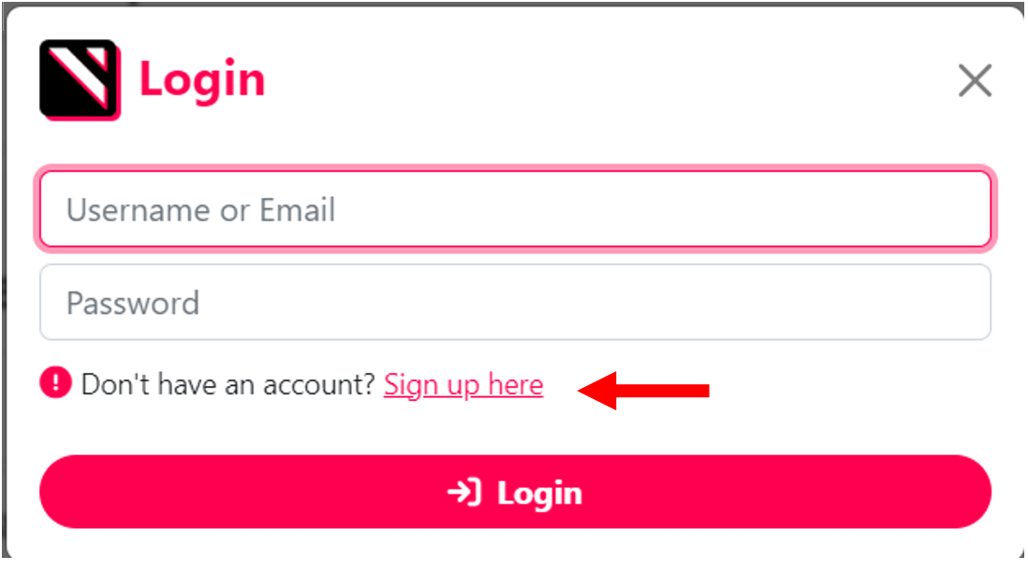

**Figure 35: Login Modal before clicking on Sign Up link**

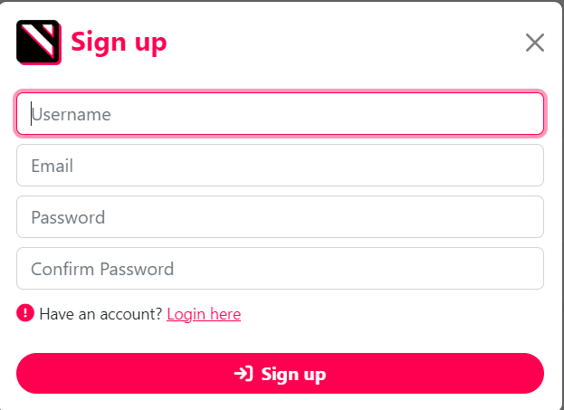

**Figure 36: After clicking on the Sign up link**

1. Click on the Log In button on the homepage. Verify that the login modal is displayed.

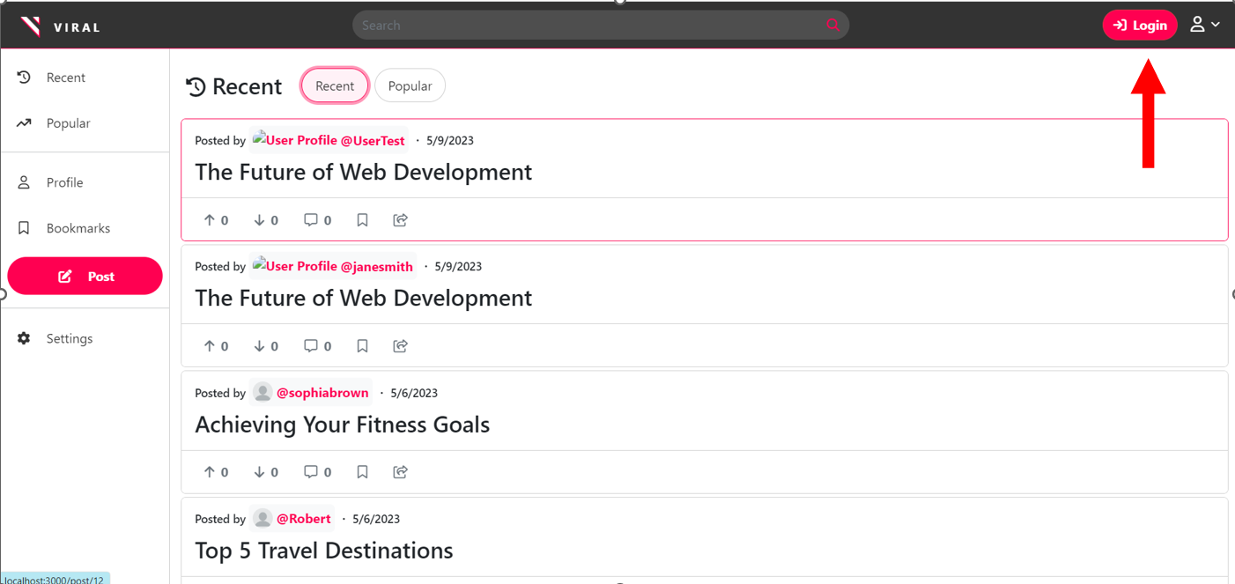

**Figure 37: Login Button**

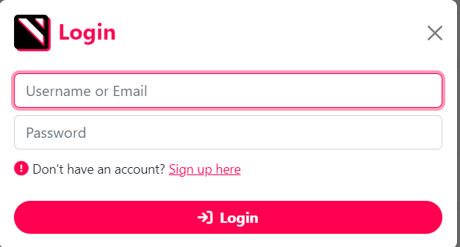

**Figure 38: After clicking on the Login button**

1. Click on any post on the homepage. Verify that the post details are loaded.

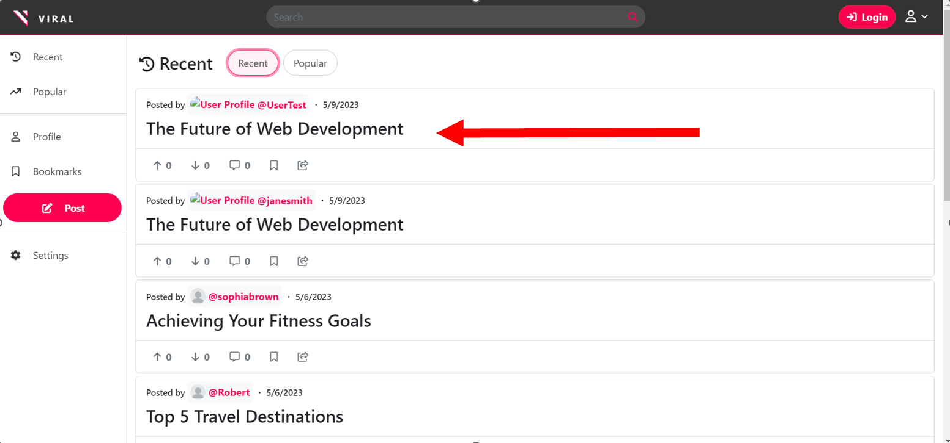

**Figure 39: Viewing List of posts**

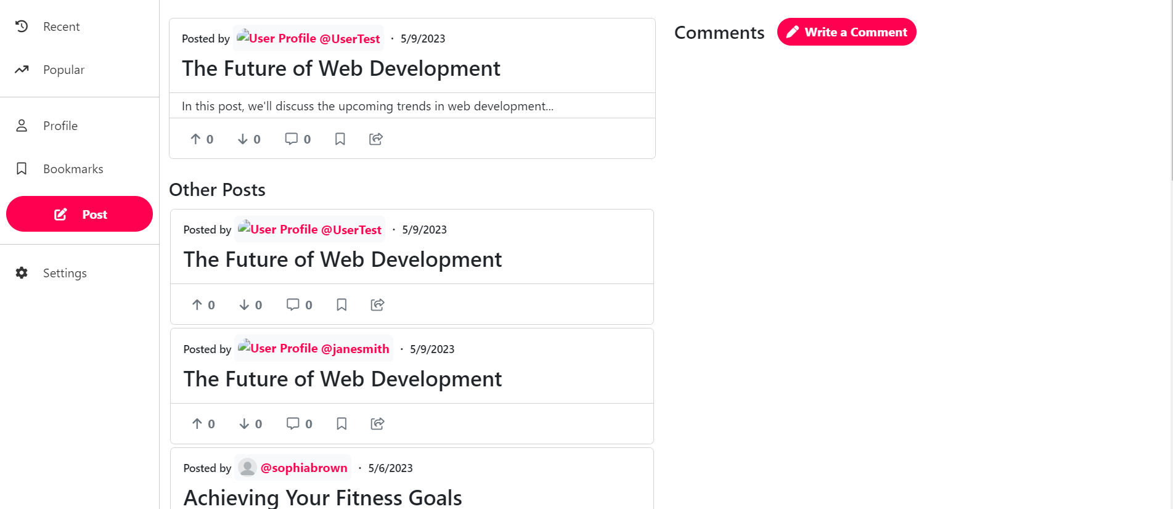

**Figure : View after clicking on the chosen post**

1. Click on the user’s name on a post. Verify that the user’s profile page is loaded.

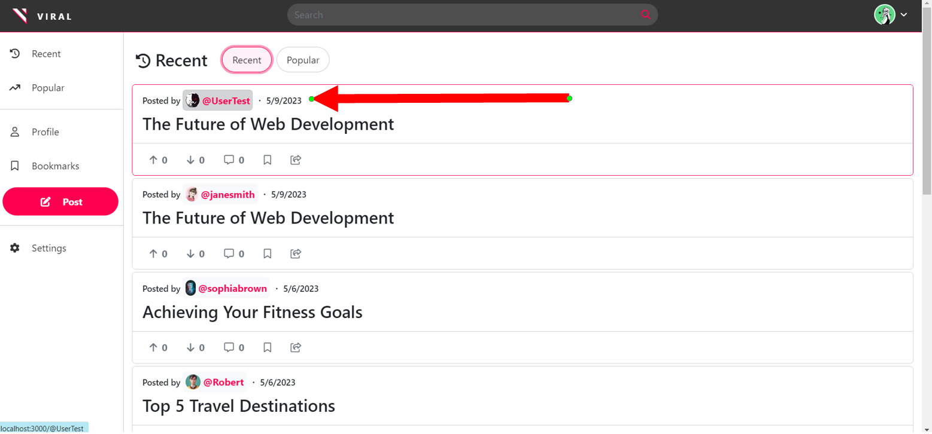

**Figure 40: User highlighted above**

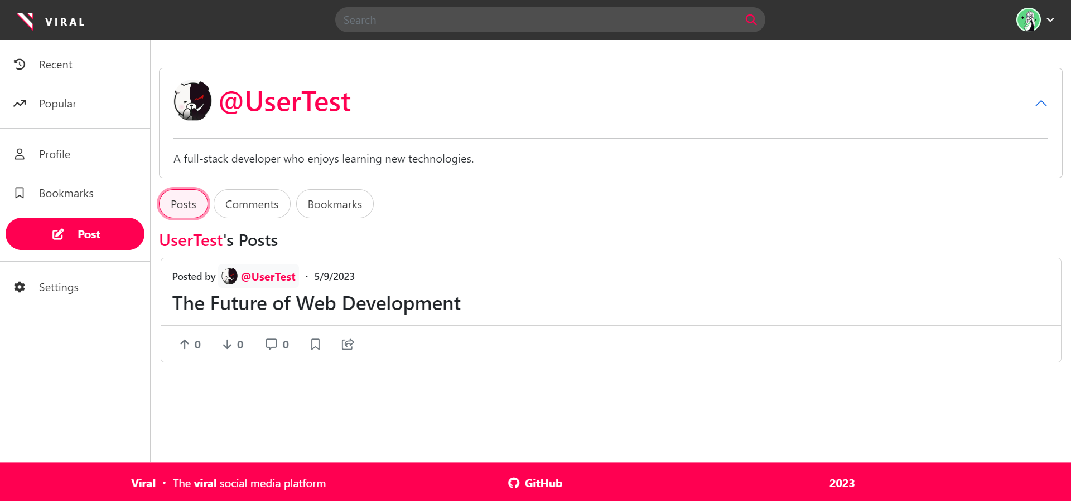

**Figure 41: View after clicking on the user profile**

1. Use the search bar to search for a specific post. Verify the search results page is loaded.

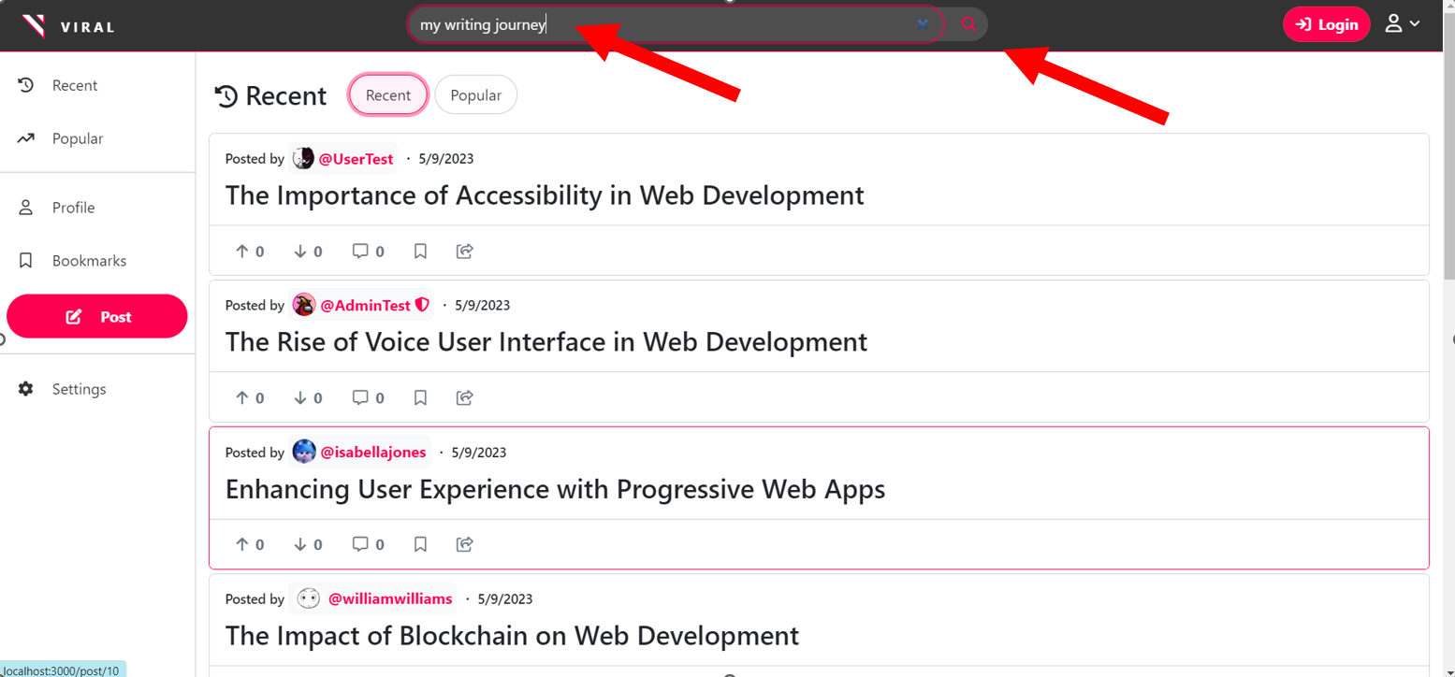

**Figure 42: Searching for “my writing journey”**

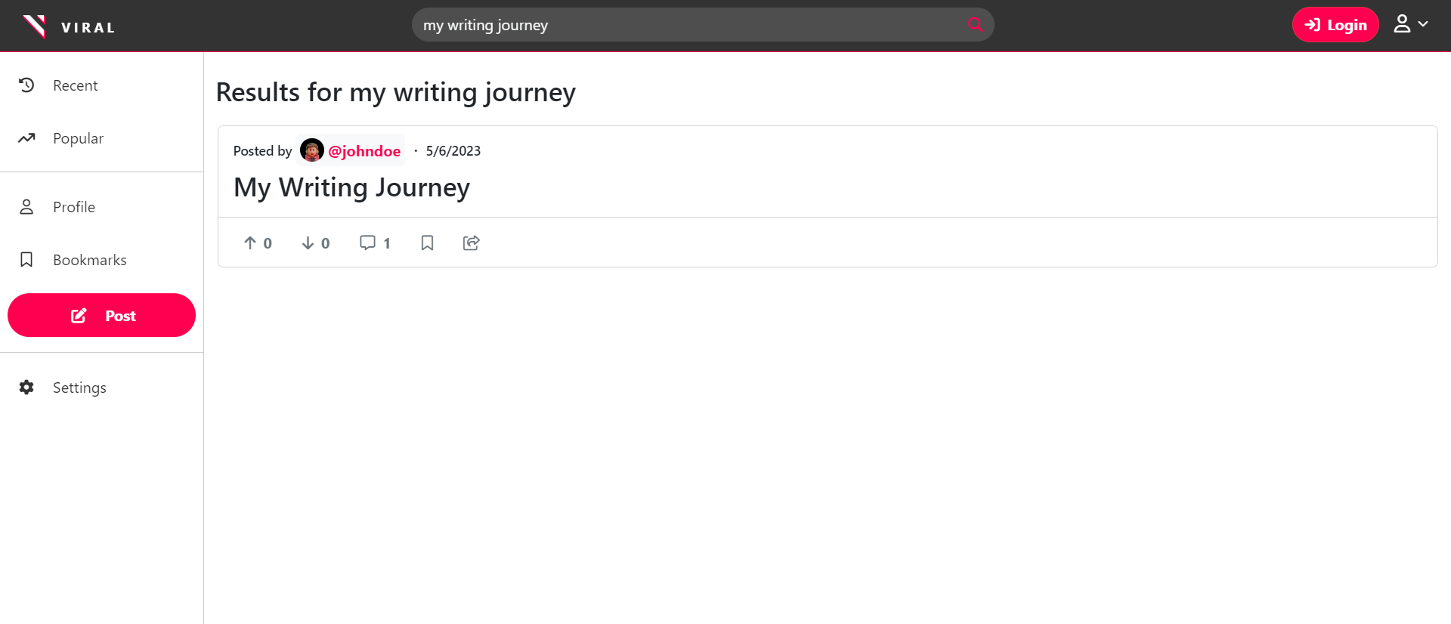

**Figure 43: Search Results**

#### 

#### Users

##### Navigation:

1. Log in to the platform and verify that the user is redirected to the homepage.

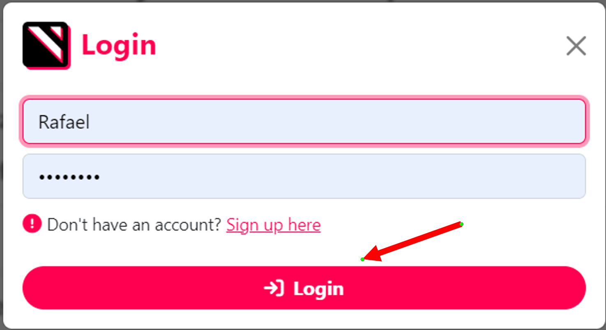

**Figure 44: Before Login**

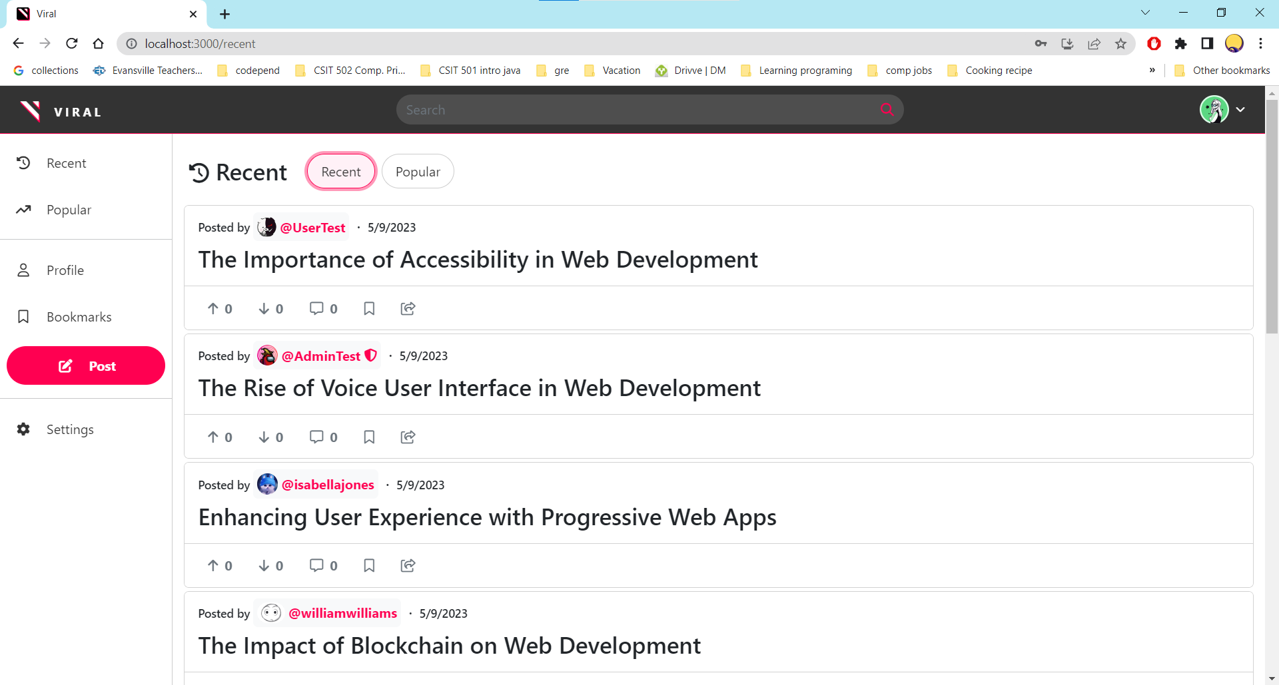

**Figure 45: After Login**

1. Click on the user’s profile button. Verify that the user’s profile page is loaded.

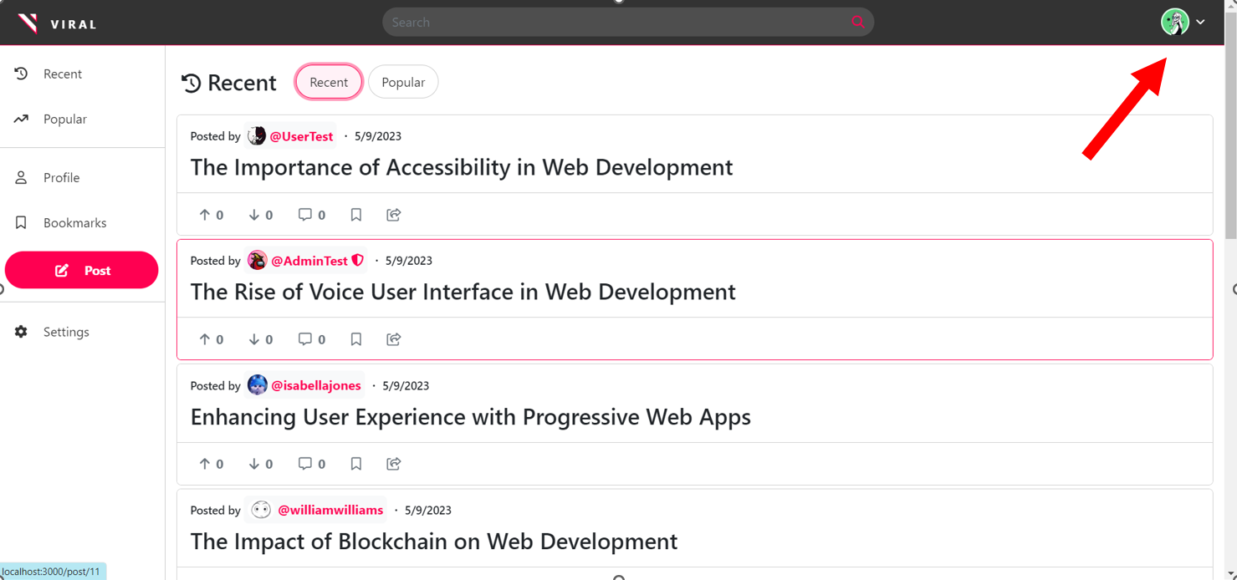

**Figure 46: Before clicking on the profile icon**

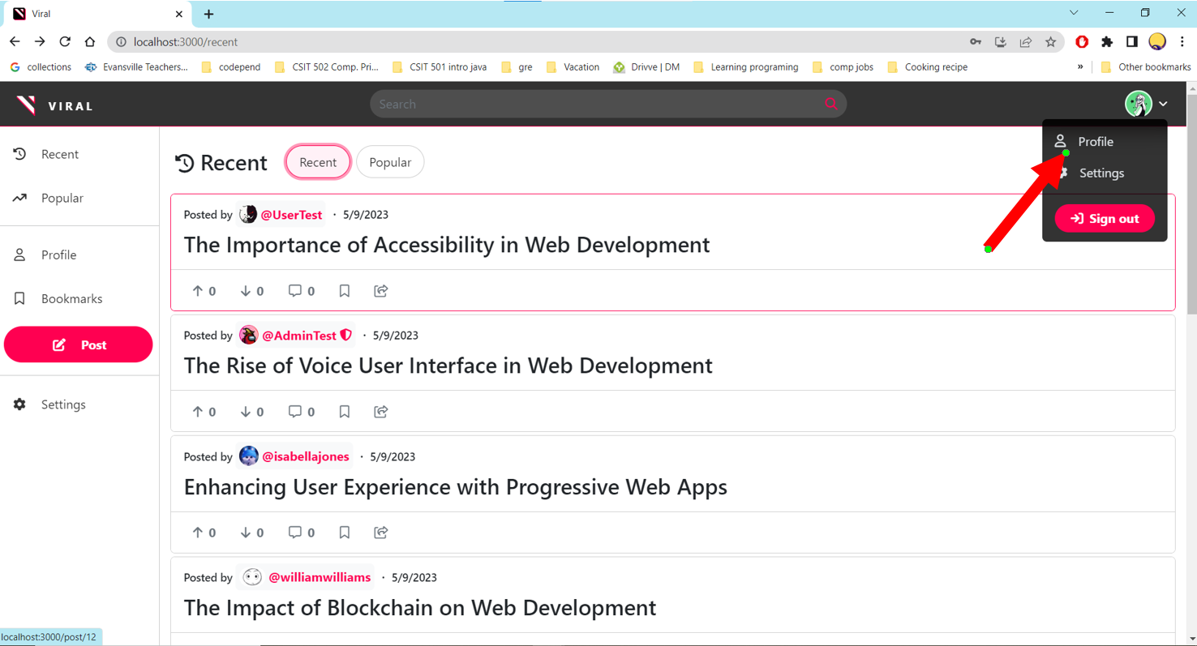

**Figure 47: Before clicking on the profile button**

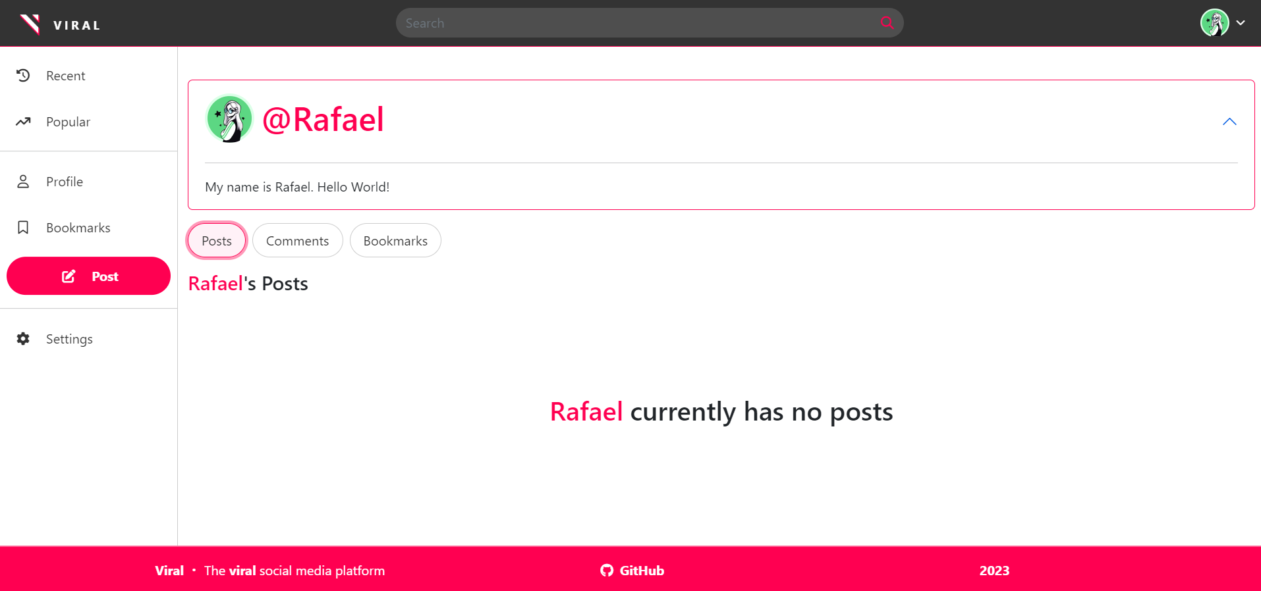

**Figure 48: After clicking on the profile**

1. Click on the Post button. Verify that the post creation modal is displayed.

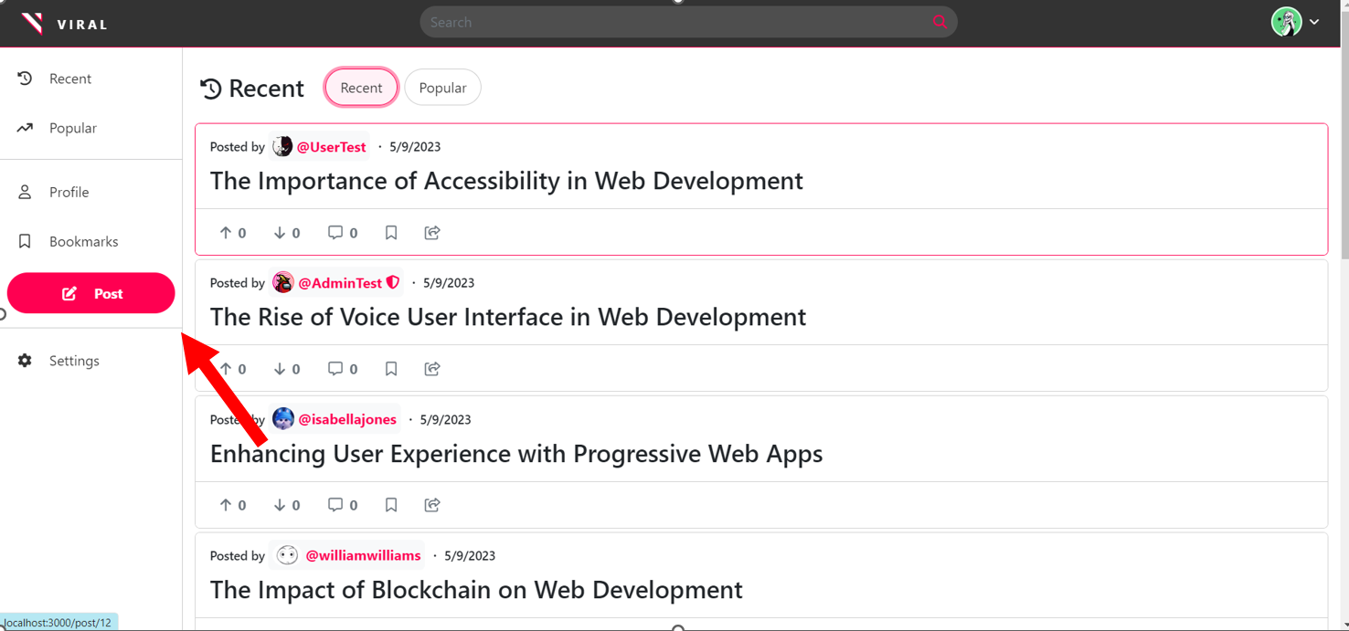

**Figure 49: Before clicking on the post button**

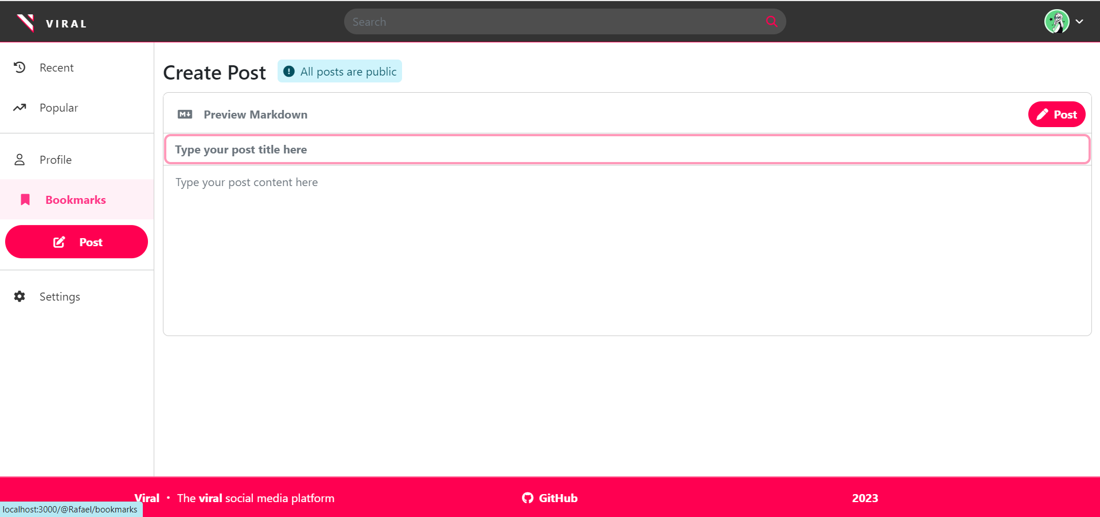

**Figure 50: After clicking on the post button.**

1. Click on the bookmarks tab on the user’s profile page. Verify that the user’s bookmarked posts are displayed.

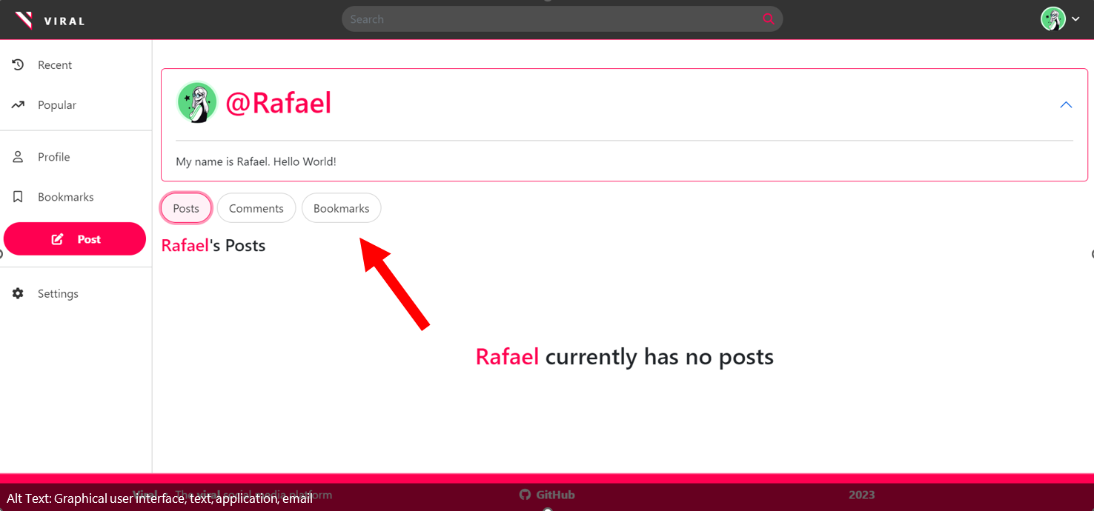

**Figure 51: Before clicking on Bookmarks button**

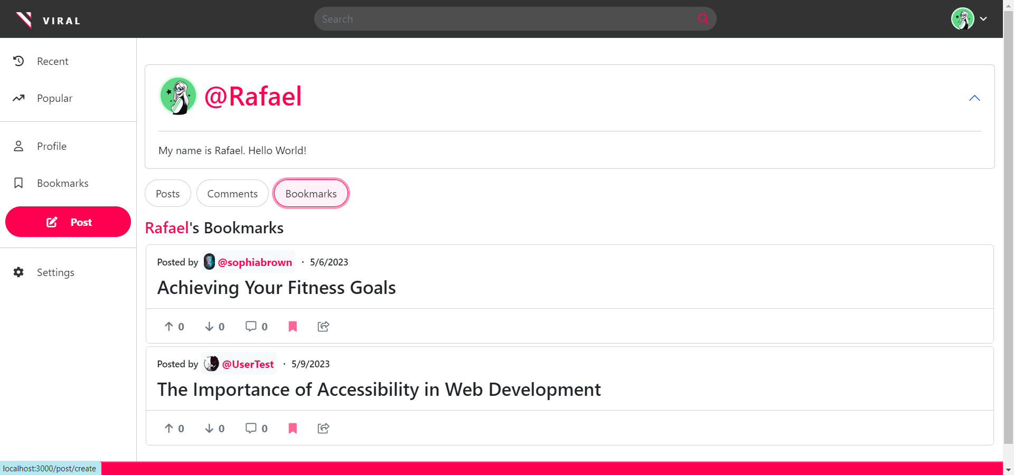

**Figure 52: After clicking on Bookmark button**

##### 

##### Input Data:

1. Enter valid details in the sign-up form and click on the register button. Verify that the user is registered and redirected to the homepage.

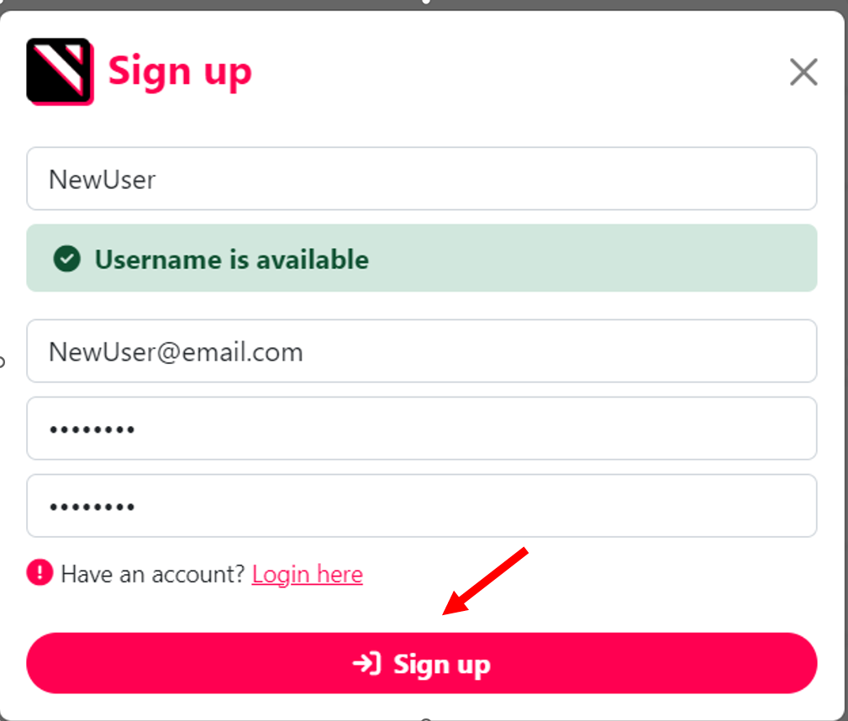

**Figure 53: Before NewUser signup**

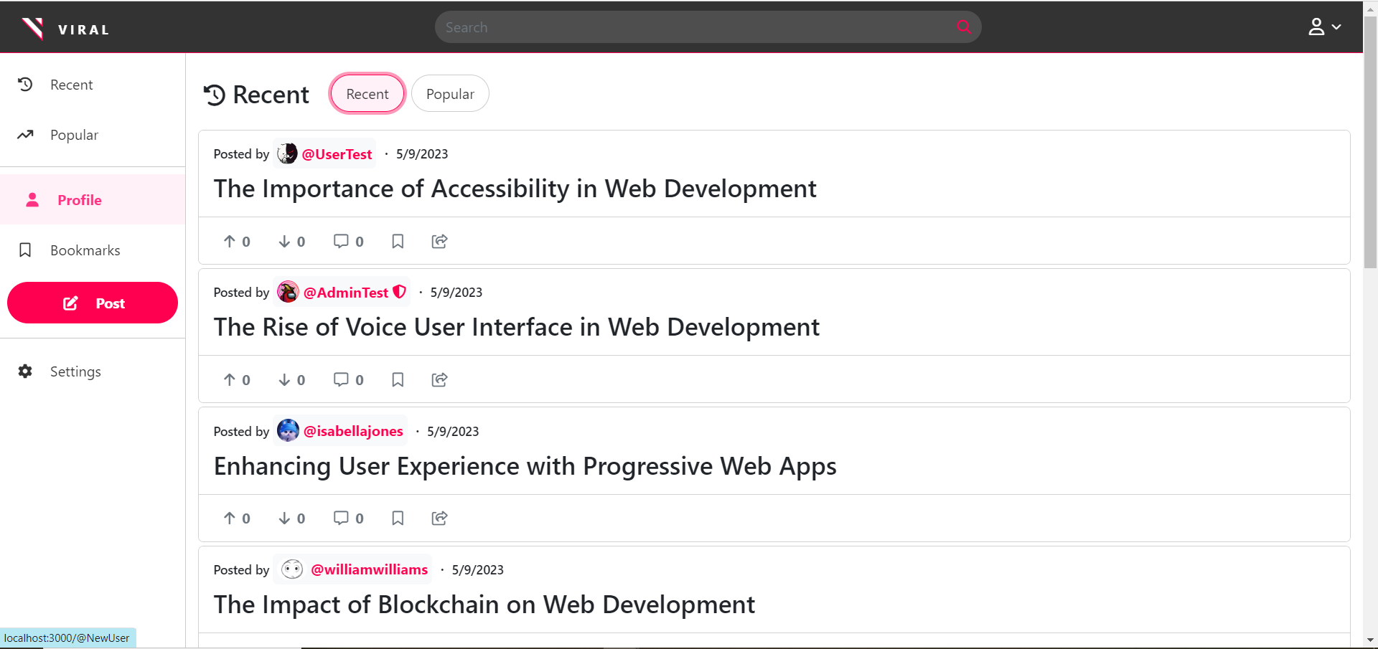

**Figure 54: After User Signup**

1. Enter valid credentials on the login form and click on the login button. Verify that the user is logged in and redirected to the homepage.

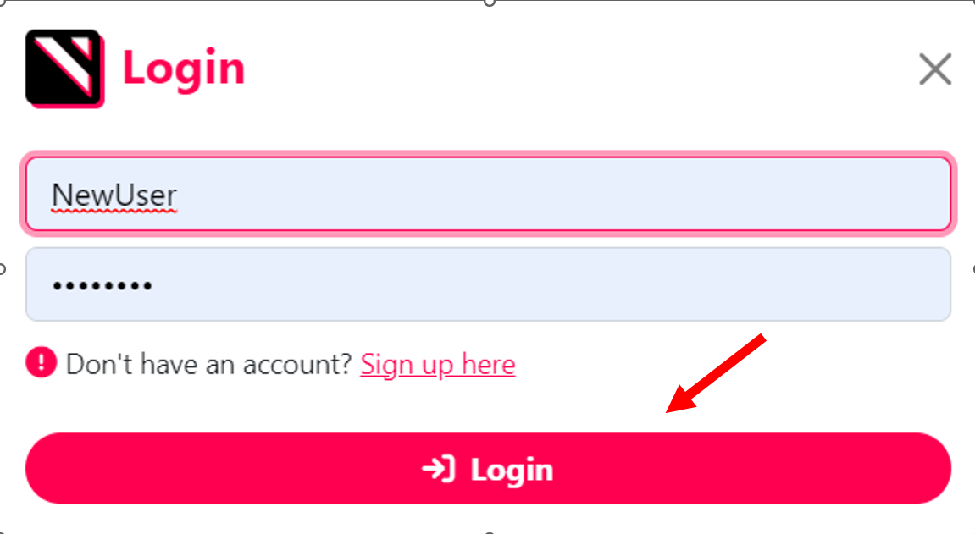

**Figure 55: Before Login**



**Figure 56: After Login**

1. Create a new post with valid content and click on the Post button. Verify that the post is created and displayed on the homepage.

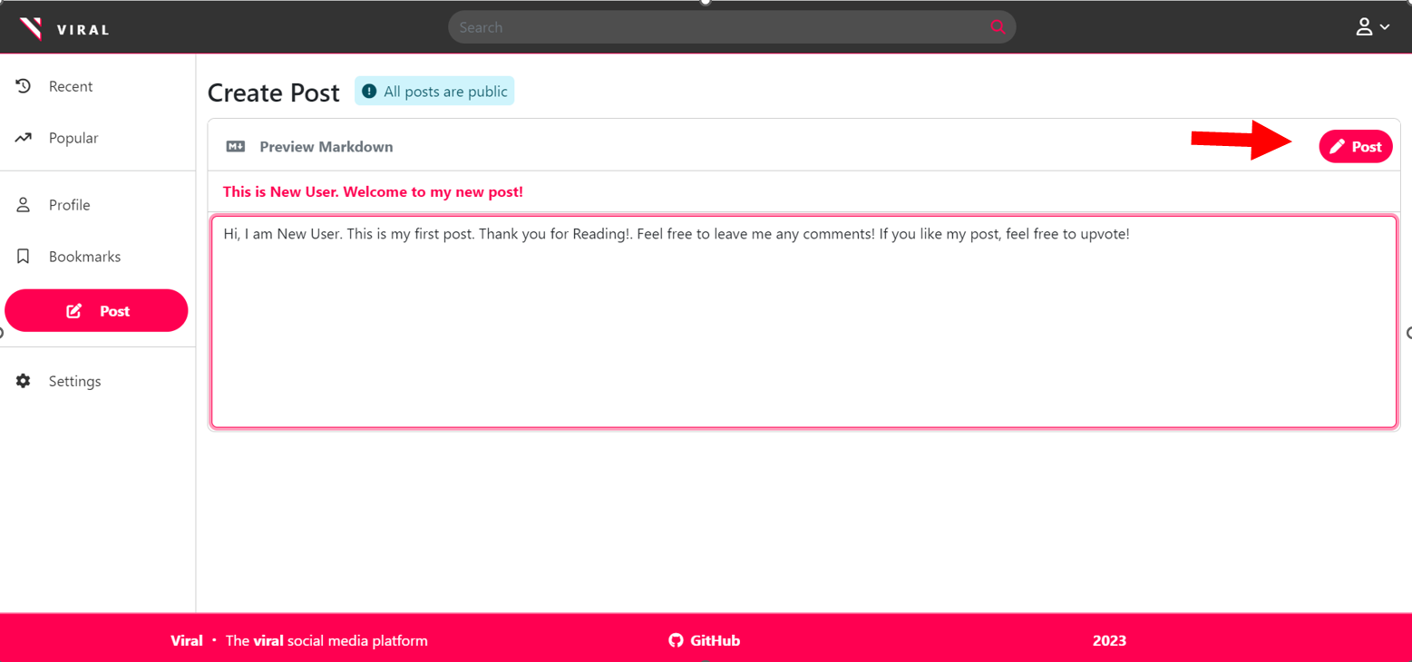

**Figure 57: Before Post Creation**

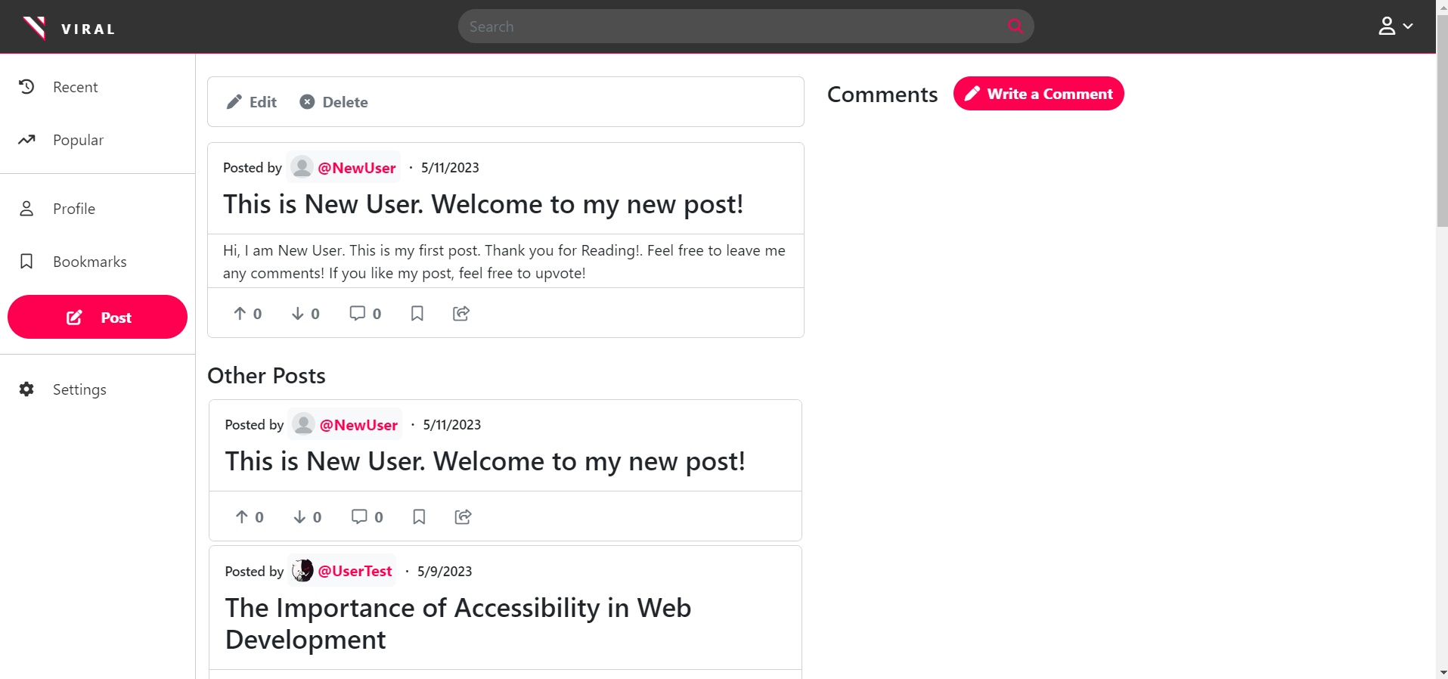

**Figure 58: After Post creation**

1. Upvote or downvote a post or comment. Verify that the vote is registered.

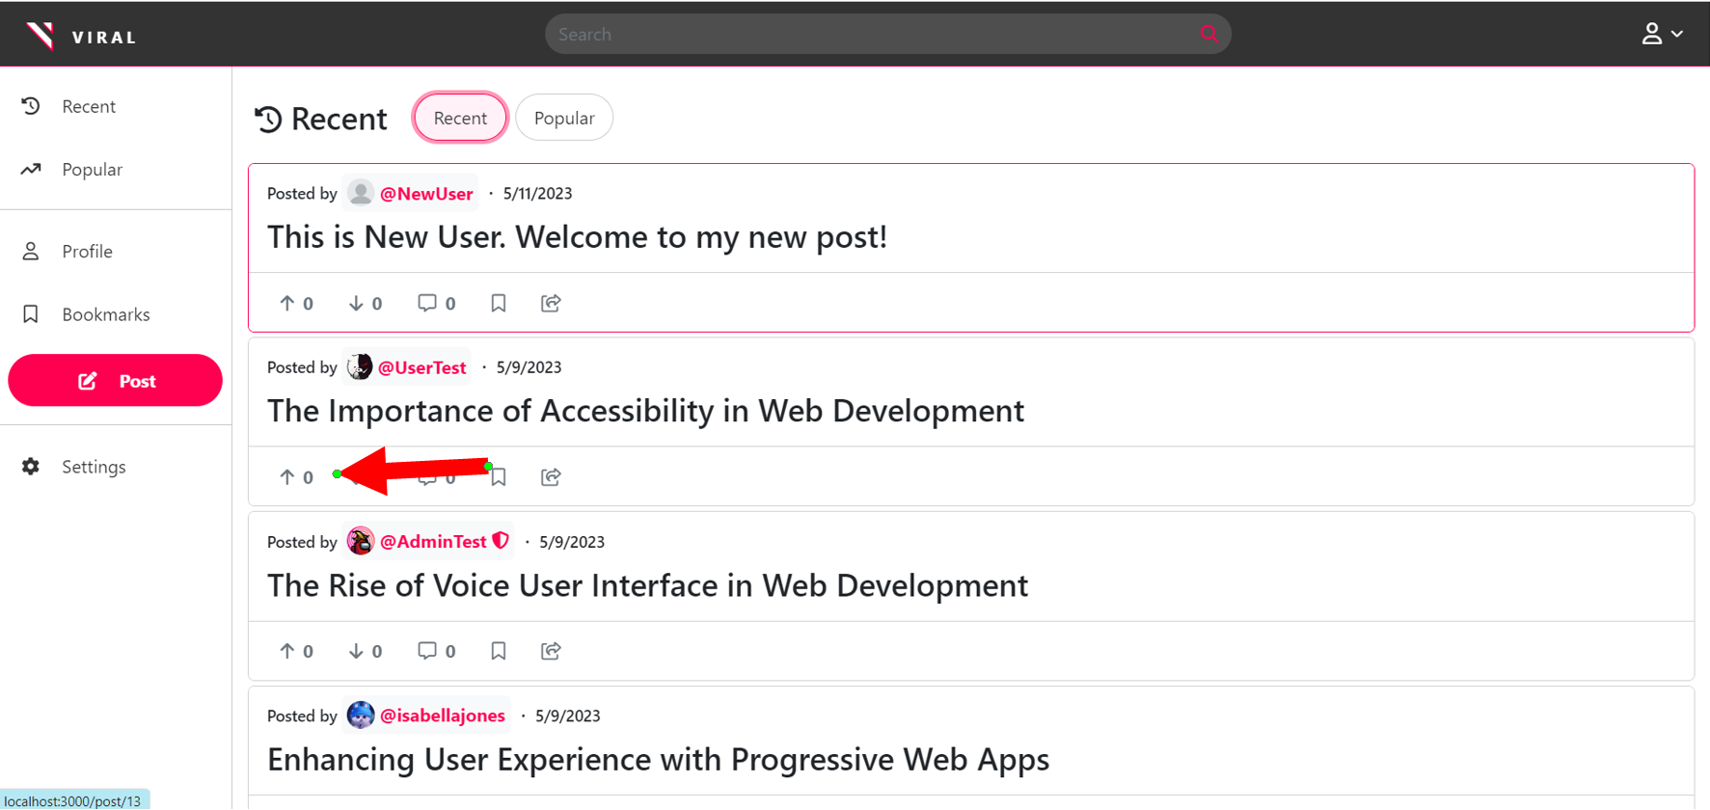

**Figure 59: Before Upvoting Post**

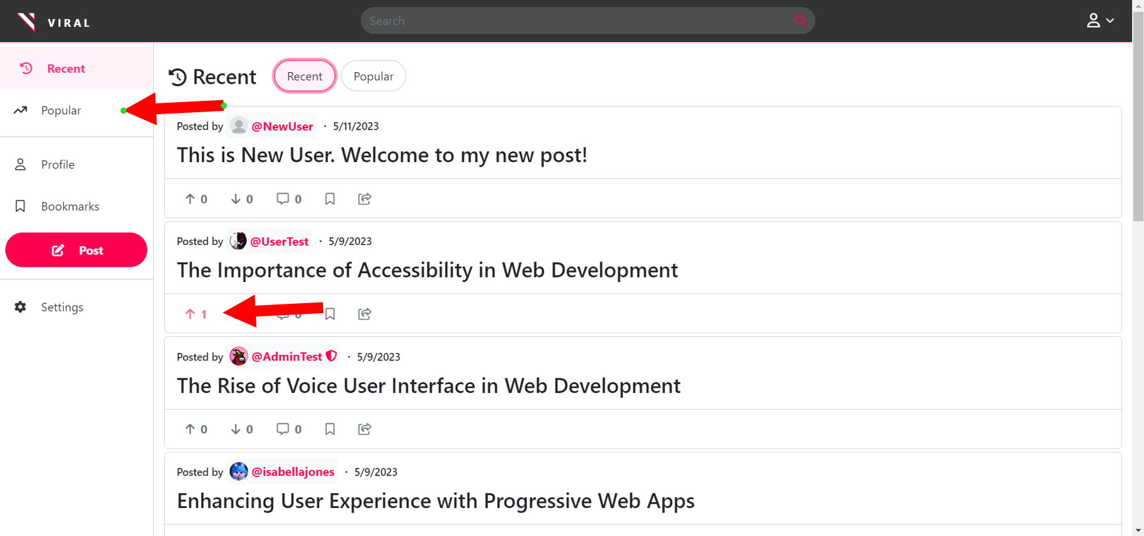

**Figure 60: After Upvoting Post and before clicking on Popular button**

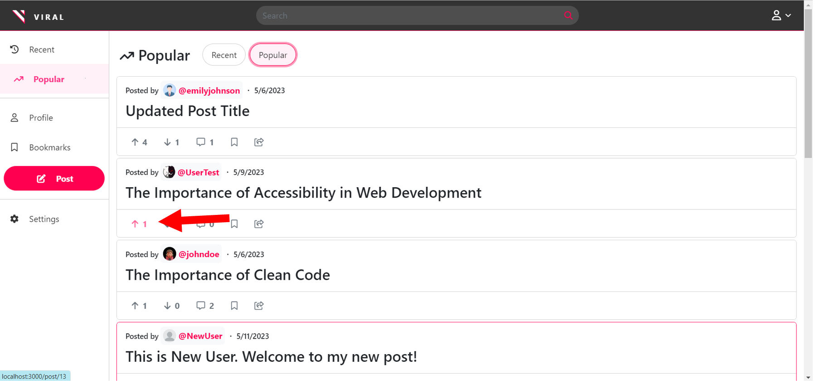

**Figure 61: After upvoting and clicking on “popular” button.**

1. Add a bookmark to a post. Verify that the post is added to the user’s bookmarks.

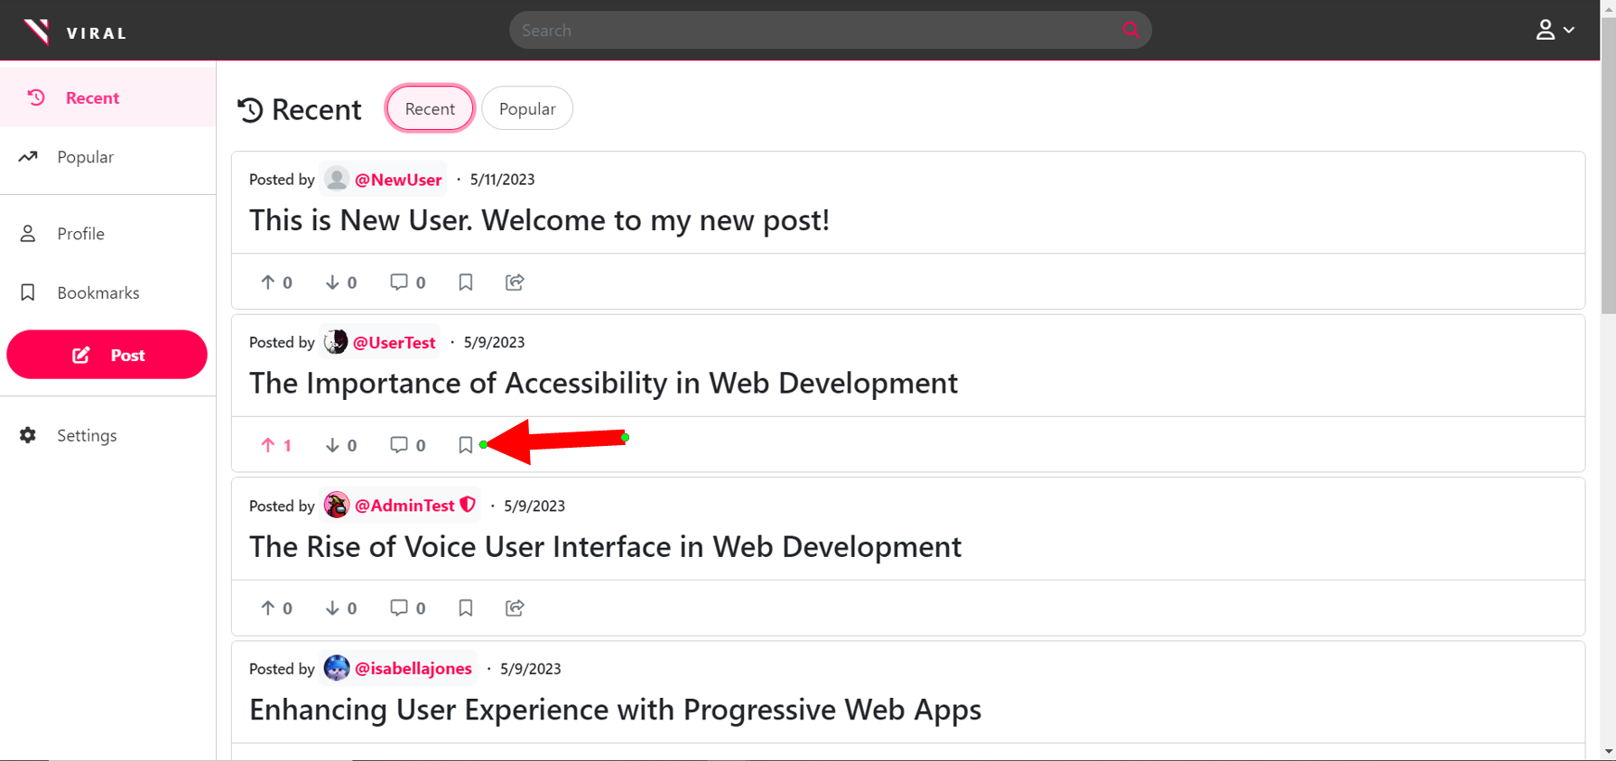

**Figure 62: Before adding a bookmark to a post**

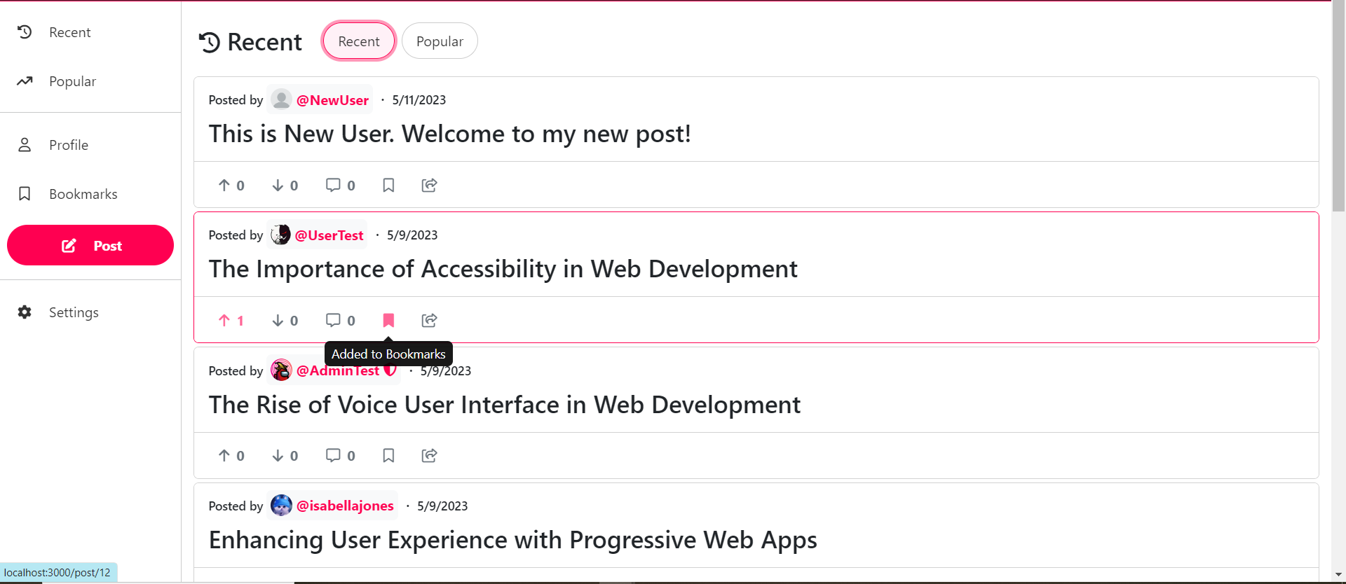

**Figure 63: After clicking the bookmark button**

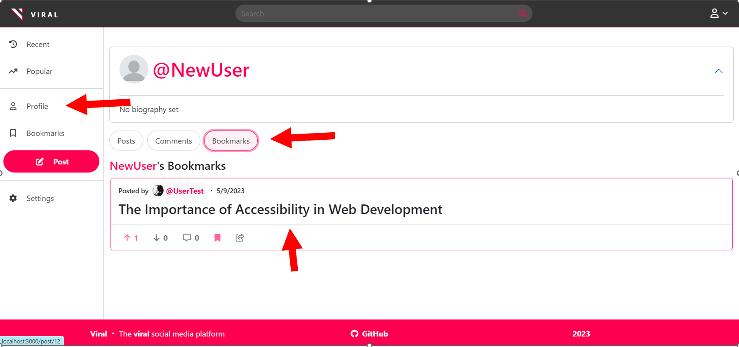

**Figure 64: Confirming Bookmark was added to the User.**

1. Update user profile details and verify that the changes are saved.

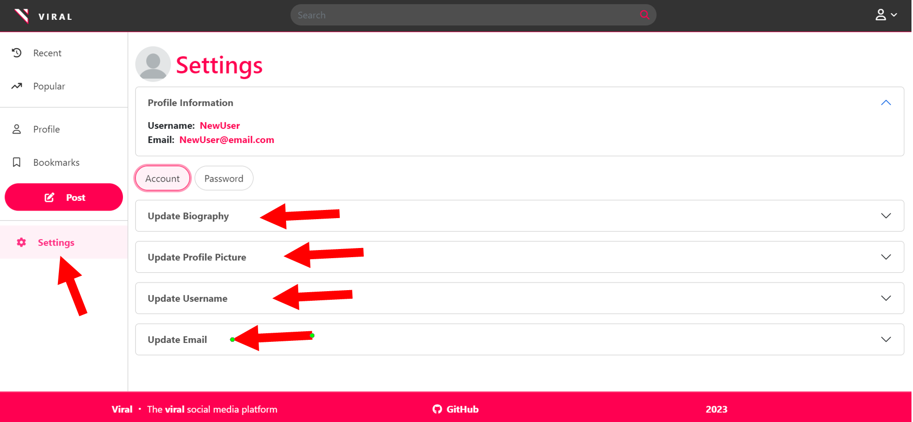

**Figure 65: Pinpointing all entries that will be modified.**

###### Update Biography

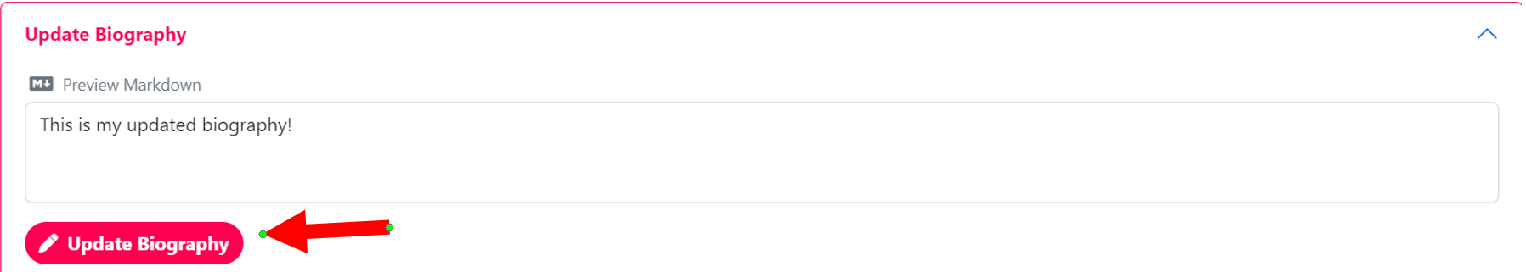

**Figure 66: Before biography update.**

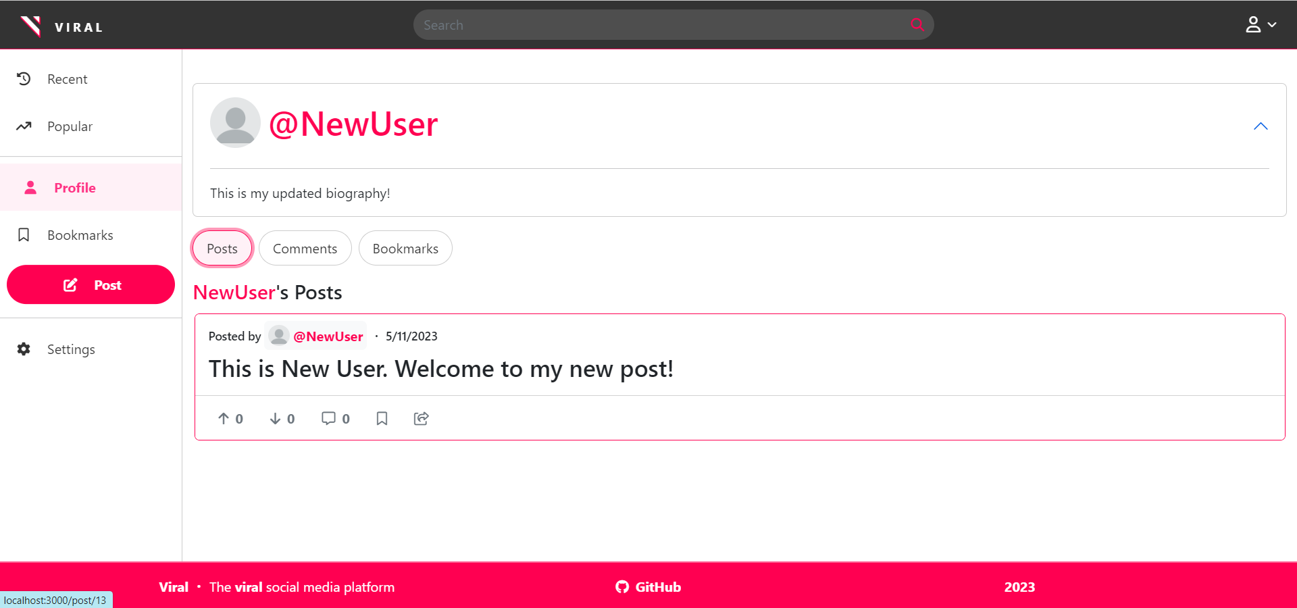

**Figure 67: After biography update**

###### Update Profile Picture

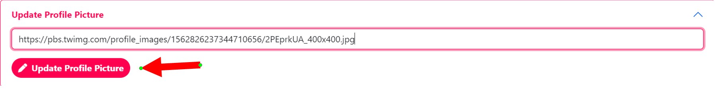

**Figure 68: Before profile picture update**

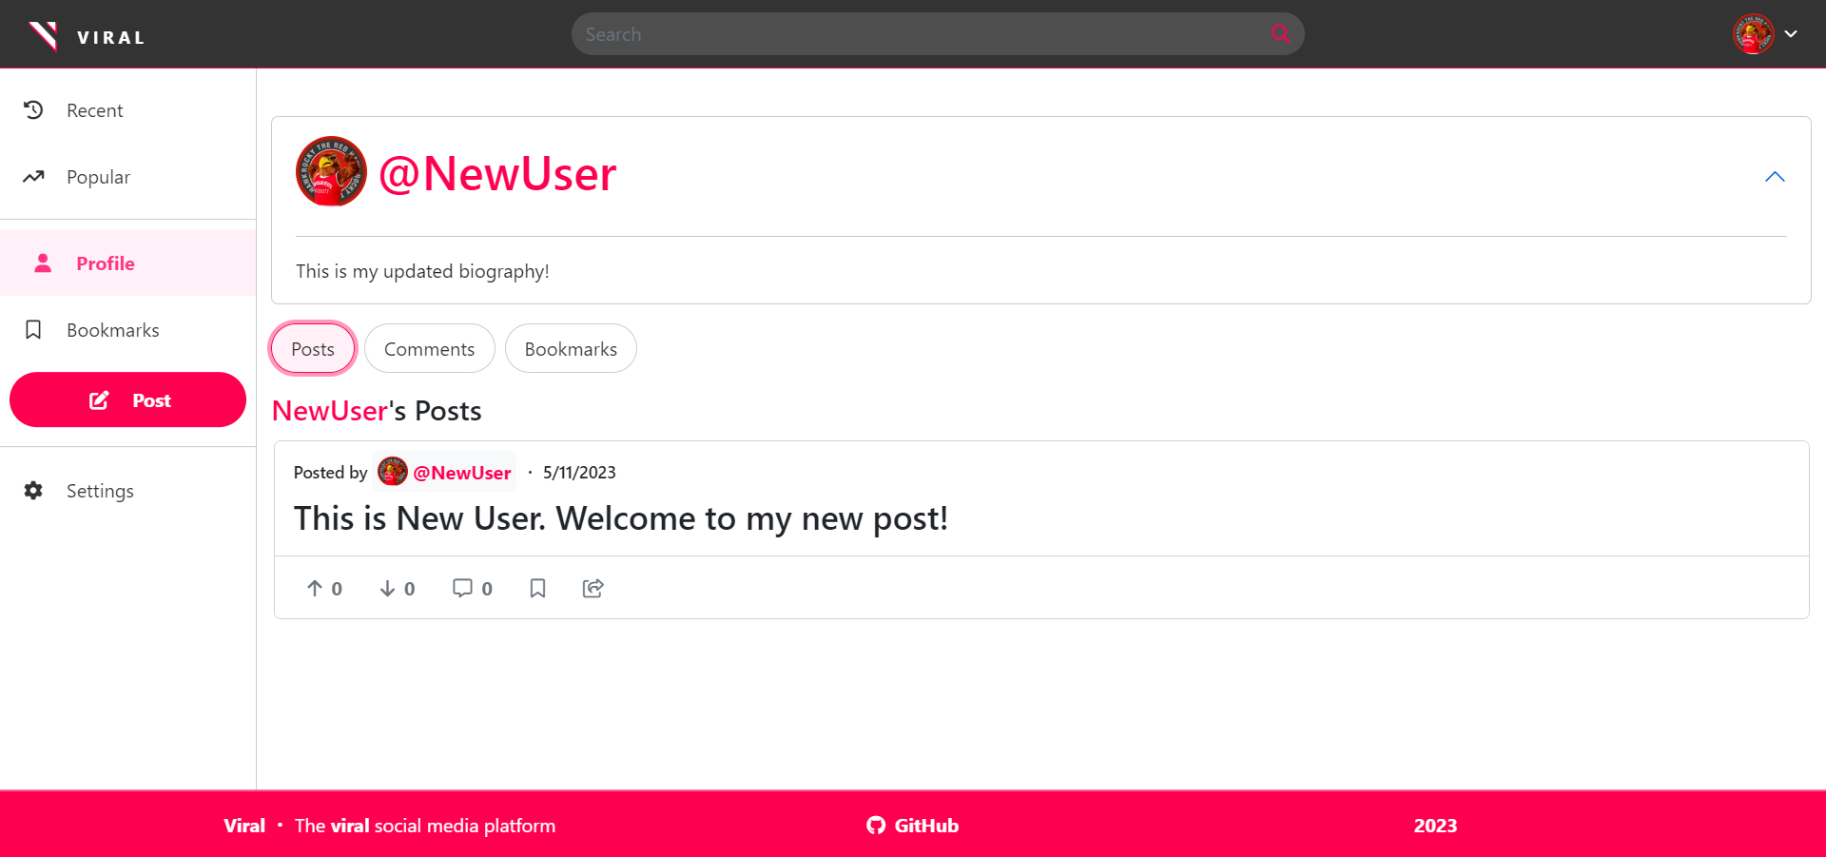

**Figure 69: After profile picture update**

Update Username

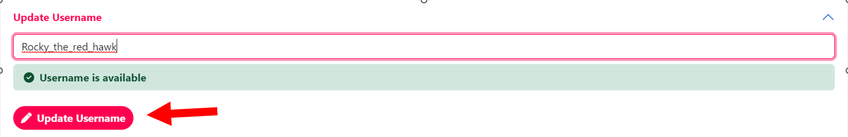

**Figure 70: Before Username Update**

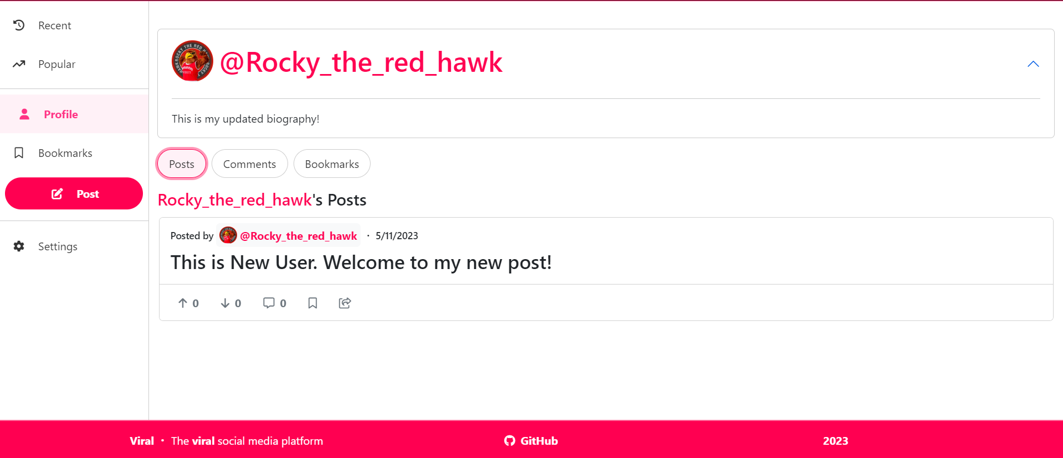

**Figure 71: After Username Update**

Update Email

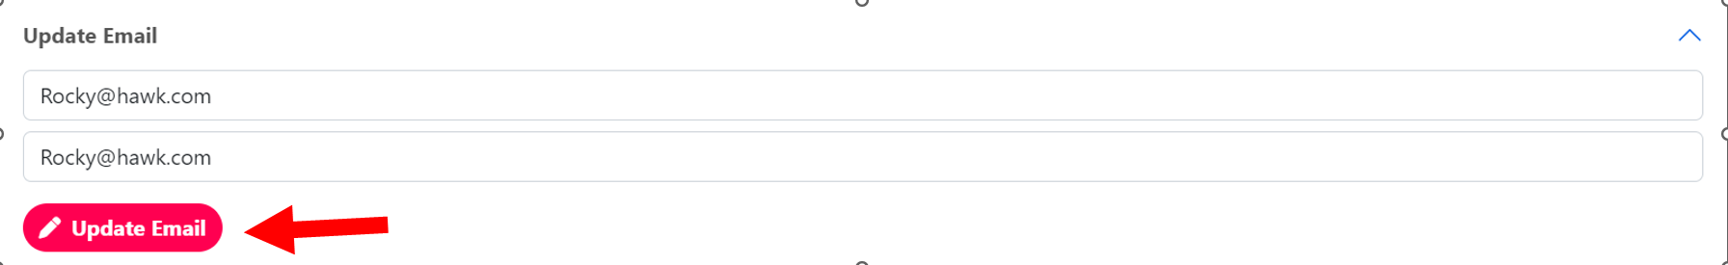

**Figure 72: Before email update**

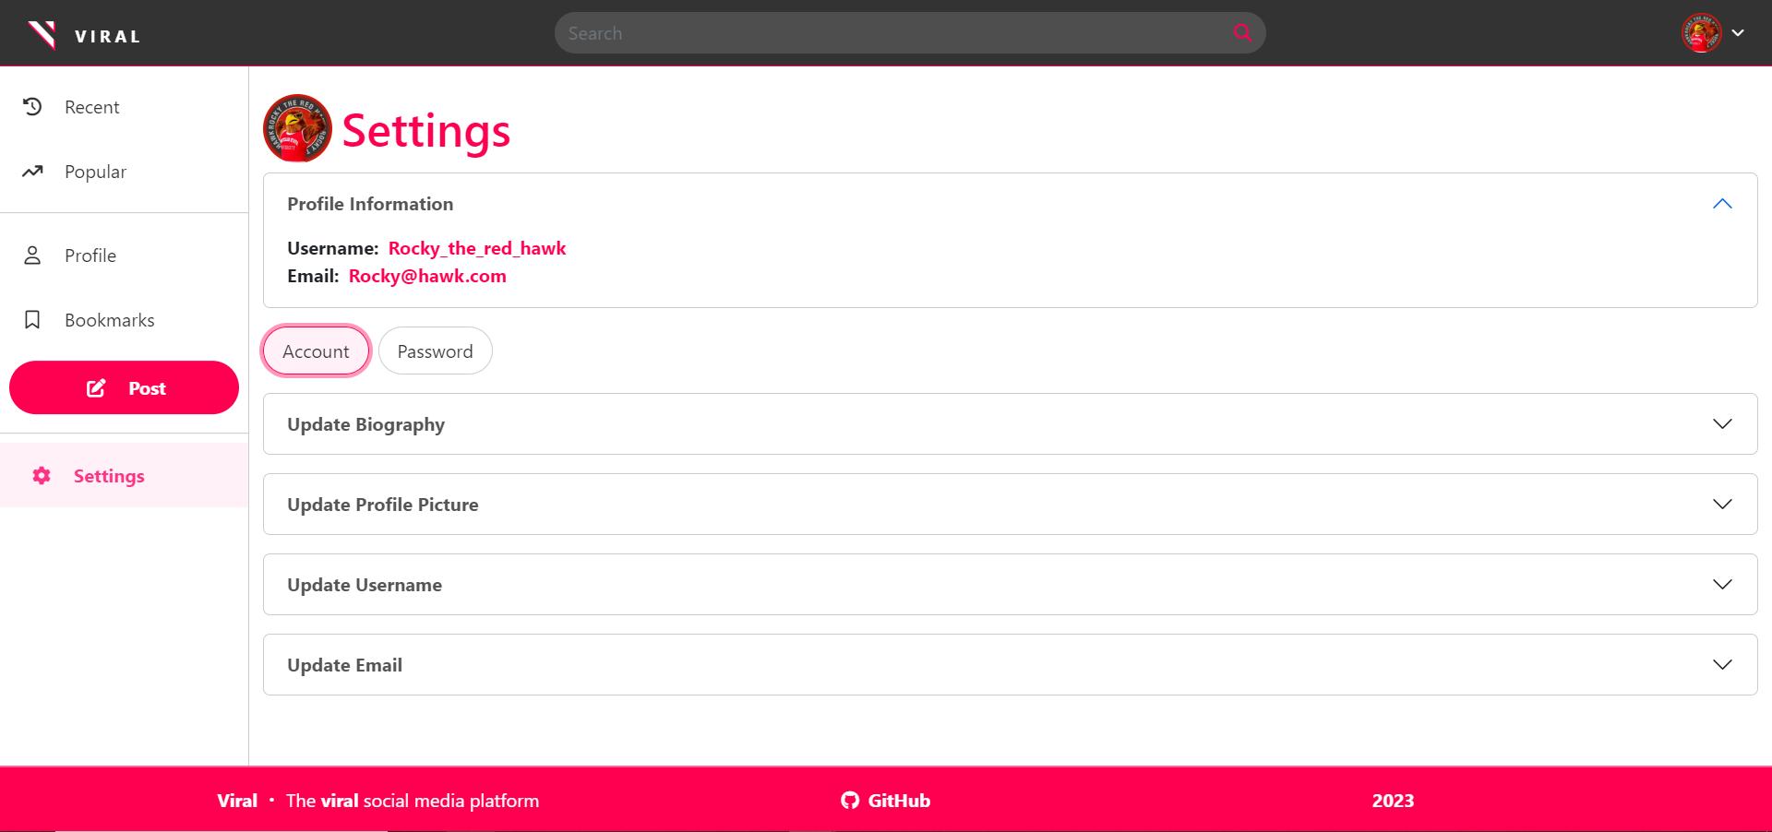

**Figure 73: After Email update**

1. Add a comment to a post

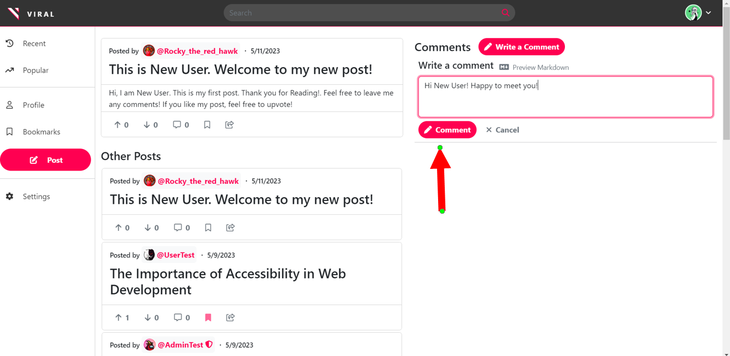

**Figure 74: Before adding a comment to post**

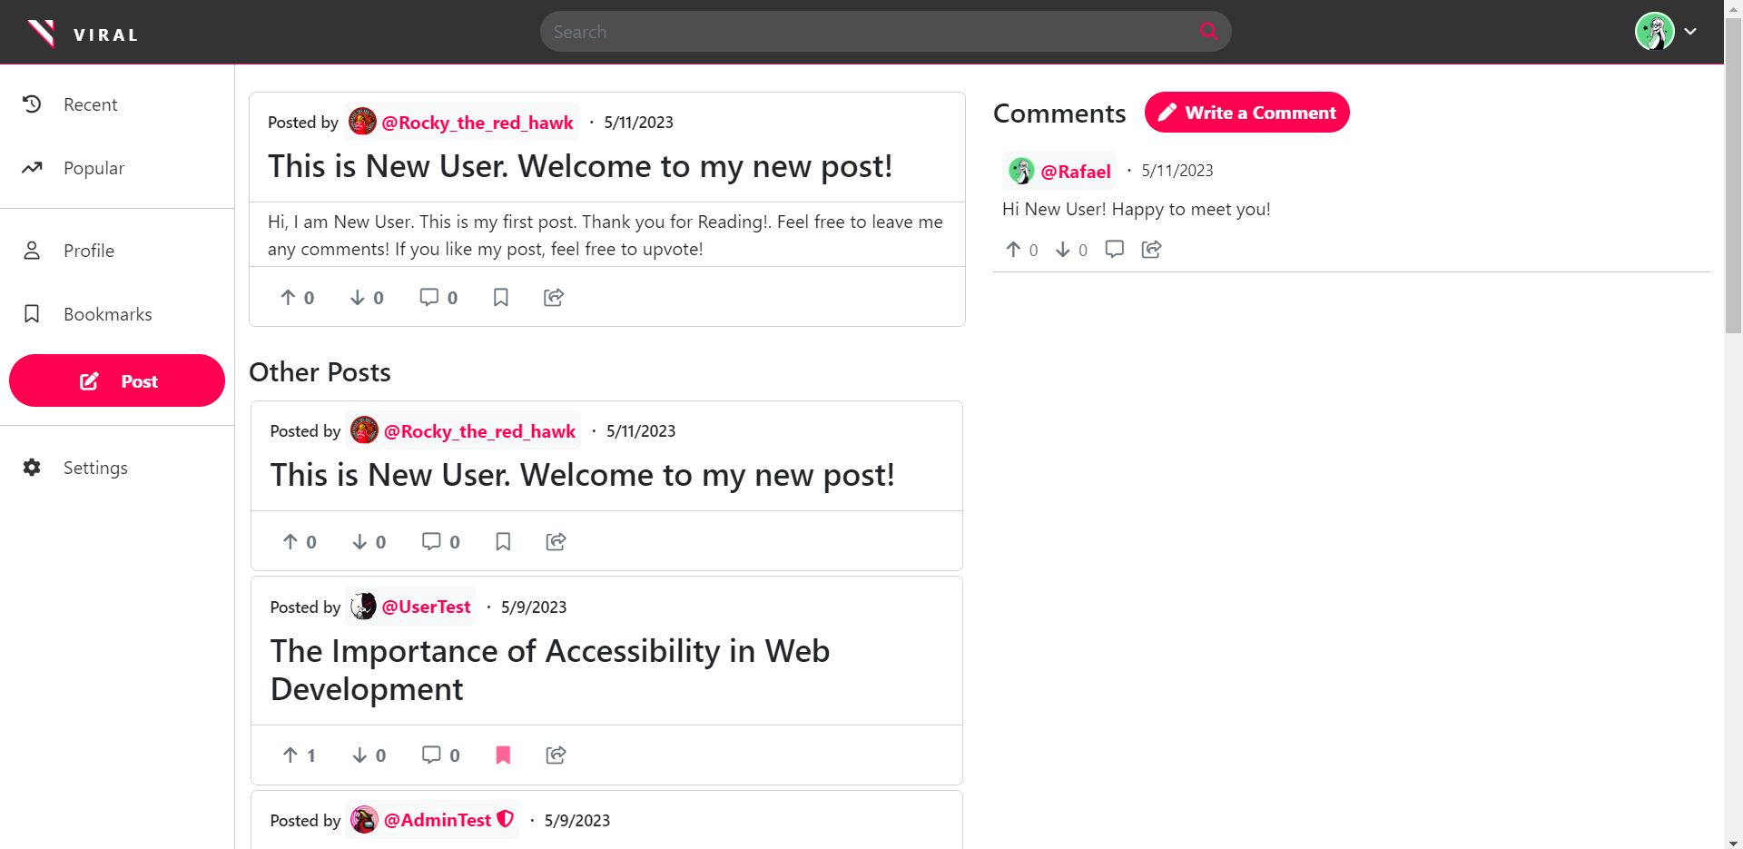

**Figure 75: After adding a comment to post**

##### Responsiveness:

1. Resize the browser window to various screen sizes and verify that the layouts adjust accordingly.

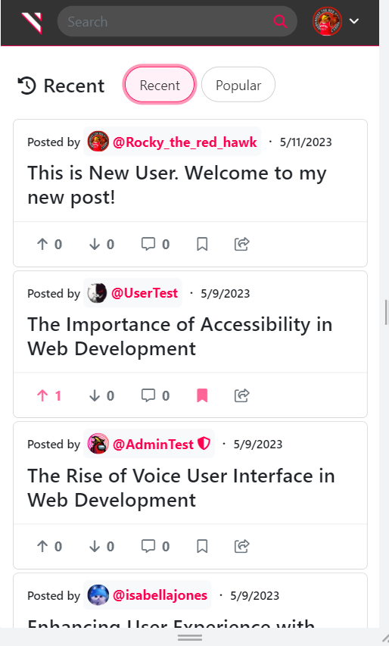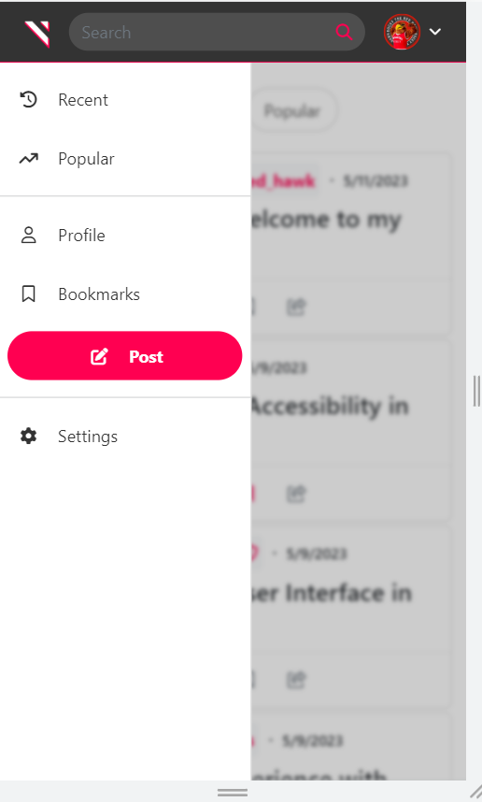

**Figure 76,77 : Resized examples 1**

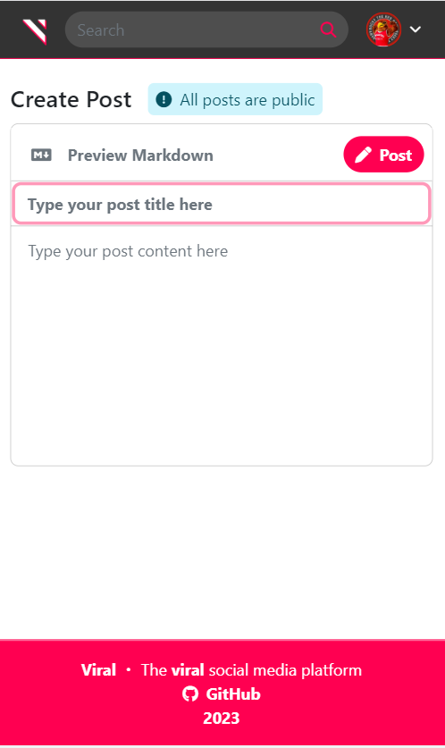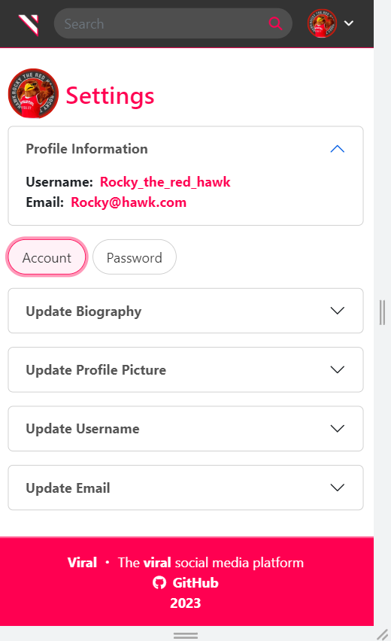

**Figure 78,79: Resized examples 2**

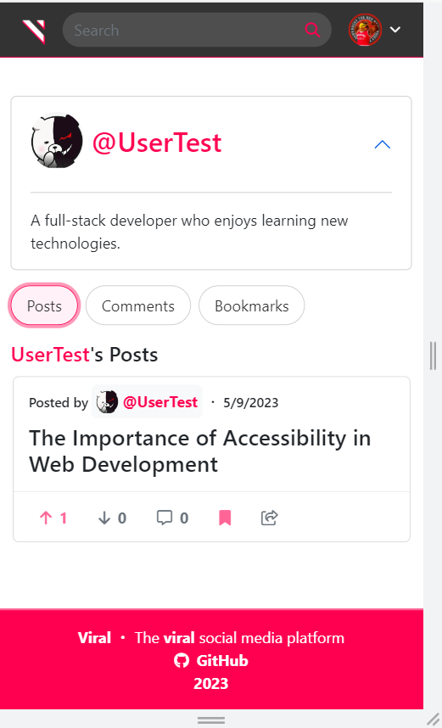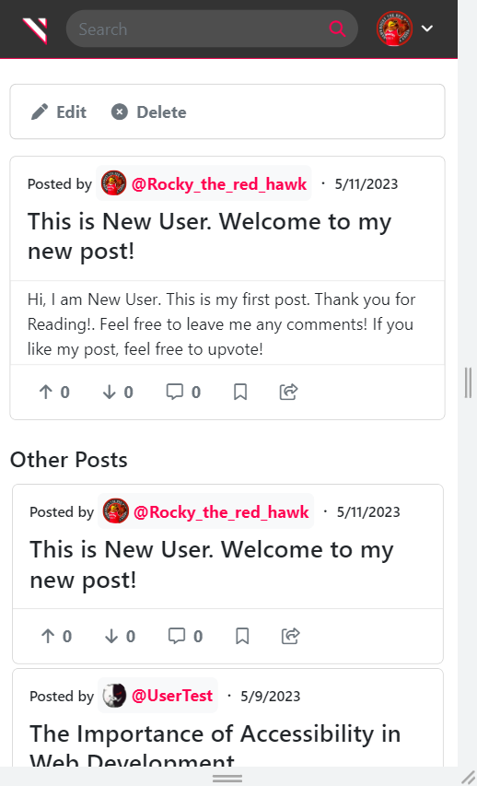

**Figure 80,81: Resized examples 4**

##### 

##### Error Handling:

1. Enter invalid credentials in the login form and click on the login button. Verify that the system displays an error message.

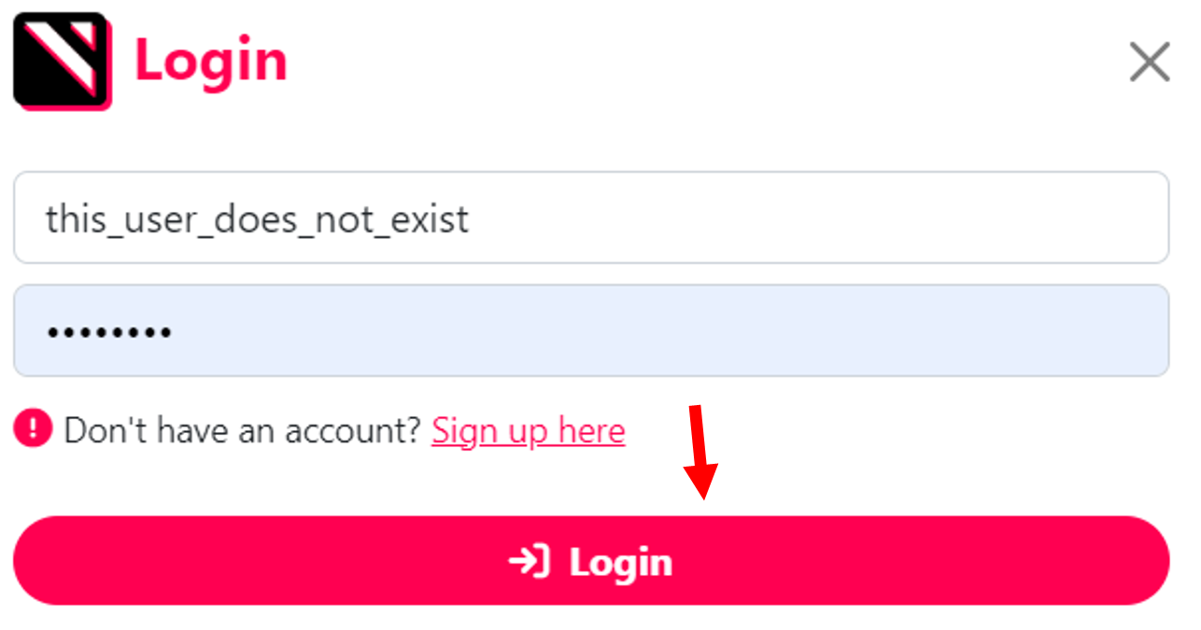

**Figure 82: Before logging in with a non existent User.**

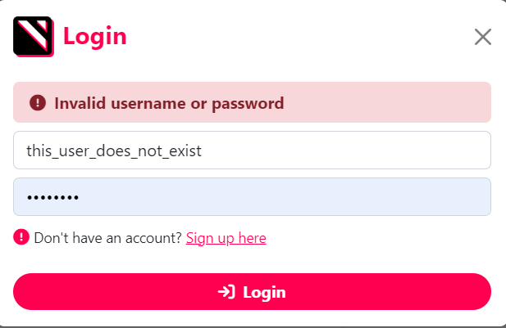

**Figure 83: After login attempt with non-existent User**

1. Submit the sign-up form with invalid details and verify that the system displays appropriate error messages.

###### Passwords do not match

###### 

**Figure 84: After signing up with unmatching passwords.**

###### Email is not in email format

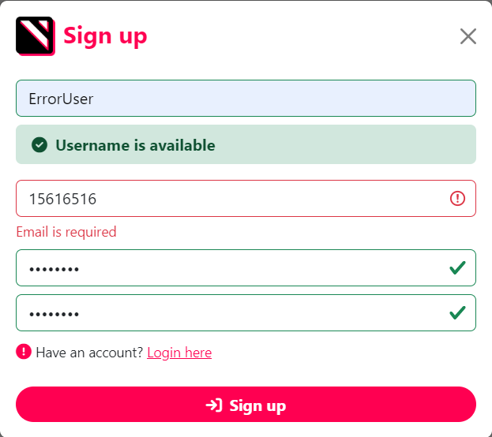

**Figure 85: Signing up with invalid email format.**

#### 

#### 

#### 

#### Admin

##### Navigation:

1. Log in to the admin account and verify that the dashboard displays

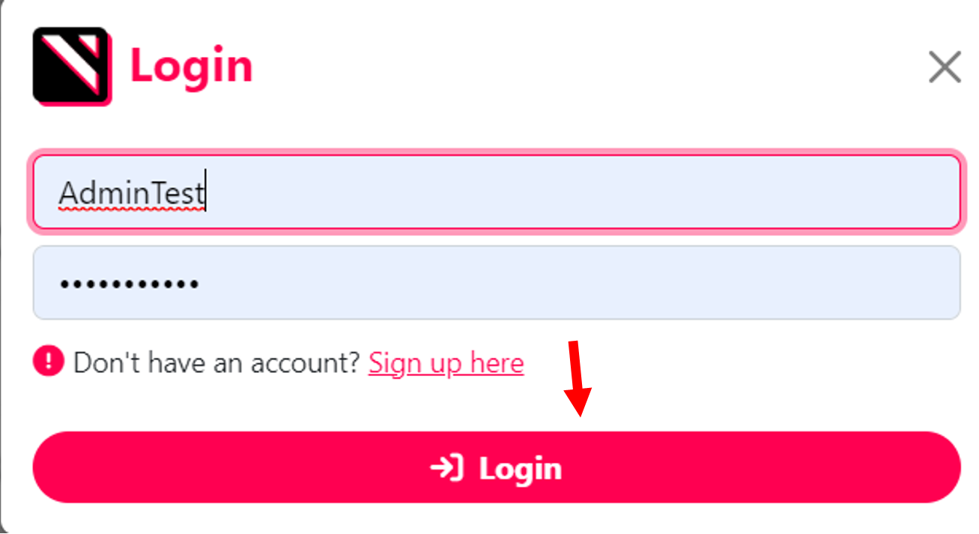

**Figure 86: Before logging in as admin**

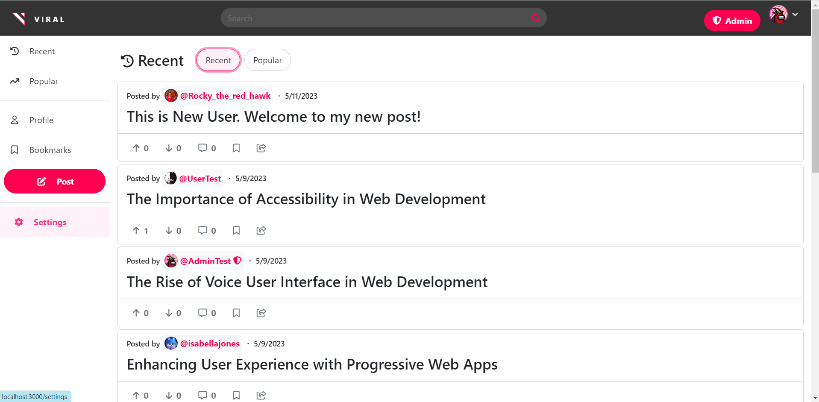

**Figure 87: After logging in as admin**

1. Observe that All Users option appears for admin. Click on it and ensure you receive a list of users.

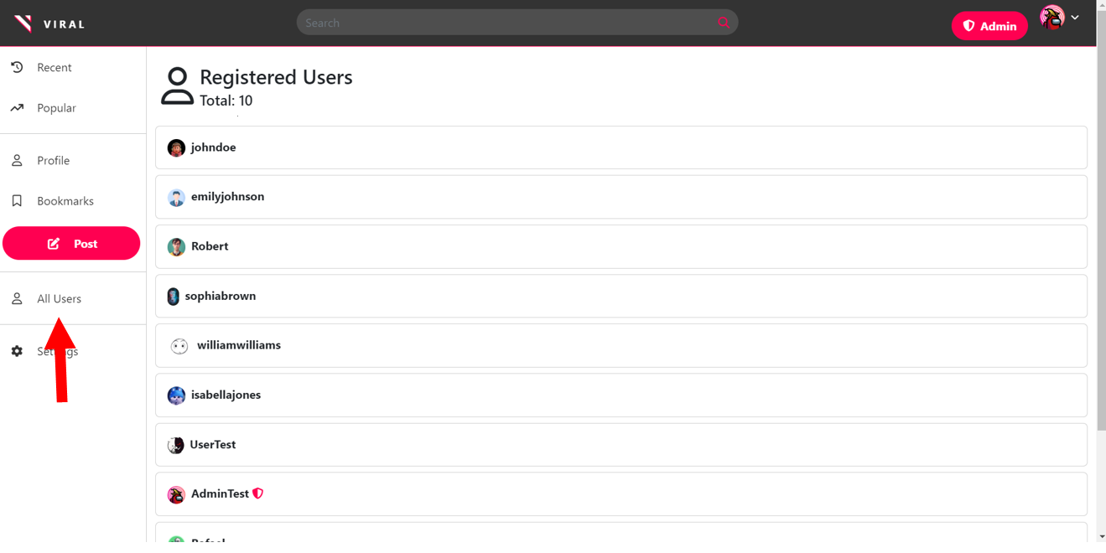

**Figure 88: Observe all users (Admin Exclusive Feature)**

1. Click on a User. Verify that the user is shown with an edit or delete button.

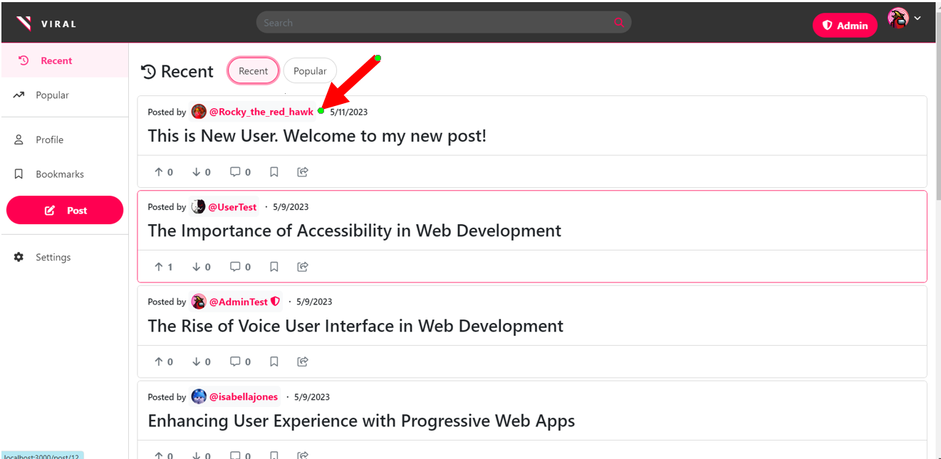

**Figure 89: Before Admin click on User**

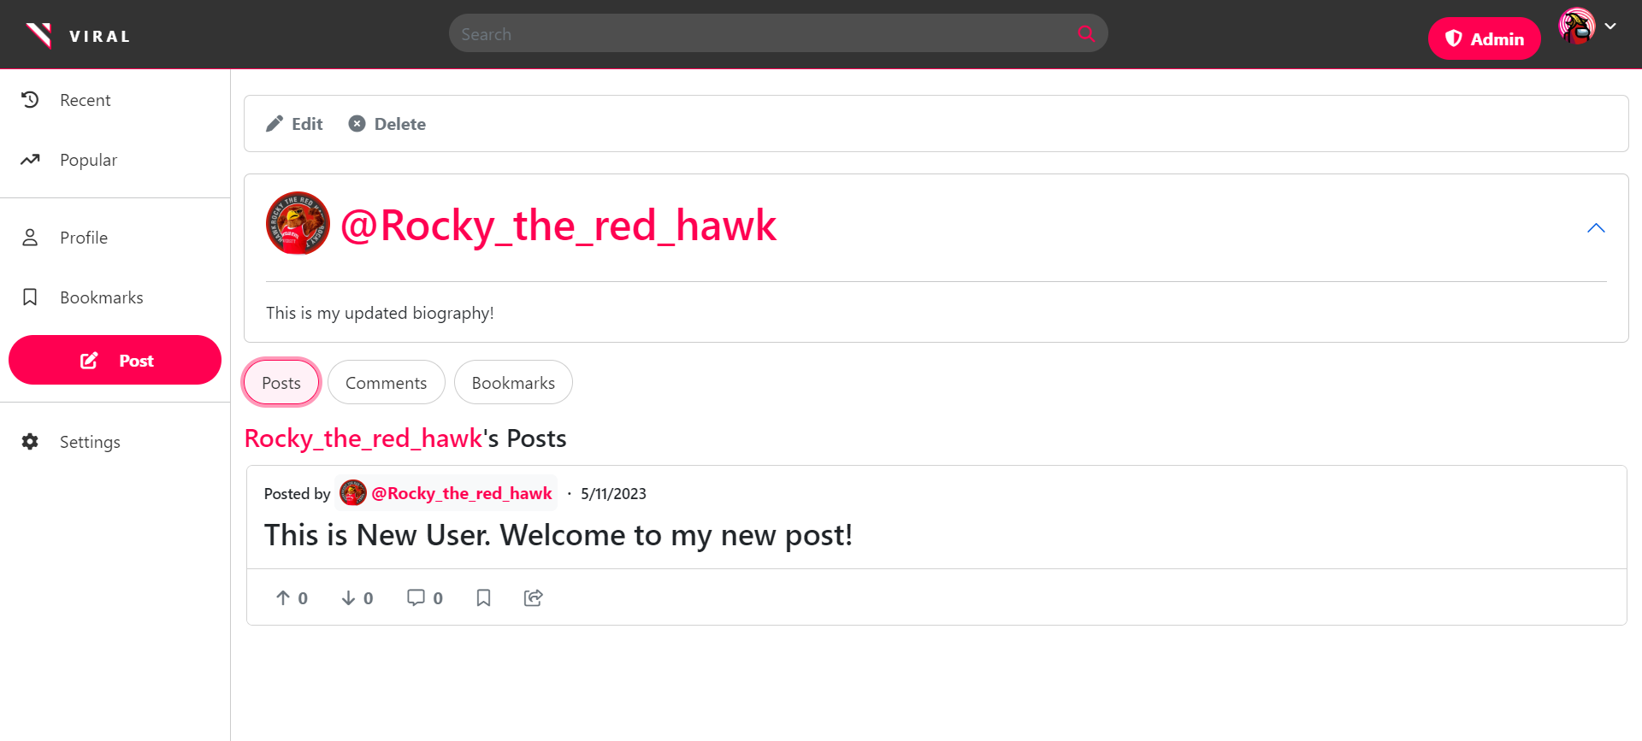

**Figure 90: After Admin click on User, Edit and Delete buttons are displayed**

1. Click on the Posts tab. Verify that the post is shown with an edit or delete button.

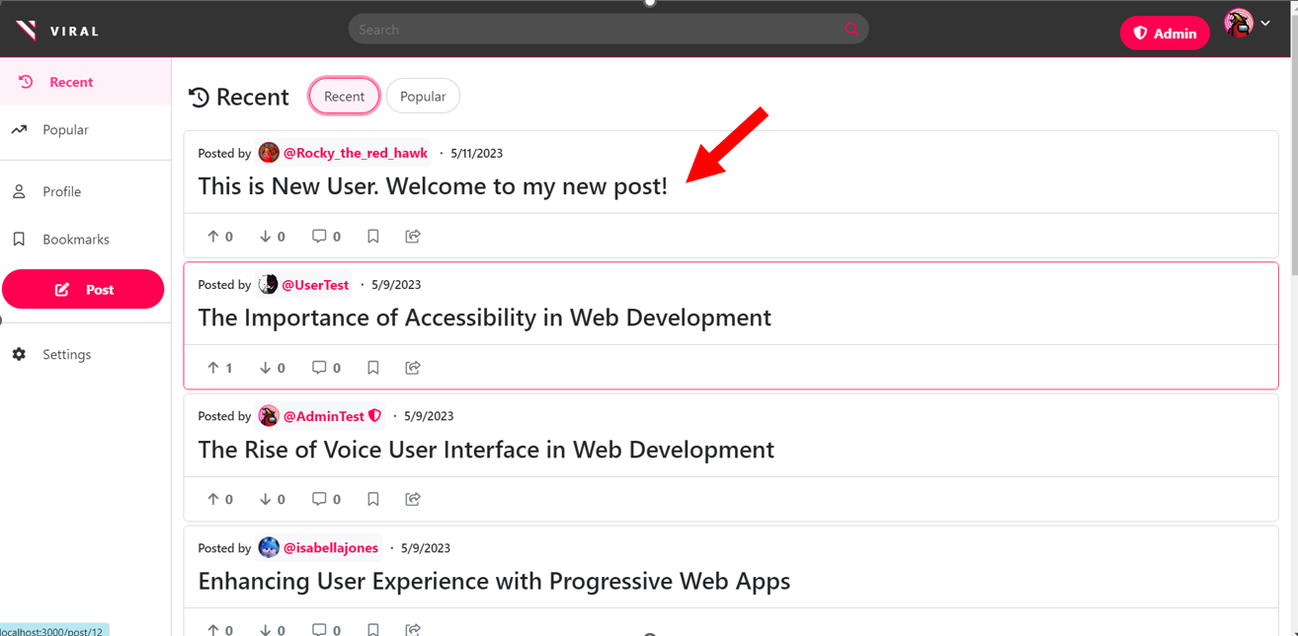

**Figure 91: Before Admin clicks on a Post**

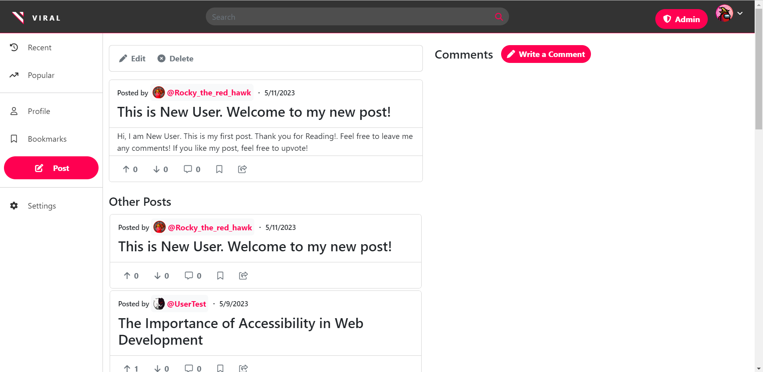

**Figure 92: After Admin clicks on a Post, Edit and Delete buttons are displayed**

##### Input Data:

1. Update or delete a user by clicking on Edit or Delete button for that user in the Users page. Verify that the user is updated or removed from the system.

###### Edit User

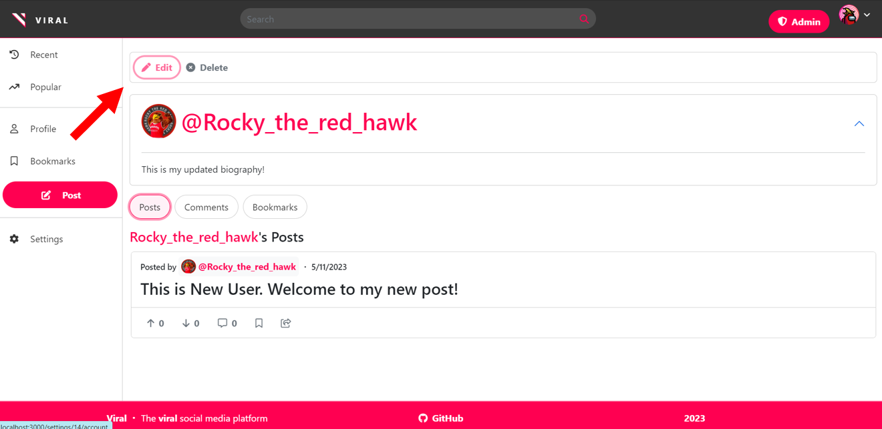

**Figure 93: Before clicking on Edit button.**

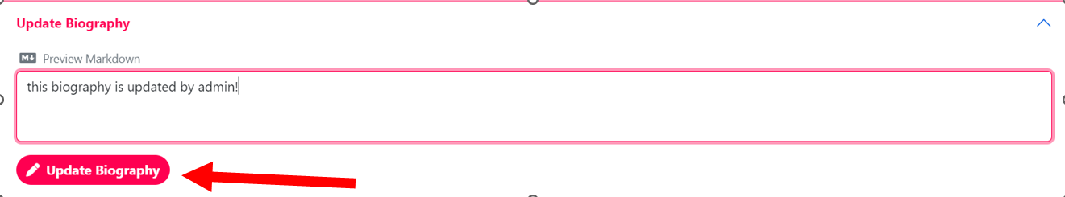

**Figure 94: After clicking on Edit Button**

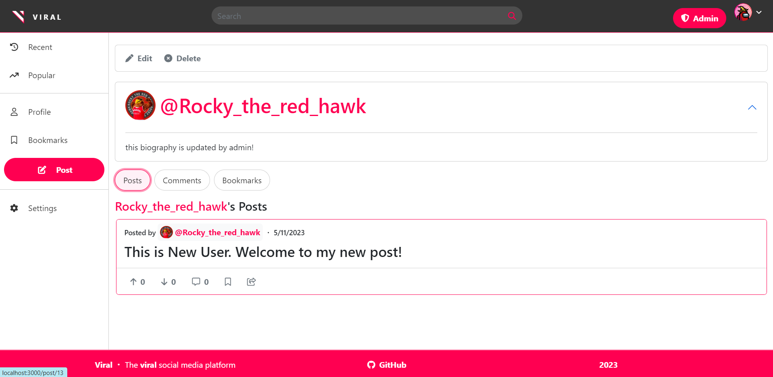

**Figure 95: Updated biography by Admin**

###### Delete User

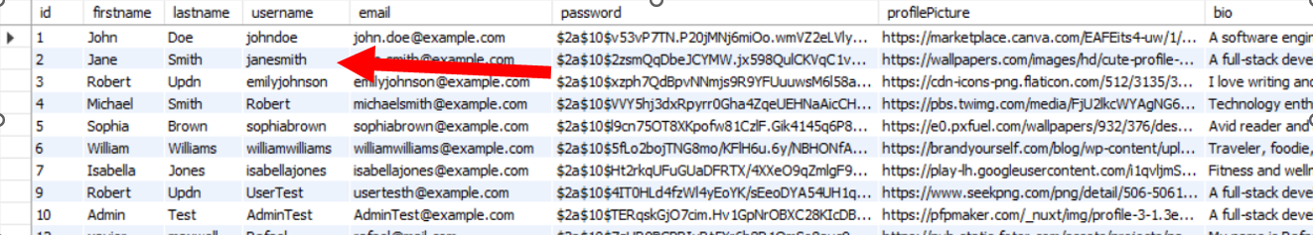

**Figure 96: SQL databse showing janesmith existing**

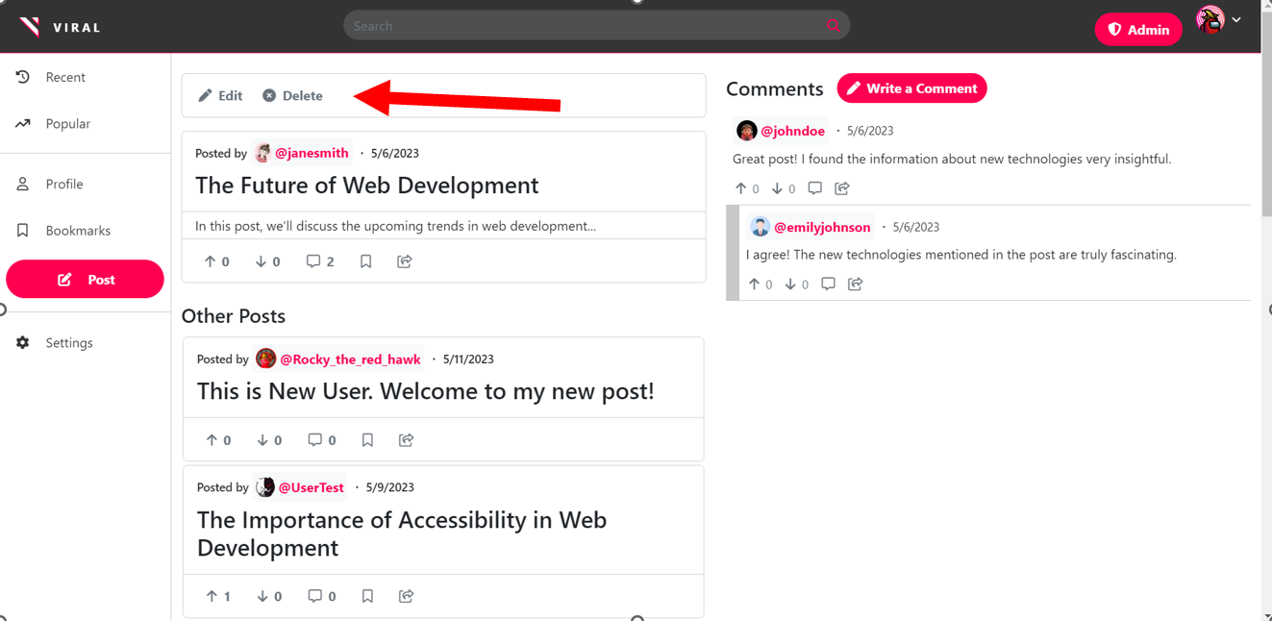

**Figure 97: deleting janesmith from database as Admin.**

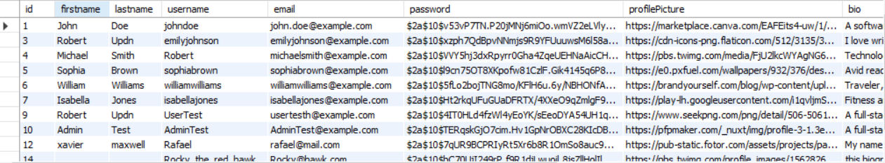

**Figure 98: janesmith is non-existent.**

1. Update or delete a post by clicking on the Edit or Delete button for that post in Posts page. Verify that the post is updated or removed from the system.

###### Update Post

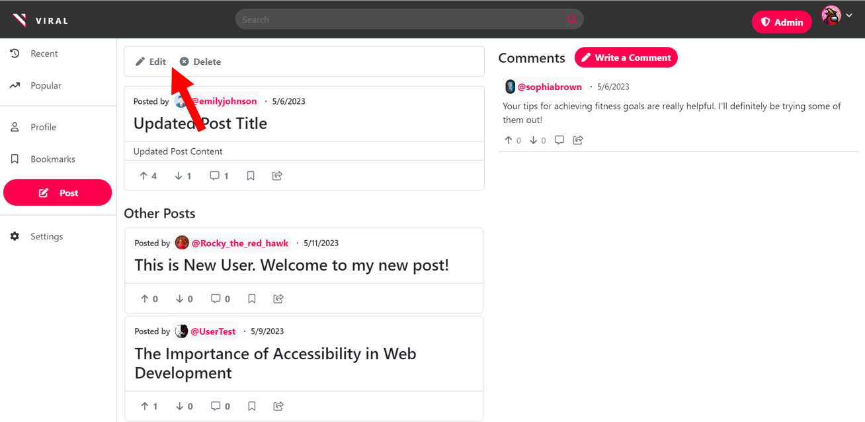

**Figure 99: Before Clicking Edit button a Admin**

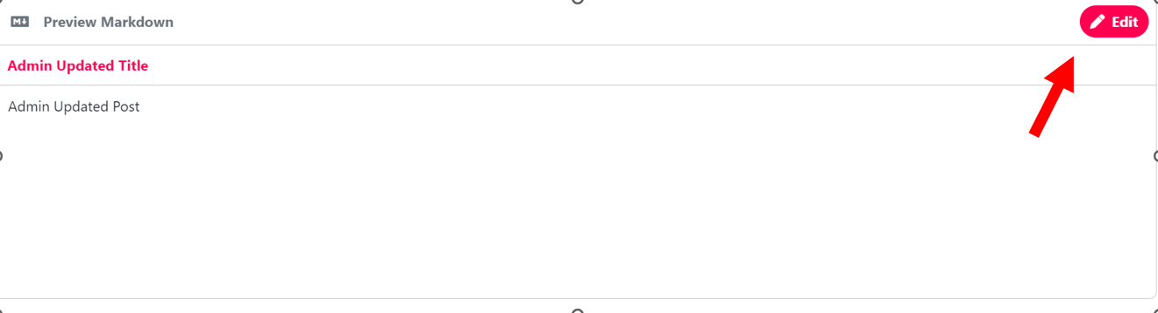

**Figure 100: Before Editing Title as Admin**

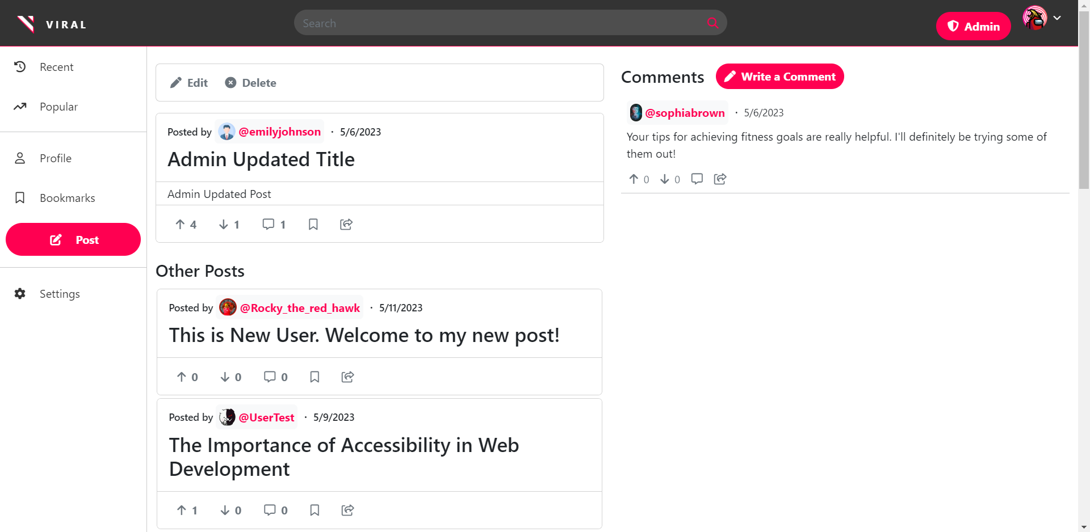

**Figure 101: After editing title as Admin**

Delete Post

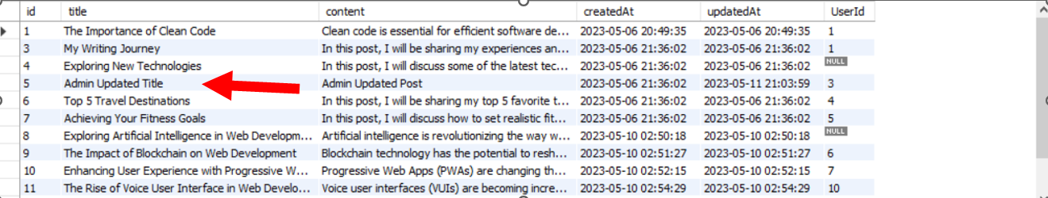

**Figure 102: Post in sql database before deletion.**

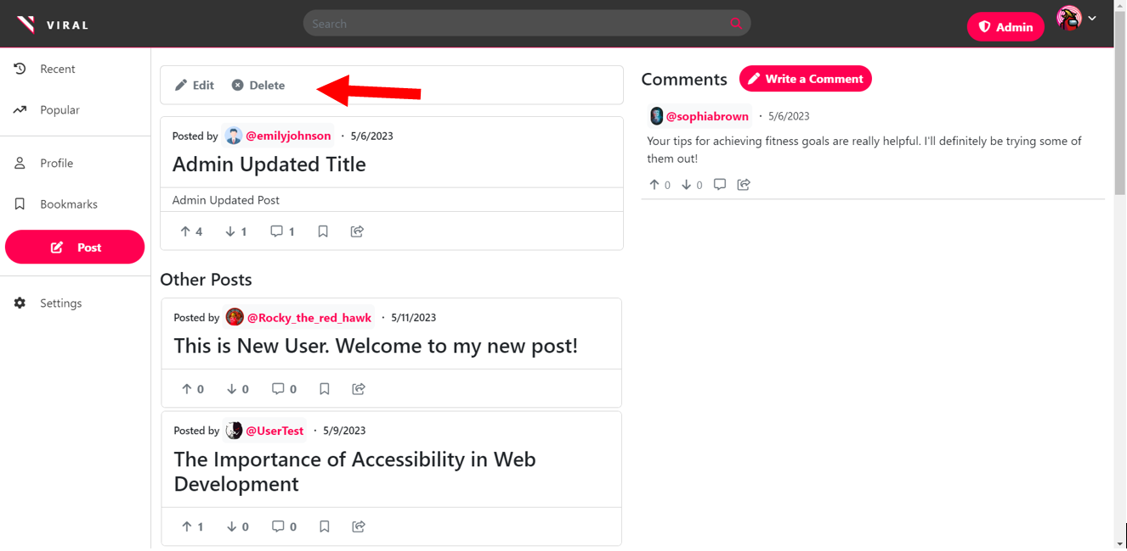

**Figure 103: Before pressing Delete button as Admin on chosen post**

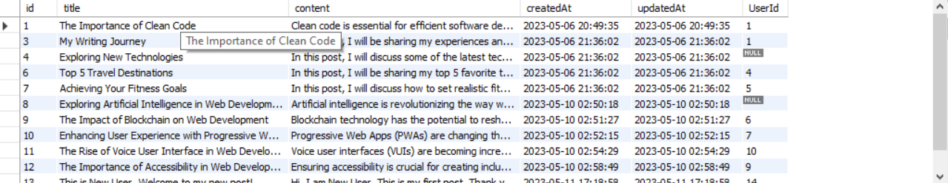

**Figure 104: Post is now deleted from database**

##### 

##### 

##### 

##### 

##### Responsiveness:

1. Resize the browser window to various screen sizes and verify that the layout adjusts accordingly.

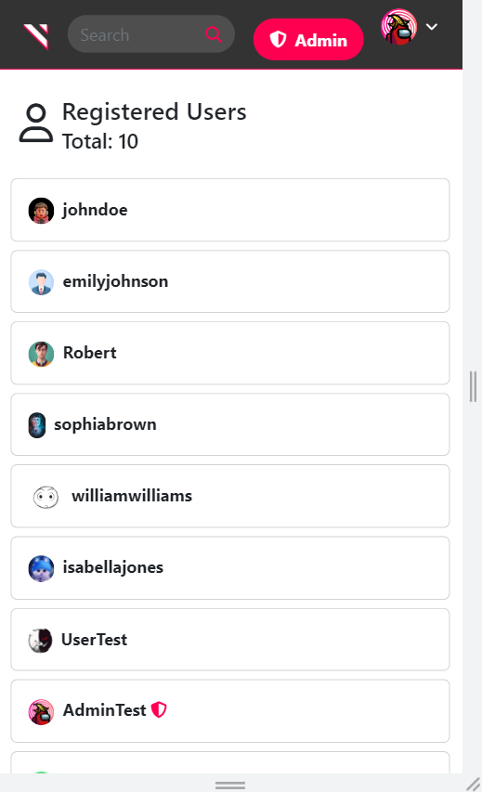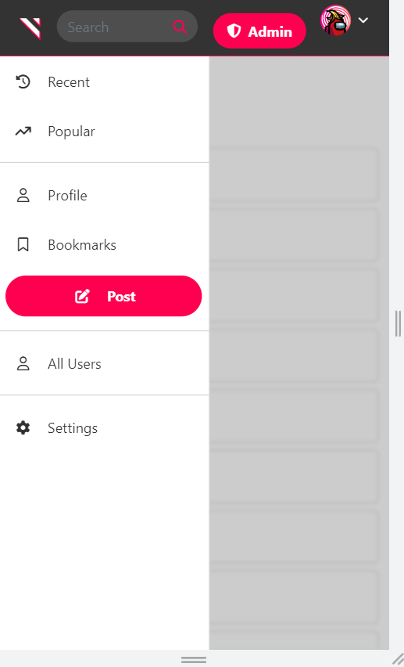

**Figure 105,106: Example of mobile view for admin functions.**

##### Error Handling:

1. Update a user with invalid details and verify that the system displays appropriate error messages.

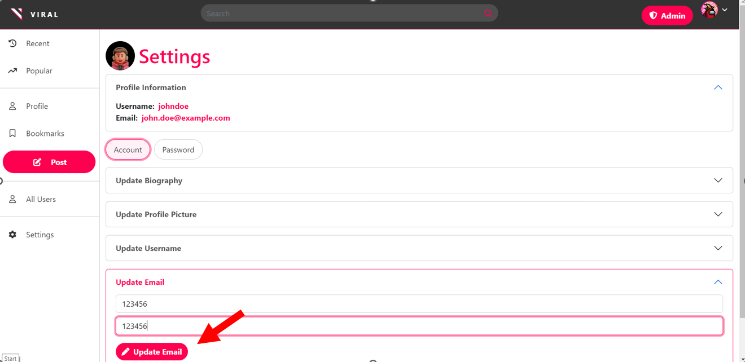

**Figure 107: Before editing user email with wrong email format as Admin.**

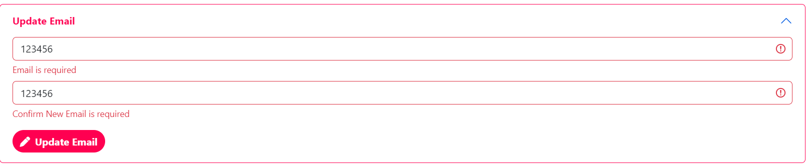

**Figure 108: After attempting to edit user email with the wrong format as an Admin.**

# 4. Discussion

During the testing phase, we conducted a comprehensive evaluation of the Viral social media platform, encompassing its guest, user, and admin interfaces. Our primary objective was to ensure a user-friendly and intuitive user interface, with all functionalities easily accessible. Additionally, we paid close attention to the platform's responsiveness across different devices and screen sizes.

For the guest interface, we thoroughly tested the navigation, user input, responsiveness, and error handling aspects. While most functionalities performed well, we encountered a critical bug related to comments that caused the application to crash. The development team promptly addressed this issue, ensuring the stability and reliability of the platform. Another issue we identified was a flaw in the sign-up process, allowing users to register even if the password and password confirmation did not match. This vulnerability was swiftly resolved to maintain data integrity and enhance the overall user experience.

Testing the user interface involved validating navigation, user input, responsiveness, and error handling functionalities. We rigorously tested various scenarios, including the login process, profile access, post creation, voting, bookmarking, profile updates, and commenting. Throughout this testing phase, we encountered minor issues, such as the inability to include spaces in post titles. The development team promptly rectified these issues, ensuring users could input titles accurately and seamlessly interact with the platform.

In the admin interface, our testing focused on navigation, input data, responsiveness, and error handling. We verified the login process, dashboard access, user management, and post management functionalities. While most features worked as intended, we discovered an oversight that prevented admins from viewing their own settings. This issue was promptly resolved, allowing admins to access and modify their settings as expected.

Alternatively, many improvements can be made to Viral to enhance the platform's user experience and security. One such feature is a rich tagging system, where users can associate numerous tags of their choice with their posts to provide greater context. Furthermore, a tagging system can introduce users to search by tag for added convenience. Another improvement is a rich search system, which features filters and a full-text search engine. Such a system would allow users to make more in-depth queries to find posts that interest them and enhance relevant results. Another is push back notifications through the use of WebSockets. Notifications would enhance the user experience, as users can be notified in real-time when someone upvotes, downvotes, or comments on their posts. Notifications would enhance the user experience as interactions between users are notified in real-time, allowing users to not need to check back occasionally if their posts or comments have received any activity.

Concerning security, another feature would be the addition of CSRF tokens to protect end-clients against malicious actors. With the current implementation, a malicious party can impersonate a user and perform any actions without consequence, as there are no authentication tokens in place. By utilizing CSRF tokens, the system would be more secure and better protected against malicious attacks, especially as admins are most vulnerable.

# 5. Conclusion

In conclusion, the Viral social media platform is a sleek and user-driven platform that offers a seamless user experience. Through rigorous testing of the guest, user, and admin interfaces, we have addressed various bugs and issues, resulting in a significantly improved platform in terms of user experience and reliability.

The platform's core features, such as the user-driven voting system and user customization options, contribute to its appeal and engagement. The ranking system based on user votes ensures that popular and relevant content is highlighted, while user customization allows individuals to personalize their accounts and express their uniqueness.

Furthermore, the platform's support for Markdown and its rich text formatting capabilities provide users with creative ways to enhance their posts and comments, making their content stand out. The inclusion of a search bar facilitates content discovery, allowing users to find posts that align with their interests easily.

Additionally, the bookmarking feature enables users to save posts for future reference, ensuring they can revisit and engage with valuable content. Guests, although limited in their actions, can still browse posts, view comments, and gain insights into user profiles, providing a glimpse of the platform's potential.

Looking ahead, the planned future implementations, such as the tag system and notification system, hold promise for further enhancing the platform's functionality and user engagement. The tag system will enhance search capabilities, making it easier for users to discover content tailored to their interests. Meanwhile, the notification system will foster real-time interactions and keep users informed about new posts and comments, enhancing the sense of community within the platform.

The Viral social media platform has undergone thorough testing, resulting in significant improvements to its user experience and reliability. With its user-driven approach, support for Markdown, and upcoming enhancements, Viral has the potential to become a vibrant and interactive social media platform that caters to diverse user interests and preferences. By continuously incorporating user feedback and advancing development efforts, the platform can continue to evolve and provide a dynamic space for users to connect, share, and engage in meaningful conversations.

# Video

<https://www.youtube.com/watch?v=xcyw95fhSKc>

# 6. References

“A demo of react-markdown” *RemarkJS*, <https://remarkjs.github.io/react-markdown/>

“Autosize” *jackmoor*, <https://github.com/jackmoore/autosize>

“bcrypt.js” *dcodeIO*, <https://github.com/dcodeIO/bcrypt.js>

“Cross-Origin Resource Sharing (CORS)” *Mozilla*, 10 May. 2023, <https://developer.mozilla.org/en-US/docs/Web/HTTP/CORS>

“Express” *Express*, <https://expressjs.com/>

“Express Session” *Express*, [https://expressjs.com/en/resources/middleware/session.html](http://expressjs.com/en/resources/middleware/session.html)

“Getting Started” *Axios*, <https://axios-http.com/docs/intro>

“How Do I Use Markdown?” *IBM*, 5 Mar. 2021, [www.ibm.com/docs/en/SSYKAV?topic=train-how-do-use-markdown](http://www.ibm.com/docs/en/SSYKAV?topic=train-how-do-use-markdown).

“Node MySQL 2” *sidorares*,<https://github.com/sidorares/node-mysql2>

“SPA (Single-page application)” *Mozilla*, 21 Feb. 2023, <https://developer.mozilla.org/en-US/docs/Glossary/SPA>

“React Bootstrap” *React Bootstrap*, <https://react-bootstrap.github.io/>

“Remark-gfm” *RemarkJS,* <https://github.com/remarkjs/remark-gfm>

“Sequelize” *Sequelize*, <https://sequelize.org/>

“TanStack Query v3” *TanStack*, <https://tanstack.com/query/v3/>